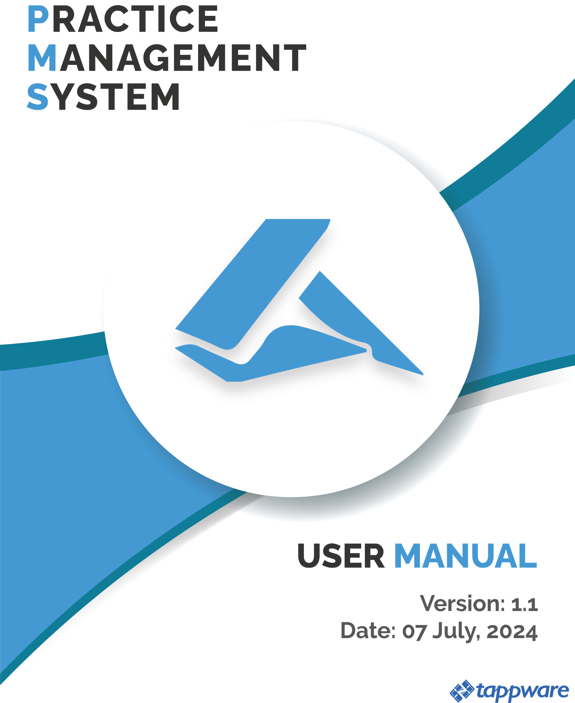

Table of Content

**PMS Application Setup Steps: 5**

Database Details 5

Setup Steps: 5

**PMS Application Registration: 6**

Step 1: Access the Registration Page 6

Step 2: Fill in the Firm’s Information 6

Step 3: Provide the Business Address 7

Step 4: Enter Contact Credentials 7

Step 5: Configure the Domain Setup 8

Step 6: Set Up Email Configuration 8

Step 7: Save or Reset 8

Searching for Existing Firms or Companies 13

Step 1: Access the Search Feature 13

Step 2: Enter a Keyword 13

Step 3: View Search Results 13

Step 4: Review Company Details 14

Notes: 14

**DB Activation form Super Admin 15**

Overview: 15

1. User Graph 15

2. Schedule Requests 15

Firm Setup Setting : 16

View: 18

Edit: 18

Status Indicators: 19

User Management setting: 20

Navigating to User Management 20

3. User List Overview 20

4. Searching for Users 20

5. Managing User Accounts 21

5.1 Deactivating a User 21

5.2 Reactivating a User 21

**1. Top-Bar 22**

1.1 Logo/Home Button 23

1.2 Toggle Sidebar Button 24

1.3 Voice Command Button 25

1.4 Notifications Button 26

1.5 Panel Header Button 27

1.6 Documents Button 28

1.7 Dashboard Button 29

1.8 Profile Button 30

**2. Admin Dashboard 31**

2.1 Active Task 32

2.2 Clients 33

2.3 Performance Overview 33

2.4 Document Review Board 34

2.5 Service Earnings 35

2.6 Letter DashBoard 36

2.7 Payment Monitoring Board 37

2.8 Active Tasks Board 37

2.9 What’s up Today Board 38

2.10 State Monitoring Board 38

2.11 Deadline Monitoring Board 39

2.12 Colleague Monitoring Board 40

2.13 Important Summary 40

2.14 Activity Board 41

2.15 Client Onboarding Summary 41

2.16 Revenue This Year 42

**3. Firm Setup 43**

3.1 Firm Profile, Contact & Address Box 43

3.2 Profile Information, About & Integrations 44

3.3 Bank Account Information 44

3.4 HMRC Account Information 45

3.5 Agent Codes 45

3.6 Accountancy Firm Documents 46

3.7 Transaction History 46

**4. Team Management 47**

4.1 Overview 47

4.1.1 Profile Overview 48

4.1.2 Clients 49

4.1.3 Documents 51

4.1.4 Activities 51

4.1.5 Important 52

4.1.6 Logs 52

4.1.7 Notifications 54

4.1.8 Control Access 55

4.2 New Member 56

4.3 Manager List 57

4.4 Colleague List 58

4.5 Colleague and Manager Mapping 59

**5. Client Management 60**

5.1 Overview 60

5.1.1 Client Mapping 61

5.2 Register Client 62

5.2.1 Basic Profile 62

5.2.2 Profile Details: 63

5.2.3 Directors and Shareholders 65

5.2.4 Upload Documents 66

5.2.5 Map Manager and Colleague 66

5.2.6 Completion 67

5.3 Bulk Register 68

5.4 Pre-Registered Clients 68

5.5 Registered Client 69

5.5.1 View 69

5.5.1.1 Overview 69

5.5.1.2 Directors and Shareholders 70

5.5.1.3 Contracts 70

5.5.1.4 Services 73

5.5.1.5 Application Users 73

5.5.1.6 Client Documents 74

5.5.1.6 Service Documents 74

5.5.1.7 Notifications 75

5.6 Client User 77

5.7 Client Mapping 77

5.8 Special Engagement Letter 79

5.9 Mailbox 79

5.10 Contract Documents 79

**6. Payment Management 80**

6.1 Ledger 80

6.1.1 Ledger Book 80

6.1.2 ledger Book Detail 81

6.2 Invoice 82

6.2.1 Generate Invoice 82

6.2.2 Invoice List 83

6.3 Payment 84

6.3.1 Direct Debit Verification 84

6.3.2 Make Payment 85

6.3.3 Deposit List 86

**7. File Management 87**

7.1 View Documents 87

7.2 Upload Task Documents 88

**8. Task Management 89**

8.1 Task 89

8.1.1 Create 90

8.1.2 Filter 91

8.1.3 Notes Button 92

8.1.4 Add Task Note Button 93

8.1.5 Progress (+) button 94

8.1.5.1 Draft 94

8.1.5.2 Preparation 94

8.1.5.3 Ready 95

8.1.5.4 In-Progress 96

8.1.5.5 Manager Approval 97

8.1.5.6 Client Approval 97

8.1.5.7 Payment 98

8.1.5.8 Submission 99

8.1.6 Action Column Buttons 100

8.2 Task Note 101

8.3 Payroll Setup 101

8.4 Payroll Reports 102

**9. Mail-Box Settings 103**

9.1 Overview 103

9.2 Mail Setup 104

9.3 Mail Outbox 105

9.4 Mail Inbox 105

9.5 Send Mail 106

**10. Service Settings 107**

10.1 Overview 107

10.2 Service List 108

10.3 Map Service & Document 109

10.4 Map Service & States 109

10.5 Document List 110

10.6 Service State List 110

10.7 Service Task 111

**11. Notification Settings 112**

11.1 Notifications 112

11.2 Notification Type 112

11.3 Notification Event 113

**12. Application Settings 114**

12.1 Overview 114

12.2 Business type 114

12.3 User-Role 115

12.4 Application-Logs 116

12.5 Holiday List 117

12.6 Voice Command 117

12.7 2FA 117

Practice Management System Registration Process

# Accountancy Firm Onboarding:

1-Self Onboarding

2-Admin

# PMS Application Setup Steps:

#### **Database Details**

* **Domain**: prac-sys.com
* **Databases**:
  + pracsys_local_master
  + pracsys_local_afdb_master
  + pracsys_local_emailer
  + pracsys_local_pdf

#### **Setup Steps:**

1. Remove data from the tables: user_profiles, users, user_entity_roles, accounting_firm_profiles, and clients.
2. Insert the accounting firms **"asico"** into the system.
3. After creating the accounting firm, verify that data is inserted into accounting_firm_profiles and client_domains tables.
4. Verify that data entries for users and userprofiles are successfully inserted and visible in the database.
5. The user must be given full privileges (including import/export) for database setup.
6. If there is a problem creating the database, or if the database is created but tables are missing, delete the database and clear three columns in the client_domain table: host, user, and password. Set retry_count to 0.
7. Then, check if the database has been copied correctly. First checkpoint: Verify if the number of tables in the source DB and destination DB are equal.
8. Login will be possible only if the **username, password, and status** are active. The only reason for not accepting the username and password is that the user must exist in the table and have an active status.
9. Asico is created as an accountancy firm, a profile has been generated. A user is also created for this with the pre-chosen email and username. Based on this, the user is considered as the default admin. When activated, an email will be sent. It must be checked whether the email is being sent after activation.
10. After setting up the email application, browse to check if the application is visible. Then, log in and test by sending an email. The test must be successful.

# 

# Accountancy Firm Onboarding:

Summary of the steps:

1-Access the Registration Page

2-Fill in the Firm’s Information

3-Provide the Business Address

4-Enter Contact Credentials

5-Configure the Domain Setup

6-Set Up Email Configuration

7-Save or Reset

8-System Processing

9-Automatic Domain Setup

10-Login with superman Account

11-Database Activation

12-Confirmation

### Searching for Existing Firms or Companies

#### 1-Access the Search Feature

2-Enter a Keyword

3-View Search Results

4-Review Company Details

# DB Activation form Super Admin

1-**Firm Setup Setting**

**2-Firm Activation Process**

**3-Database (DB) Setup**

**4-Status Change**

**5-View**

6-**Edit**

**7-Status Indicators**

### Step 1: Access the Registration Page

1. Open the PMS software or navigate to the designated registration URL.
2. Click on the Register option on the login landing page.

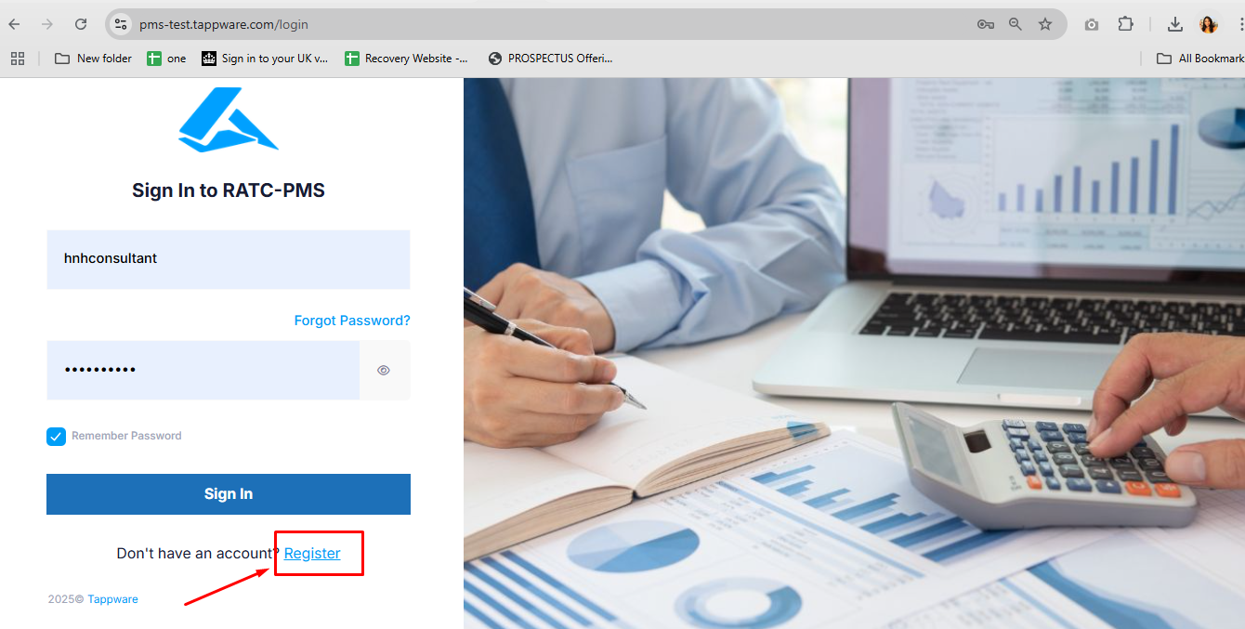

### Step 2: Fill in the Firm’s Information

***(All fields marked with required ( *) are mandatory.)*** Under the **Add Accounting Firm Information** section, complete the following fields:

* **Company Name**\*: Enter the full legal name of the company.
* **Company Phone Number**\*: Provide the company’s contact number.
* **Company Email**\*: Enter a valid email address for communication purposes.
* **Company Authentication Code**: Enter the company’s unique authentication code (optional).
* **Company Reference Number**: Enter the company’s internal reference number (optional).
* **Company Tax Reference Number**: Provide the firm’s tax reference number (optional).
* **Company Incorporation Number**\*: Enter the company’s incorporation number as per registration documents.
* **Company Incorporation Date**\*: Use the calendar icon to select the incorporation date.
* **Company VAT Registration Number**: Enter the VAT registration number (optional, if applicable).
* **Company VAT Effective Registration Date**: Select the effective date of the VAT registration using the calendar icon (optional, if applicable).

### 

### Step 3: Provide the Business Address

***(Fields marked with required ( *) are mandatory.)*** Fill in the firm’s address details under **Company Business Address**:

* **Address Line 1**\*: Enter the primary address.
* **Address Line 2**: Provide additional address details (optional).
* **Area**: Enter the geographical area or city (optional).
* **Postcode**: Provide the postal code for the address (optional).
* **Company Business Description**: Include a brief description of the firm’s business activities (optional).

### Step 4: Enter Contact Credentials

***(All fields marked with required ( *) are mandatory.)*** Under the **Contact Credentials** section, provide:

* **Contact Person Name**\*: Enter the contact person’s title, first name, and last name.
* **Contact Person Mobile**\*: Provide the mobile phone number.
* **Contact Person Email**\*: Enter a valid email address for the contact person.
* **Contact Person Designation**\*: Specify the role or designation in the firm.
* **Contact Person Username**\*: Create a username (letters, numbers, underscores, and hyphens only).

### Step 5: Configure the Domain Setup

***(Fields marked with required ( *) are mandatory.)*** Under the **Domain Setup** section:

* **Subdomain**\*: Enter the desired subdomain name (e.g., pms-test.tappware.co).

### Step 6: Set Up Email Configuration

***(All fields marked with required ( *) are mandatory.)*** Complete the **Email Setup** section:

* **Email Protocol**\*: Select the protocol (SMTP or Gmail).
* **Username**\*: Enter the email username.
* **Password**\*: Provide the email account password.
* **Host**\*: Enter the email host address (e.g., smtp.example.com).
* **Port**\*: Specify the port number (e.g., 587 for SMTP).
* **TLS**: Choose True if TLS is required; otherwise, select Null (optional).

### Step 7: Save or Reset

* Click **Submit** to save the firm’s details and initiate domain creation.
* Click **Reset** to clear all fields and start over.

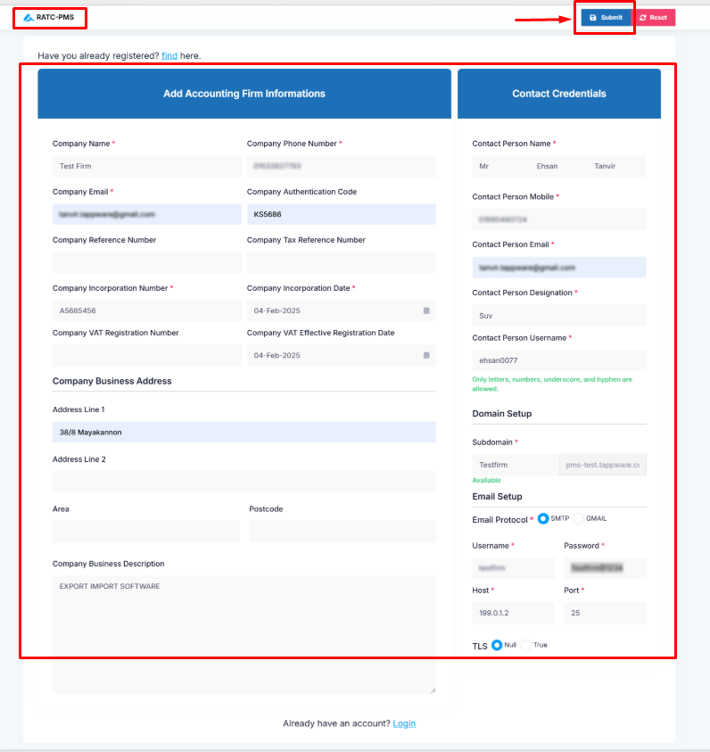

### Step 8: System Processing

* After submitting the registration form, the system will display the confirmation message:

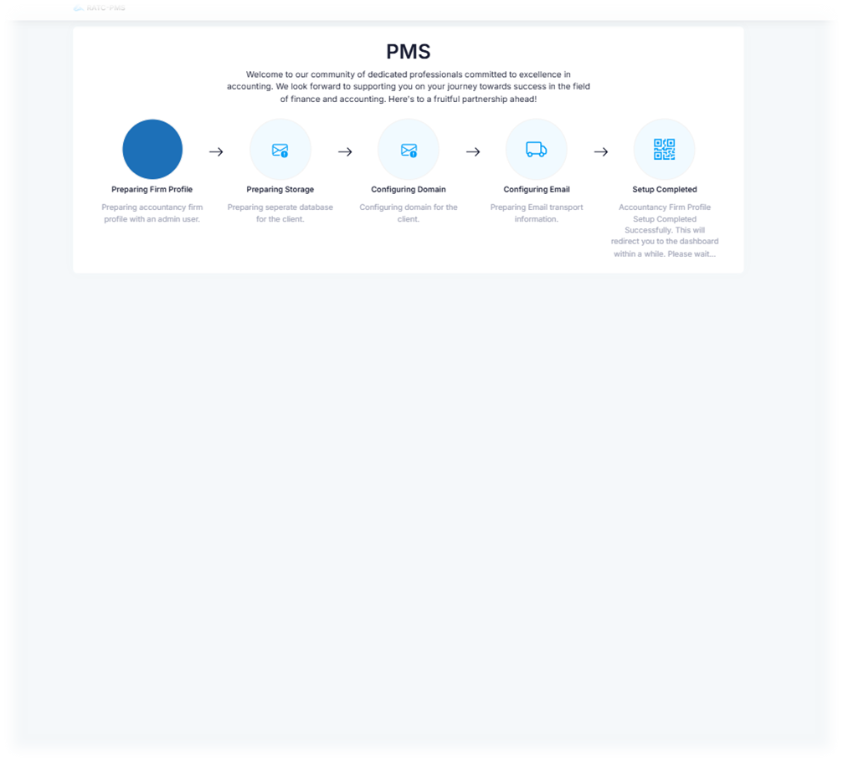

***"Congratulations on successfully registering with our accountancy firm! Welcome to our community of dedicated professionals committed to excellence in accounting. This process takes some time. Please wait..."***

The system will automatically begin the domain setup and database activation process in the background. This might take a few minutes.  
 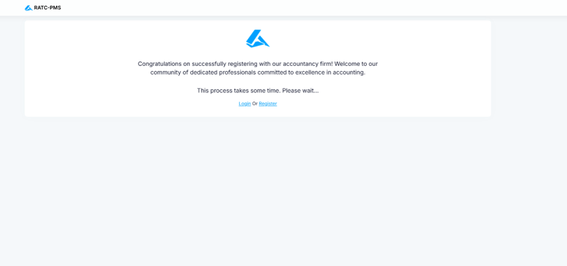

Step 9: Automatic Domain Setup

* A unique domain will be generated automatically for your firm.
* The domain will follow the format: **[firmname]**.pmsdomain.com.
* You will be notified once the domain setup is complete.

Step 10: Login with superman Account

1. After the domain is created, the **Superman Account** (Admin Account) needs to be activated.
2. Use the Superman credentials provided during registration to log in:
   * Username: (Your registered email)
   * Password: (Generated password or the one set during registration)
3. Upon login, you will have full administrative access to manage your firm’s settings and users.

Step 11: Database Activation

* The system will automatically create and activate a database for your firm.
* This database will store all records, including user data, transactions, and other firm-related information.

Step 12: Confirmation

1. Once all steps are complete, a confirmation email will be sent to the registered email address.
2. You can now start using the Practice Management System software with the new firm.

### Searching for Existing Firms or Companies

To search for any existing firm or company within the system. This feature helps you verify whether a firm is registered and view its basic details.

#### Step 1: Access the Search Feature

1. Navigate to the **Firm/Company Search** section on the registration form.
2. Use the search bar displayed at the top of the screen.

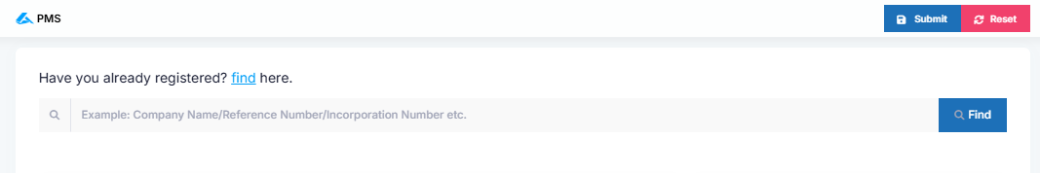

#### Step 2: Enter a Keyword

1. In the search bar, type a keyword related to the firm or company you are looking for.
   * This can include the **Company Name**, **Reference Number**, or any other identifying information.
2. Click the **Search** button to proceed.

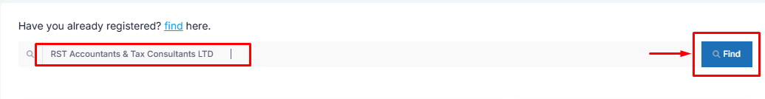

#### Step 3: View Search Results

* The search results will display the relevant companies matching the keyword.

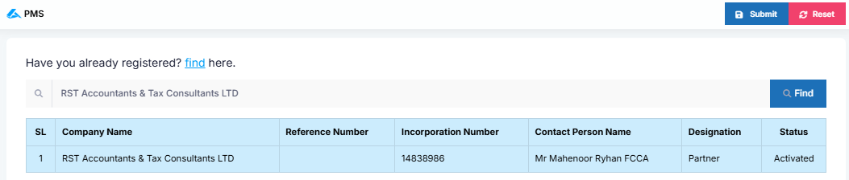

#### Step 4: Review Company Details

1. Click on a company name in the results table to view more detailed information about the firm.
2. Verify the following:
   1. **Reference Number**: A unique identifier for the firm.
   2. **Incorporation Number**: The official number assigned during registration.
   3. **Contact Person Name** and **Designation**: Details of the main point of contact.
   4. **Status**: Indicates whether the firm is **Active**, **Inactive**, or **Pending**.

### 

### **Notes:** *If the firm or company does not appear in the search results, it may not be registered. You can proceed with the registration process to create a new firm.*

# DB Activation form Super Admin

## **Overview:**

The **Super Admin Dashboard** in the PMS system provides an overview of key metrics and scheduled requests. It includes:

1. **User Graph** - A visual representation of user data over different periods.
2. **Schedule Requests** - A list of scheduled requests with their execution status.

### 1. User Graph

The dashboard includes a **User Graph** that displays user activity over different time frames:

* **Year** (Annual view)
* **Month** (Monthly view)
* **Week** (Weekly view)

This graph visually represents trends in user registrations and engagement.

### 2. Schedule Requests

The **Schedule Request** section provides a list of scheduled processes, displaying:

* Lists all scheduled system requests.
* The request type (e.g., **CompanyHouseChangesTrigger**) and execution time are displayed.
* **Error Messages** are shown in red if a request fails.
* An X button allows for manual cancellation or removal of failed requests.

Schedule requests can be filtered by:

1. **Year**
2. **Month**
3. **Day**

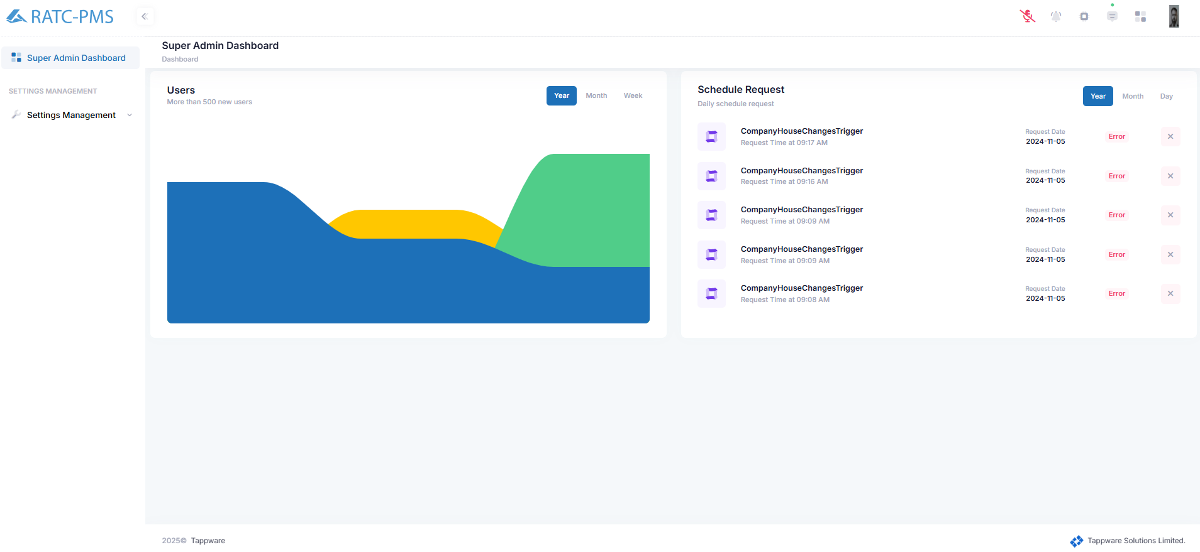

### **Firm Setup Setting :**

The Accountancy Firm Setup section in PMS enables the Super Admin to manage newly registered firms. This section provides tools to activate, configure, and oversee firms efficiently.

Steps to Register and Activate a Firm

* **Firm Registration**
  + New firms are registered under Firm Setup Settings.
  + Once registered, firms will appear in the Firm Setup List.

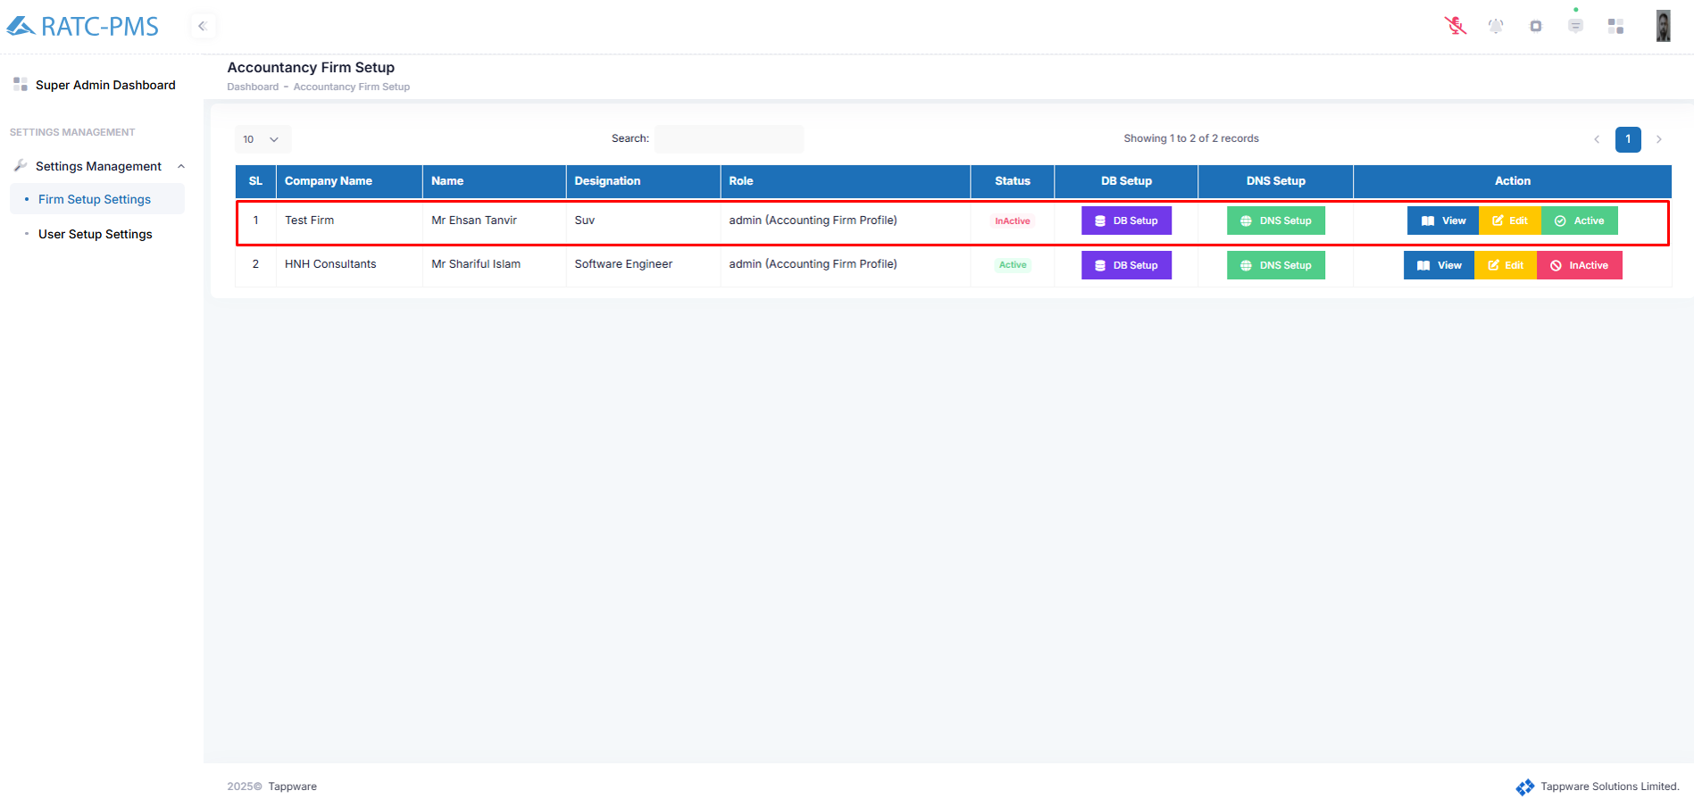

* **Firm Activation Process**To activate a registered firm, the Super Admin must complete the following steps:
* **Database (DB) Setup:**  
  Click the DB Setup button to configure the firm's database.

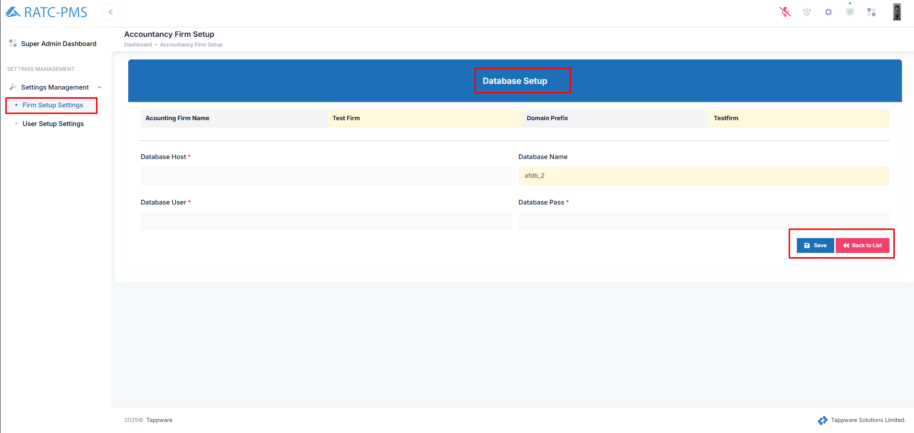

Input information in the relevant field and click save.

* **Status Change:**

By default, a new firm is marked as Inactive

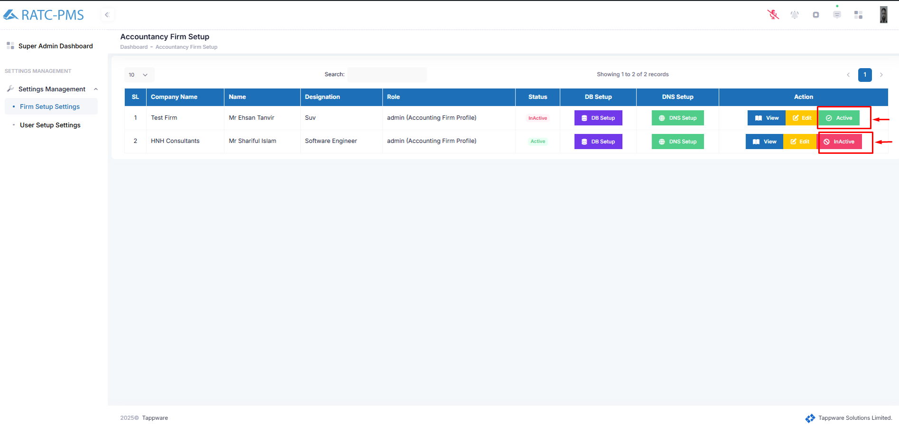

* After completing the DB and DNS setup, the Super Admin must manually activate the firm by clicking the Active button.

***After activating the firm the credential email is automatically sent to a related email address.***

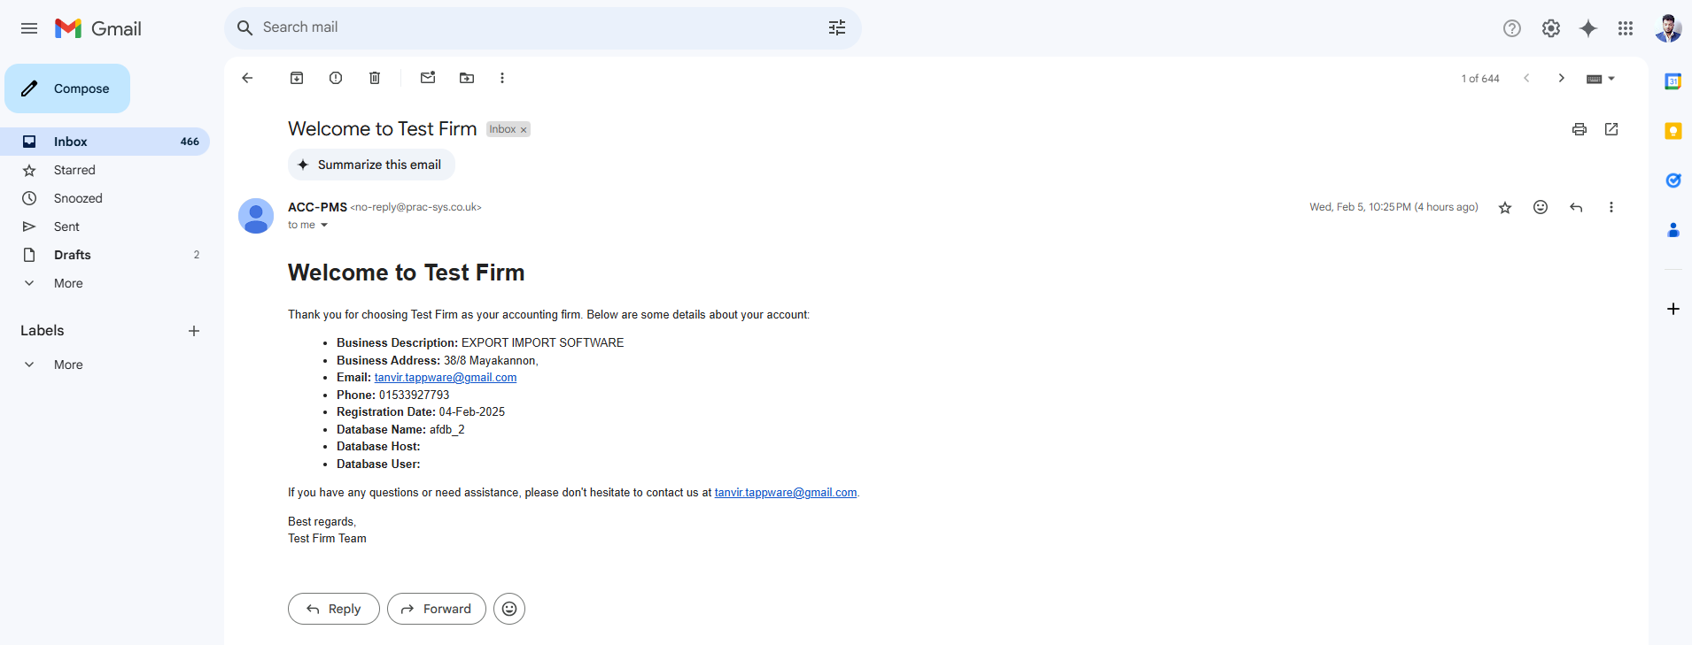

**The Super Admin can perform the following actions for each firm:**

#### **View**:

Click the View button to access detailed information about the firm.

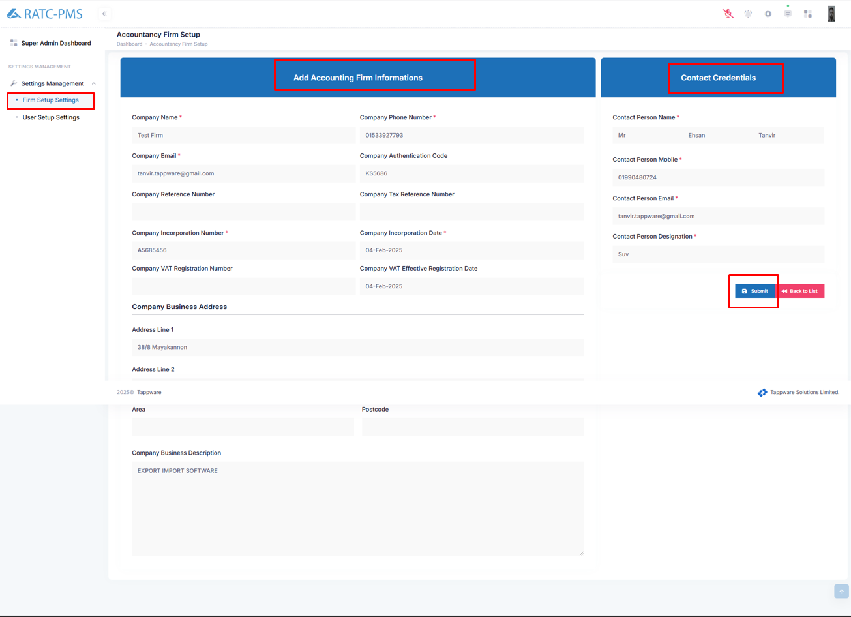

**Edit:**

Click the Edit button to update the firm’s details.



* **Activate/Inactivate:**
  + Click Active to enable the firm.
  + Click Inactive to disable the firm.

#### **Status Indicators:**

* Active (Green): The firm is fully set up and operational.
* Inactive (Red): The firm setup is incomplete or has been disabled.

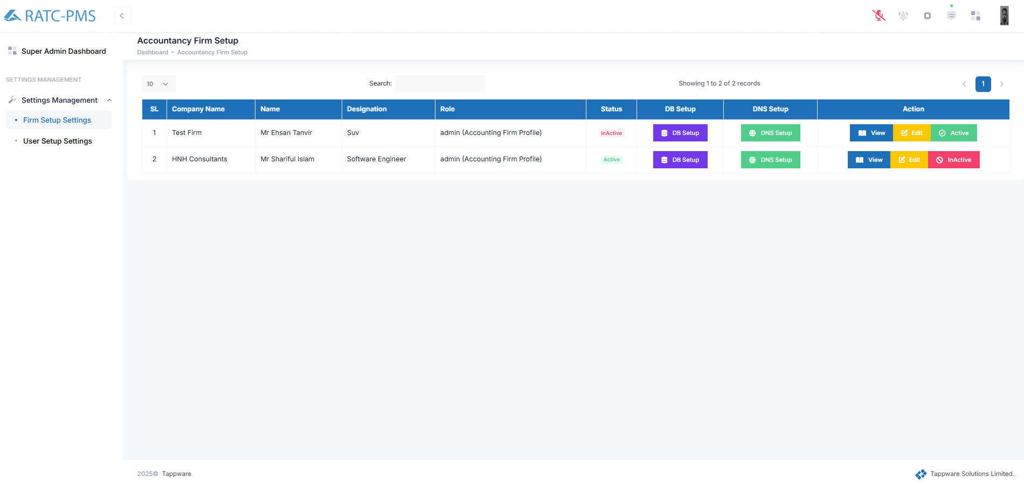

## **User Management setting:**

## **Navigating to User Management**

1. Log in to the **PMS** platform.
2. From the **Super Admin Dashboard**, locate the **Settings Management** section on the left menu.
3. Click on **User Setup Settings** to access the User Management Setting panel.

## **3. User List Overview**

The **User Settings** panel displays a list of all registered users with the following columns:

* **SL (Serial Number):** Unique identifier for each user.
* **Name:** The registered name of the user.
* **Designation:** The role/title of the user within the organization.
* **Role:** Assigned access level (e.g., super_admin, admin, manager, colleague).
* **Status:** Indicates whether the user is **Active** or **Inactive**.
* **Action:** Provides an option to deactivate a user.

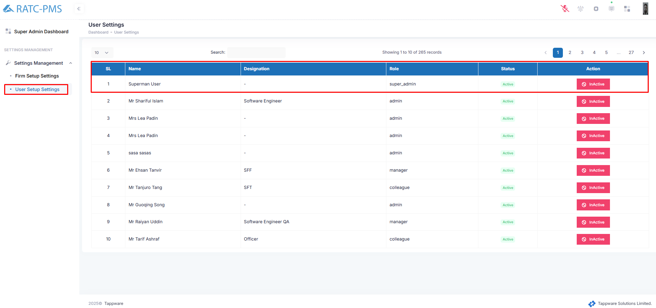

## **4. Searching for Users**

1. Use the **Search** bar at the top of the User Settings panel.
2. Enter a name or designation to filter the results.
3. The list updates dynamically to show matching records.

## **5. Managing User Accounts**

### **5.1 Deactivating a User**

1. Locate the user you want to deactivate in the user list.
2. Click on the **InActive** button in the **Action** column.
3. Confirm the action if prompted. The user’s status will change to **Inactive**.

### **5.2 Reactivating a User**

1. Locate the inactive user in the user list.
2. If there is an option to **Activate**, click on it.
3. The user’s status will change to **Active**.

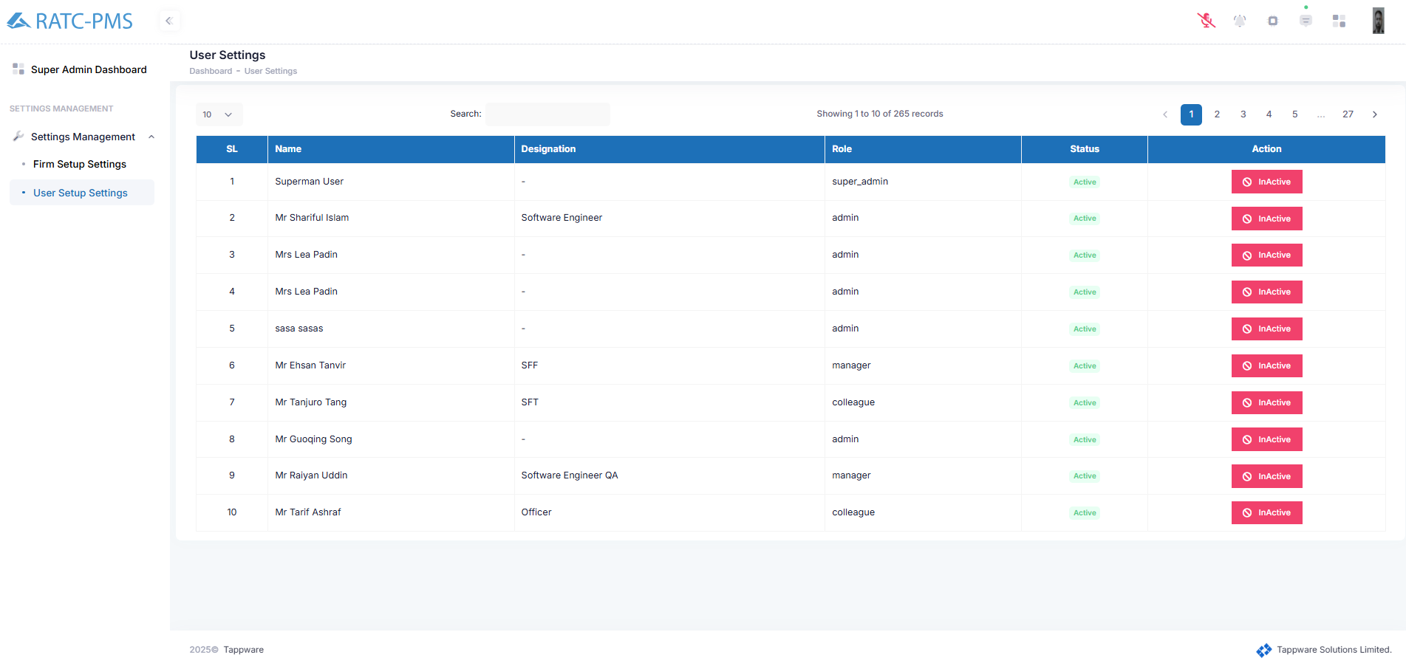

Practice Management System

# Top-Bar

The top-bar of the software provides easy access to essential functions, enhancing user experience and efficiency. It includes buttons for home navigation, toggling the sidebar, voice command functionality, notifications, panel header access, documents, dashboard overview, and user profile management. This streamlined interface ensures quick and intuitive navigation across the website’s features.

# 

Fig: Top-bar Overview

## 

## 1.1 Logo/Home Button

The home button on the topbar provides users with a quick and easy way to return to the main or landing page of the application. This functionality allows users to reset their navigation and start fresh from the central hub of the app, ensuring they can access the primary features and sections of the software without getting lost in deeper navigation paths.

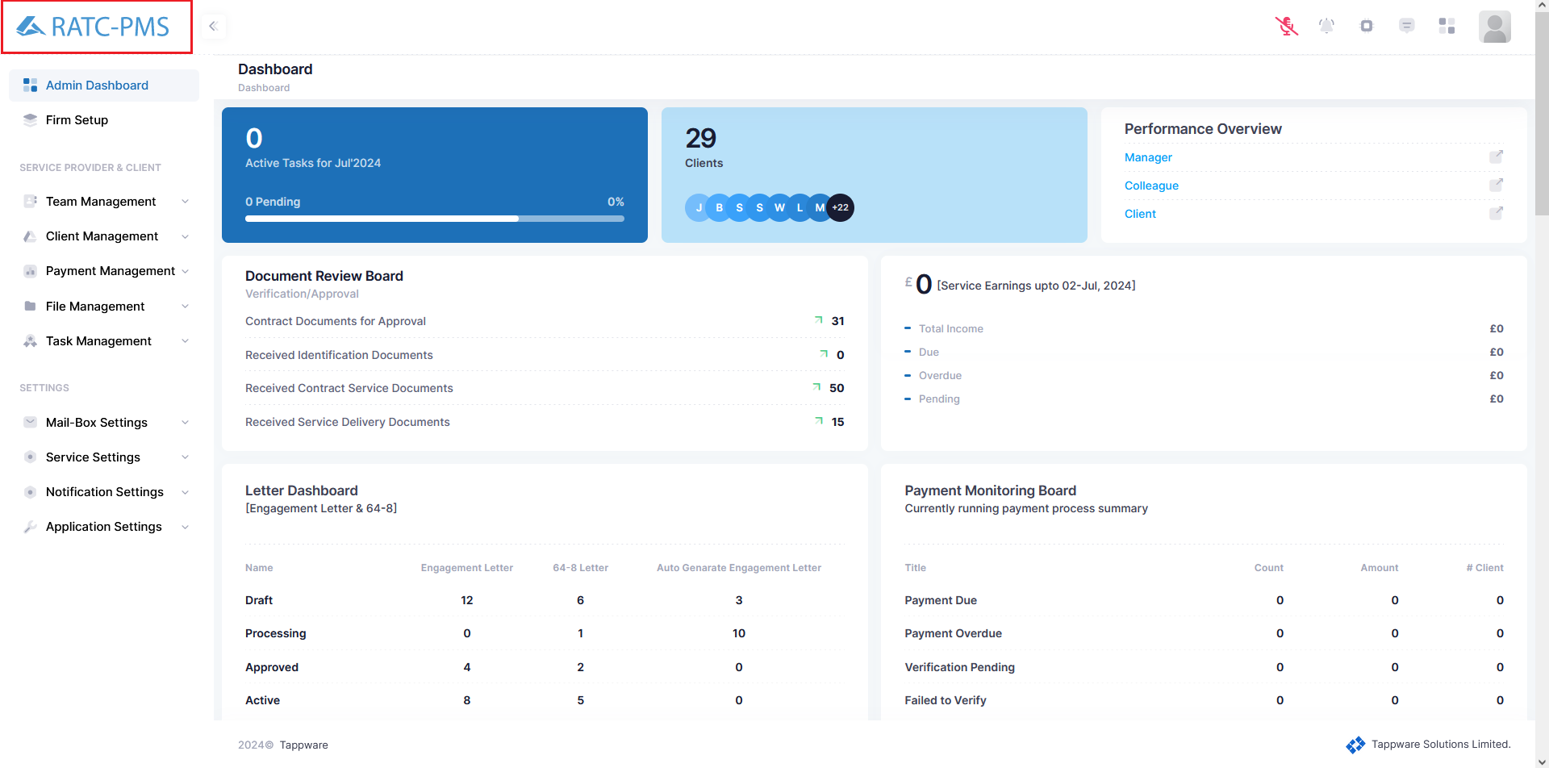

Fig: Logo/Home Button

## 1.2 Toggle Sidebar Button

The toggle sidebar button allows users to show or hide the sidebar with a single click. This functionality helps users manage their workspace by providing more screen space when needed. It enhances usability by offering a flexible and customizable interface, catering to different user preferences and tasks.

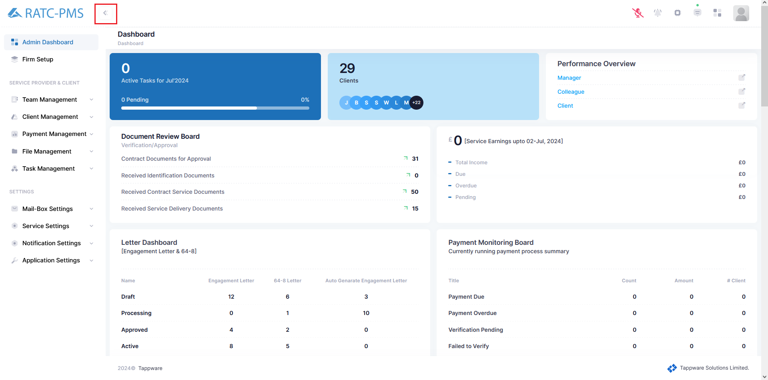

Fig: Toggle Sidebar Button

## 1.3 Voice Command Button

The Voice Command button in the topbar enables users to interact with the software through spoken commands. This feature enhances accessibility and convenience, allowing users to perform actions, navigate through the application, and manage tasks hands-free, improving workflow efficiency and user experience. Users can find all the voice command lists from Settings→ Application Settings → Voice Command.

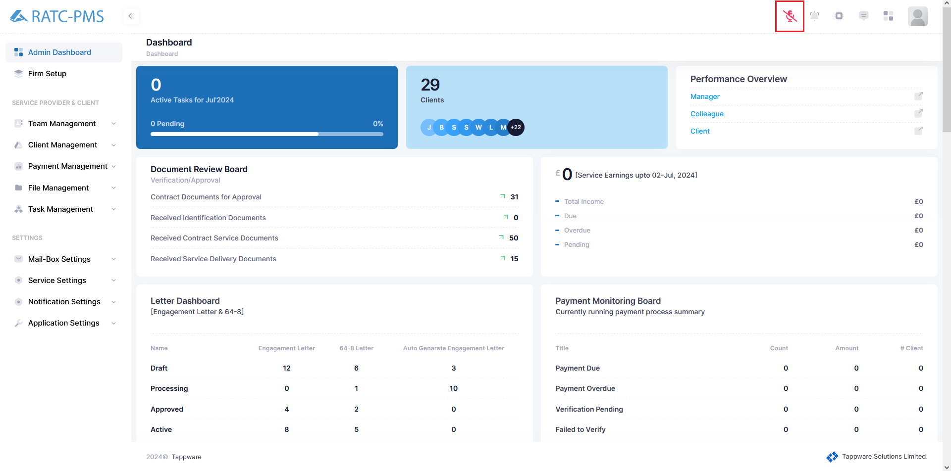

Fig: Toggle Sidebar Button

## 1.4 Notifications Button

The Notification button in the top bar provides users with real-time alerts and updates. When clicked, it opens a panel displaying notifications, such as task updates and time. This ensures users stay informed about important events and changes, helping them to manage their activities and responsibilities more effectively.

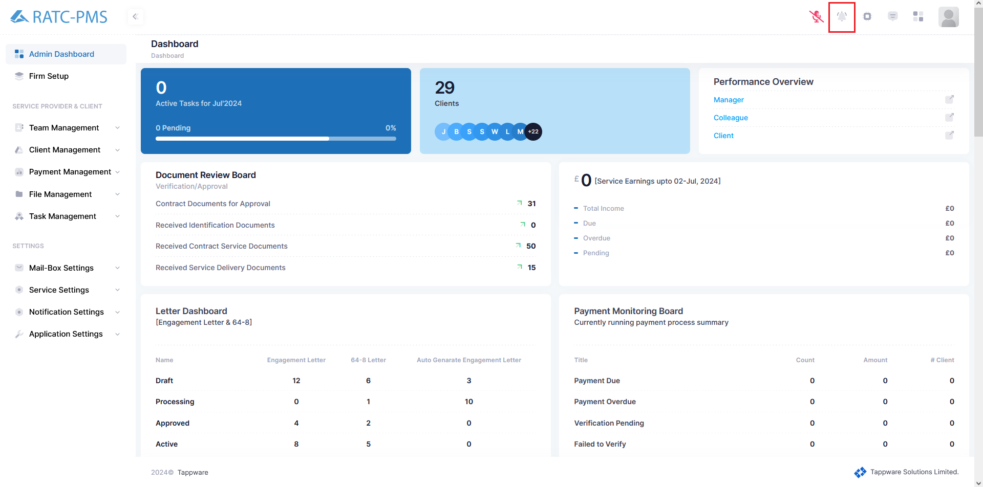

Fig: Notification Button

## 1.5 Panel Header Button

The

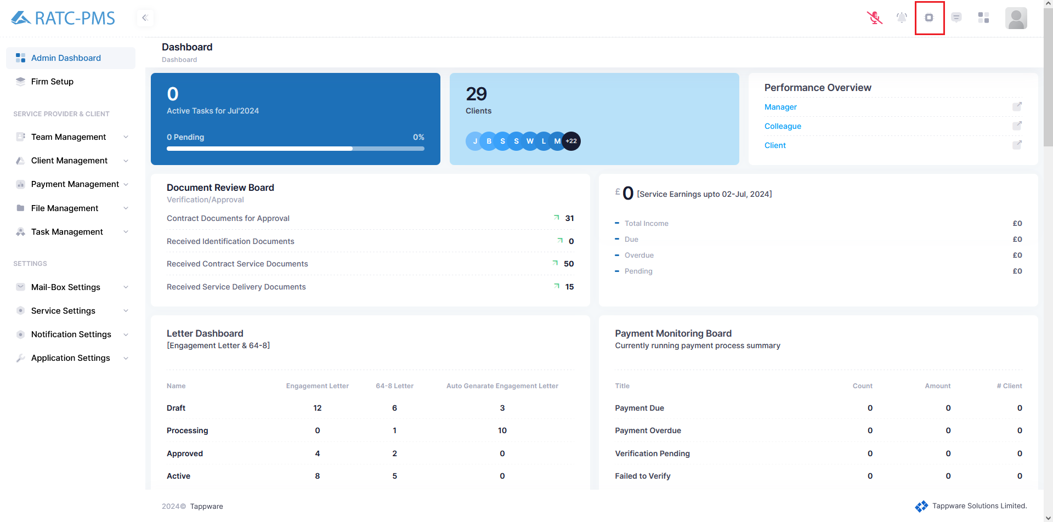

Fig: Panel Header Button

## 1.6 Documents Button

The Documents button in the topbar offers quick access to all documents related to the user's tasks and projects. This feature streamlines document handling, ensuring essential information is always within reach.

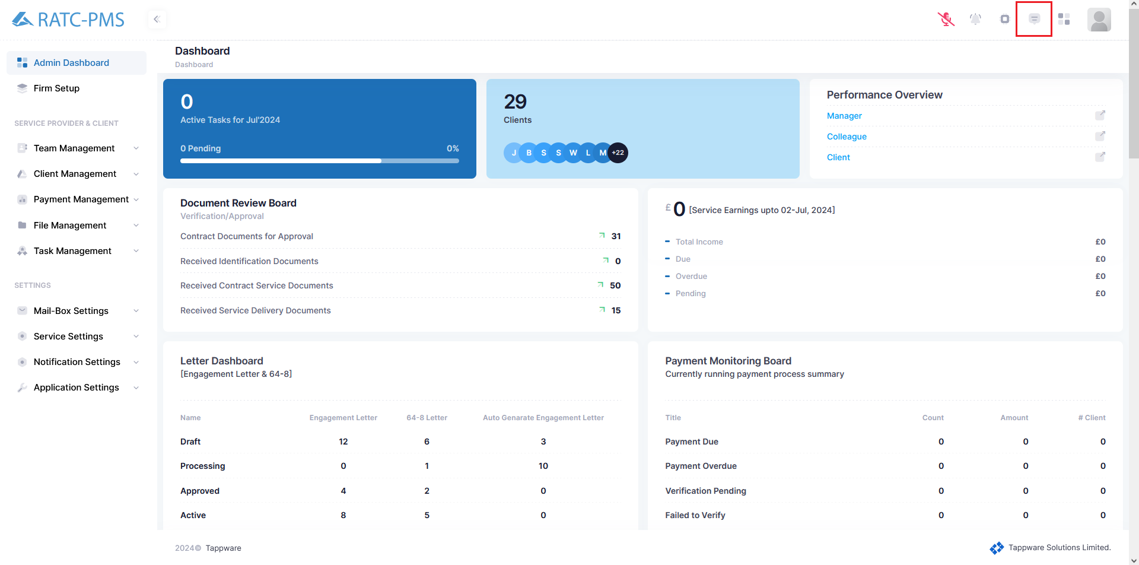

Fig: Documents Button

## 1.7 Dashboard Button

The

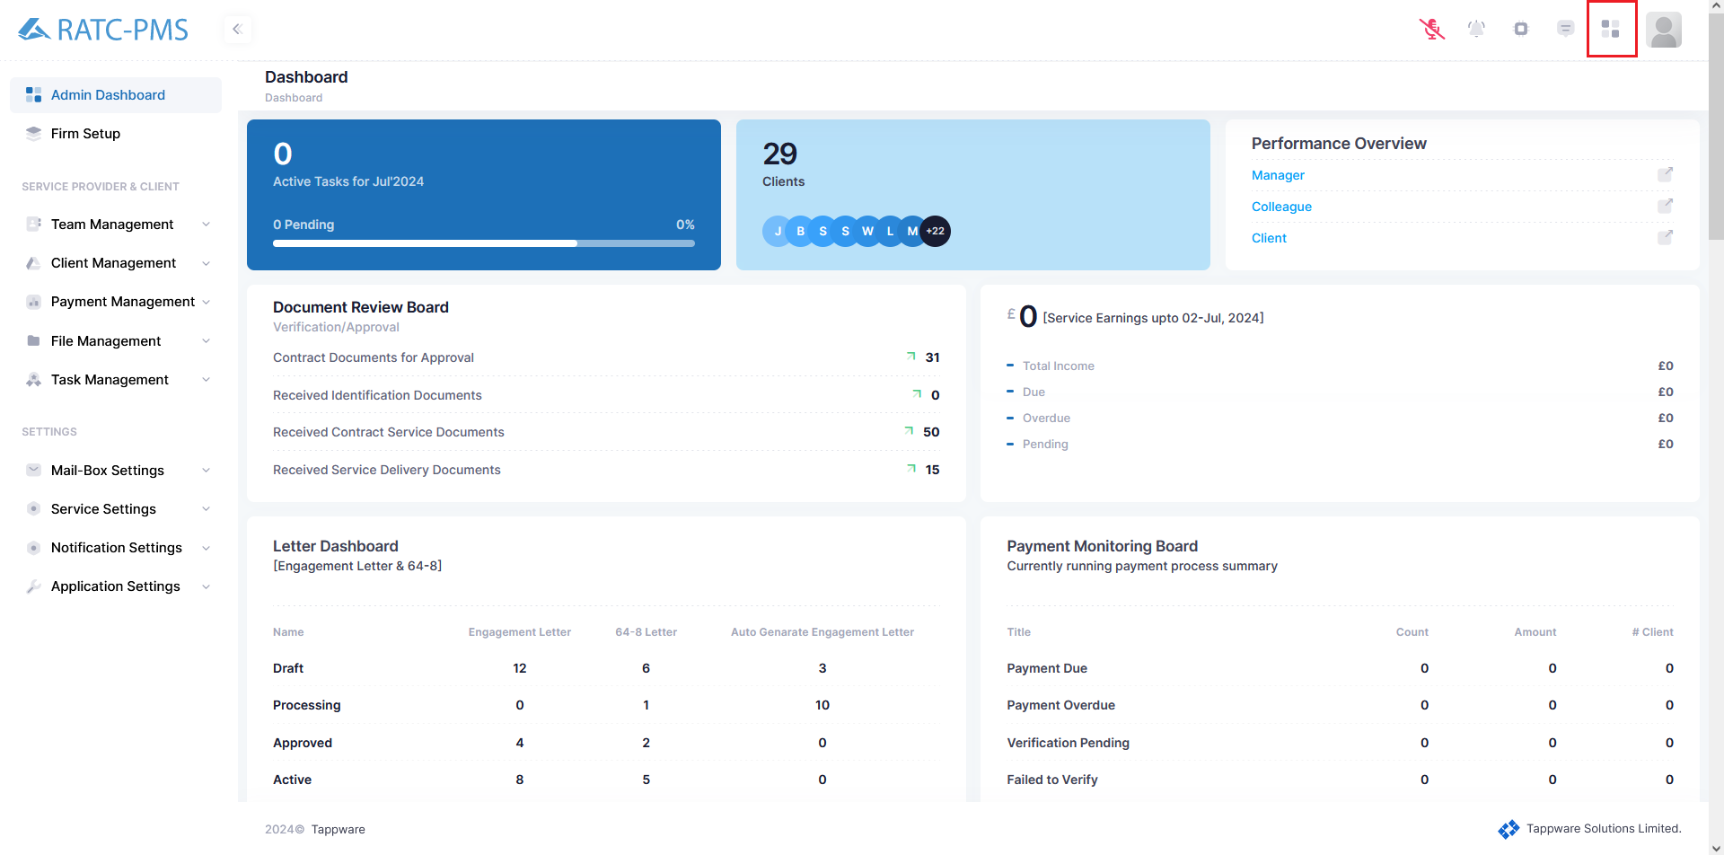

Fig: Dashboard Button

## 1.8 Profile Button

When clicked, it opens a small window with My Profile, Change Password and Sign Out button. The My Profile button allows users to access and manage their personal account settings and get information. Change password button allows the user to change their existing password. Lastly, the Sign Out button will log out the user and bring them to the Login page. This Profile button feature provides a convenient way for users to maintain and personalize their account, enhancing their overall experience with the software.

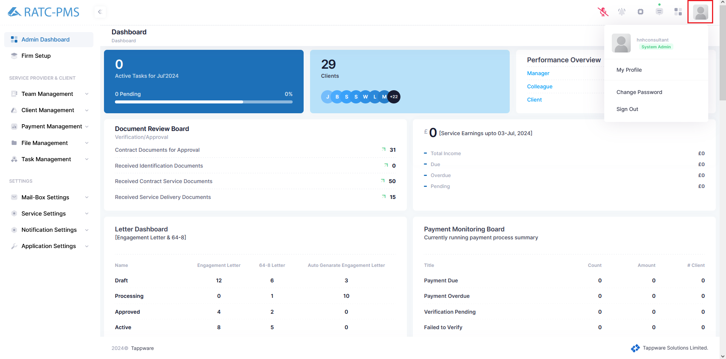

Fig: Profile Button

# 

# Admin Dashboard

The dashboard of the task management website provides a comprehensive overview of key metrics and activities.

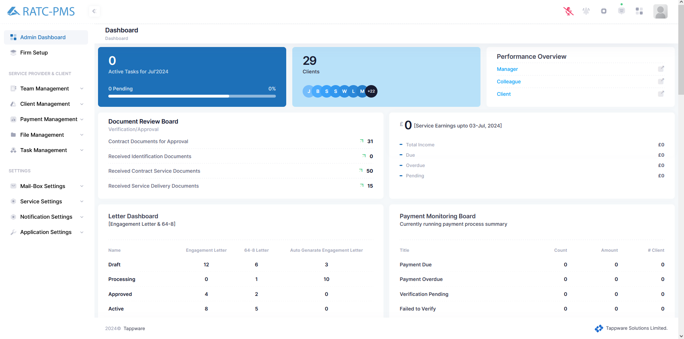

Fig: Dashboard

## 

## 2.1 Active Task

The ‘Active Task’ board displays the total number of active tasks ongoing during the current month. It provides a quick snapshot of workload and task progress, helping users stay informed about the volume of tasks being handled. This box typically includes visual indicators like numerical counts and progress bars to illustrate trends in task activity over the month, making it easy to monitor progress.

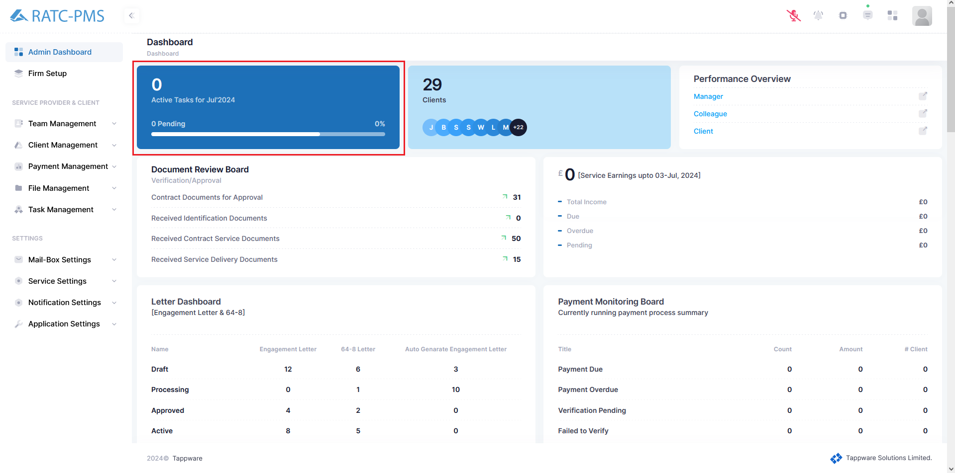

Fig: Active Task Progression board for the current month

## 2.2 Clients

The "Clients Count Board" displays the total number of clients currently being managed.

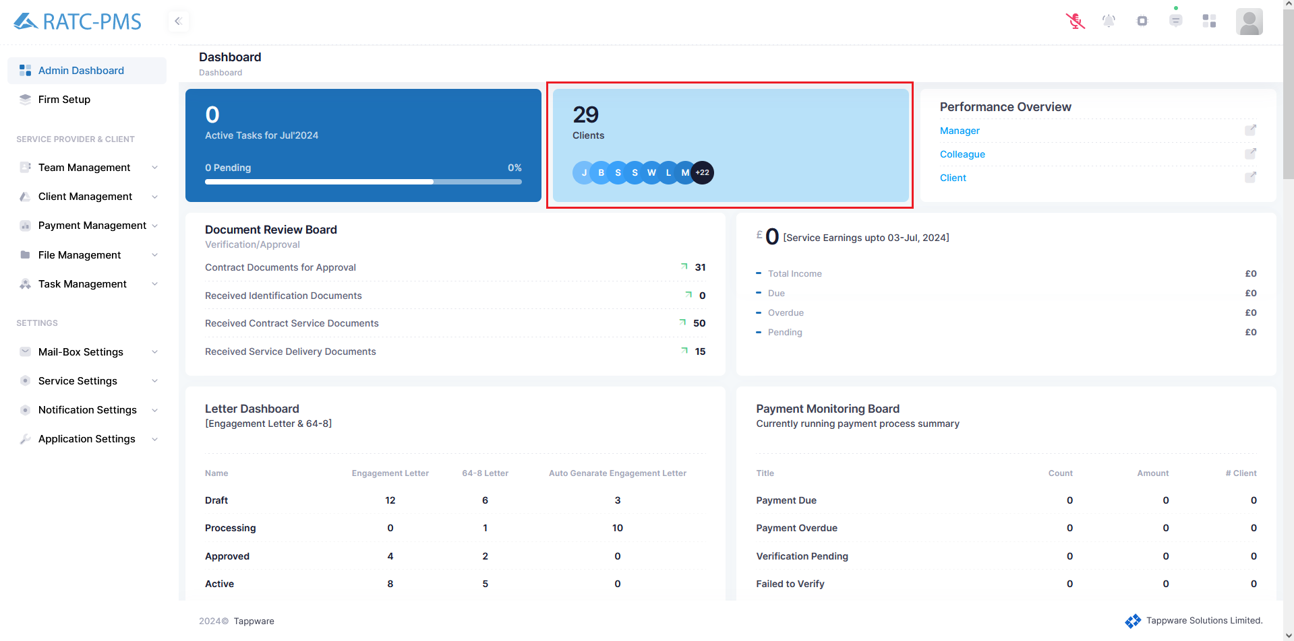

Fig: Total Amount of Clients

## 2.3 Performance Overview

The "Performance Overview" board displays three links which are Manager List, Colleague list and client list. Each list will display all the members of that designation.

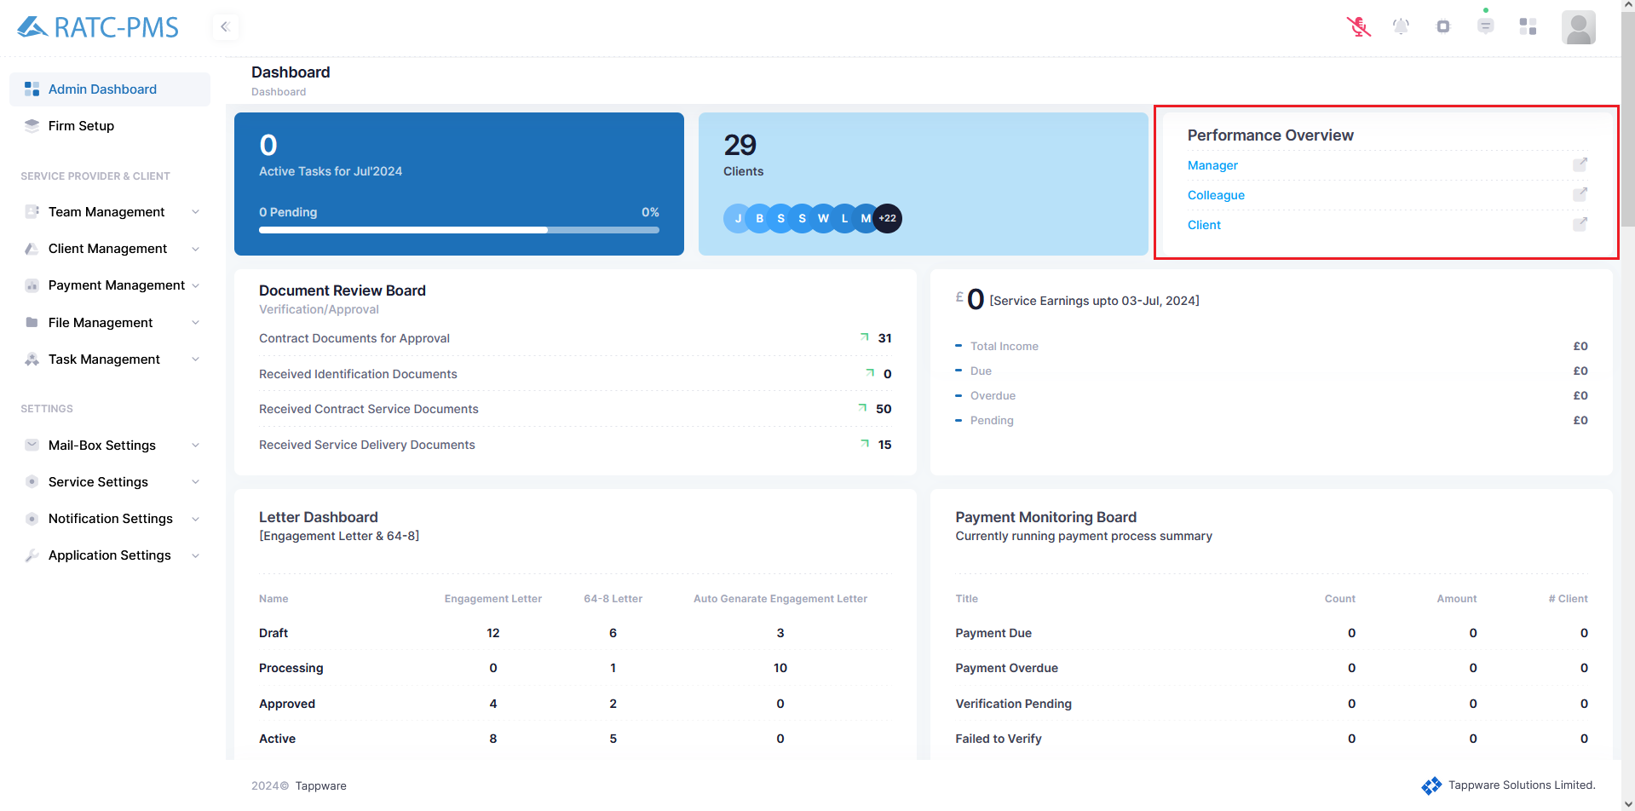

Fig: Performance Overview

## 2.4 Document Review Board

The "Document Review Board" is segmented into four distinct sections, each providing critical insights into document management and approval processes:

1. **Contract Documents for Approval**: This section displays the number of contract documents currently pending approval. It serves as a vital checkpoint to ensure all contractual agreements are reviewed and authorized promptly. Clicking this link will direct user to the Contract Documents Page
2. **Received Identification Documents**: Here, the count of all received identification documents is presented. This helps in tracking and verifying client or personnel identities, ensuring compliance with regulatory and organizational requirements.
3. **Received Contract Service Documents**: This section shows the count of received service-related contract documents. This link opens a side window with all the client names who submitted their Contract Service documents. Users can Approve, Reject, View and Delete the document from the side window.
4. **Received Service Delivery Documents**: This part displays the number of service delivery documents received. It provides an overview of the service completion paperwork, ensuring that all service deliveries are documented and accounted for accurately. Users can view the document from the side window.

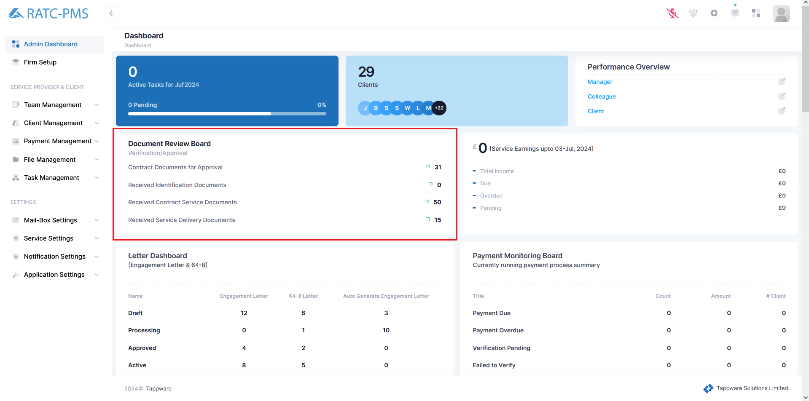

Fig: Document Review Board

## 2.5 Service Earnings

The "Service Earnings Box" provides a comprehensive overview of the financial status related to service earnings, encompassing four key metrics:

1. **Total Income**: This figure represents the aggregate revenue generated from all services rendered. It offers a clear indication of the overall financial performance and success of the services provided.
2. **Due**: This section displays the amount of income that is currently due but not yet received. It helps in monitoring outstanding payments and ensuring timely follow-up for collections.
3. **Overdue**: This figure highlights the income that has surpassed the due date for payment. It serves as a critical indicator for addressing delayed payments and implementing necessary measures to expedite collections.
4. **Pending**: This metric shows the total amount of income that is pending, including both due and overdue amounts. It provides a holistic view of all expected revenues that are yet to be realized, aiding in financial planning and cash flow management.

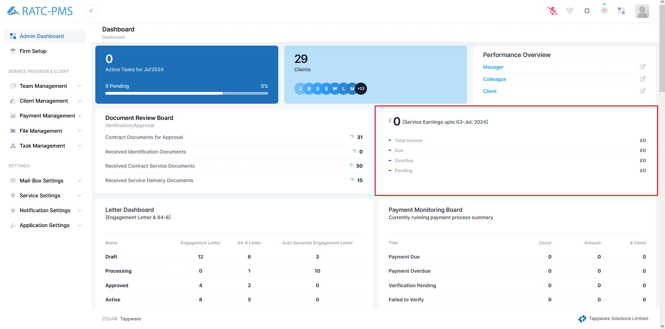

Fig: Service Earning Board

## 2.6 Letter DashBoard

This board contains the count of Engagement Letters, 64-8 Letters and Auto Generated Engagement Letters. This board also shows the states of the documents.

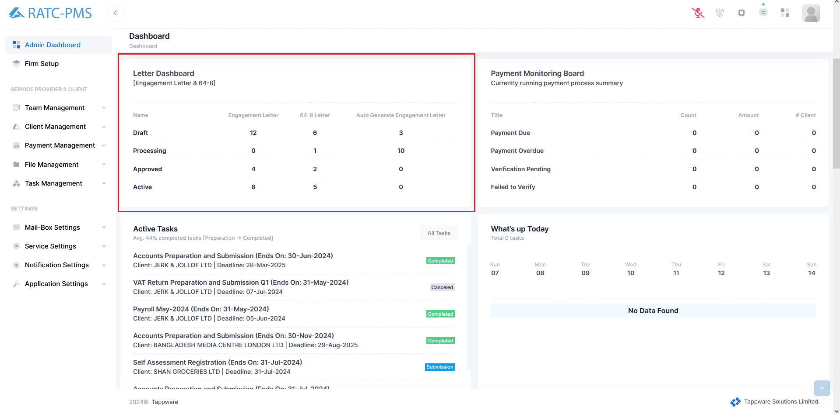

Fig: Letter DashBoard

## 2.7 Payment Monitoring Board

This board Monitors the Payment Due, Payment Overdue, Verification Pending and Failed to Verify.

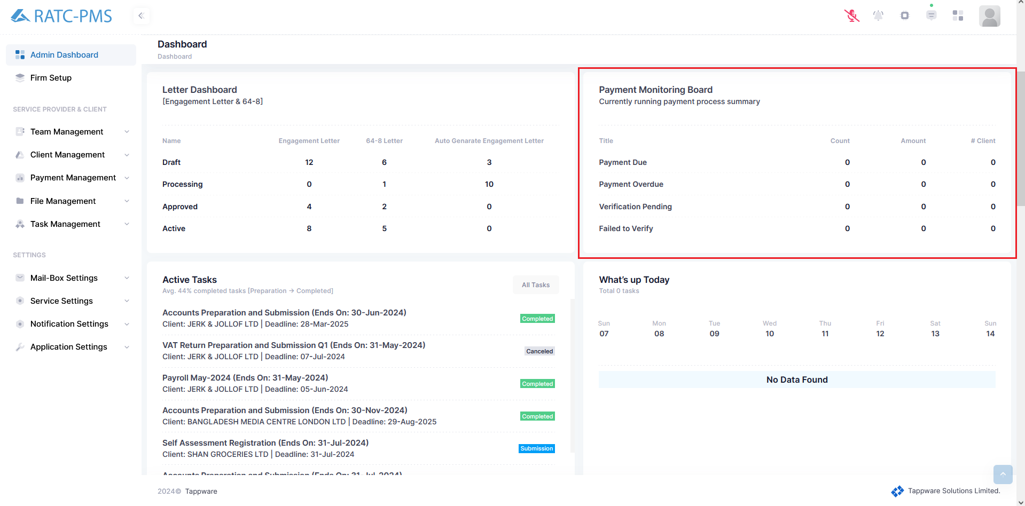

Fig: Payment Monitor DashBoard

## 2.8 Active Tasks Board

This board shows all the tasks with task name, client name, deadline and status. The task button opens a side window which shows all the tasks.

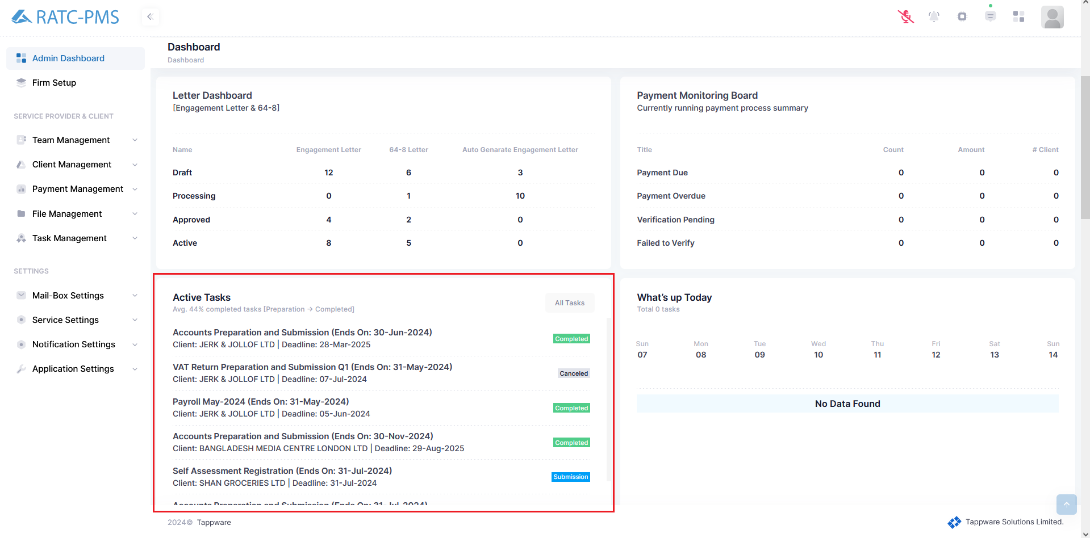

Fig: Active Tasks Board

## 2.9 What’s up Today Board

This board

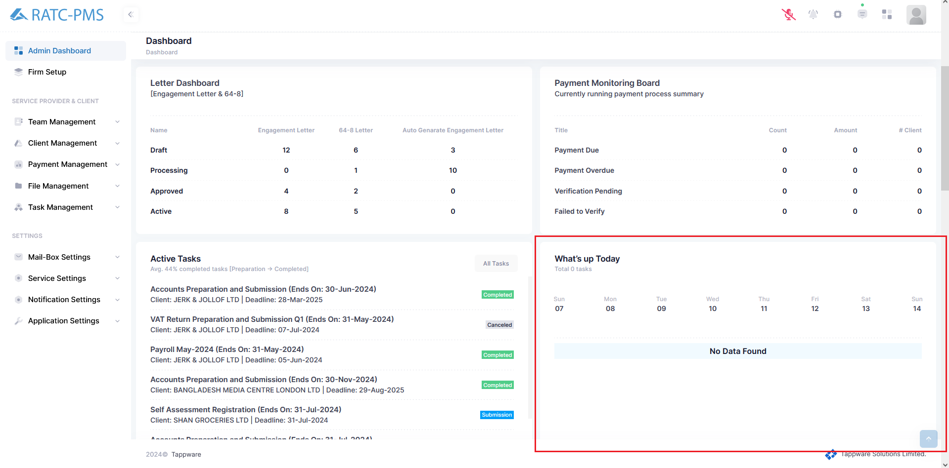

Fig: What’s up Today Board

## 2.10 State Monitoring Board

This board shows all the states of every service and how many tasks are pending for each service and what stage is it in..

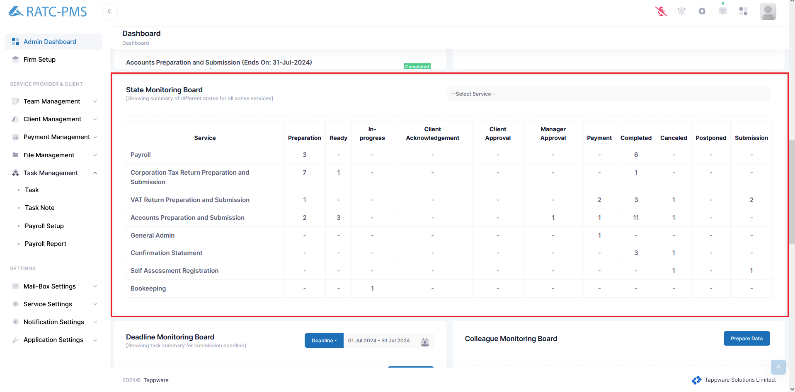

Fig: State Monitoring Board

## 

## 2.11 Deadline Monitoring Board

This board shows all the services and how many service deadlines are there for the date range. Users can click the deadline button and choose their own deadline monitoring preference by filtering it to Today, Yesterday, Last 7 days, Last 30 days, This month, Last month and Custom Range.

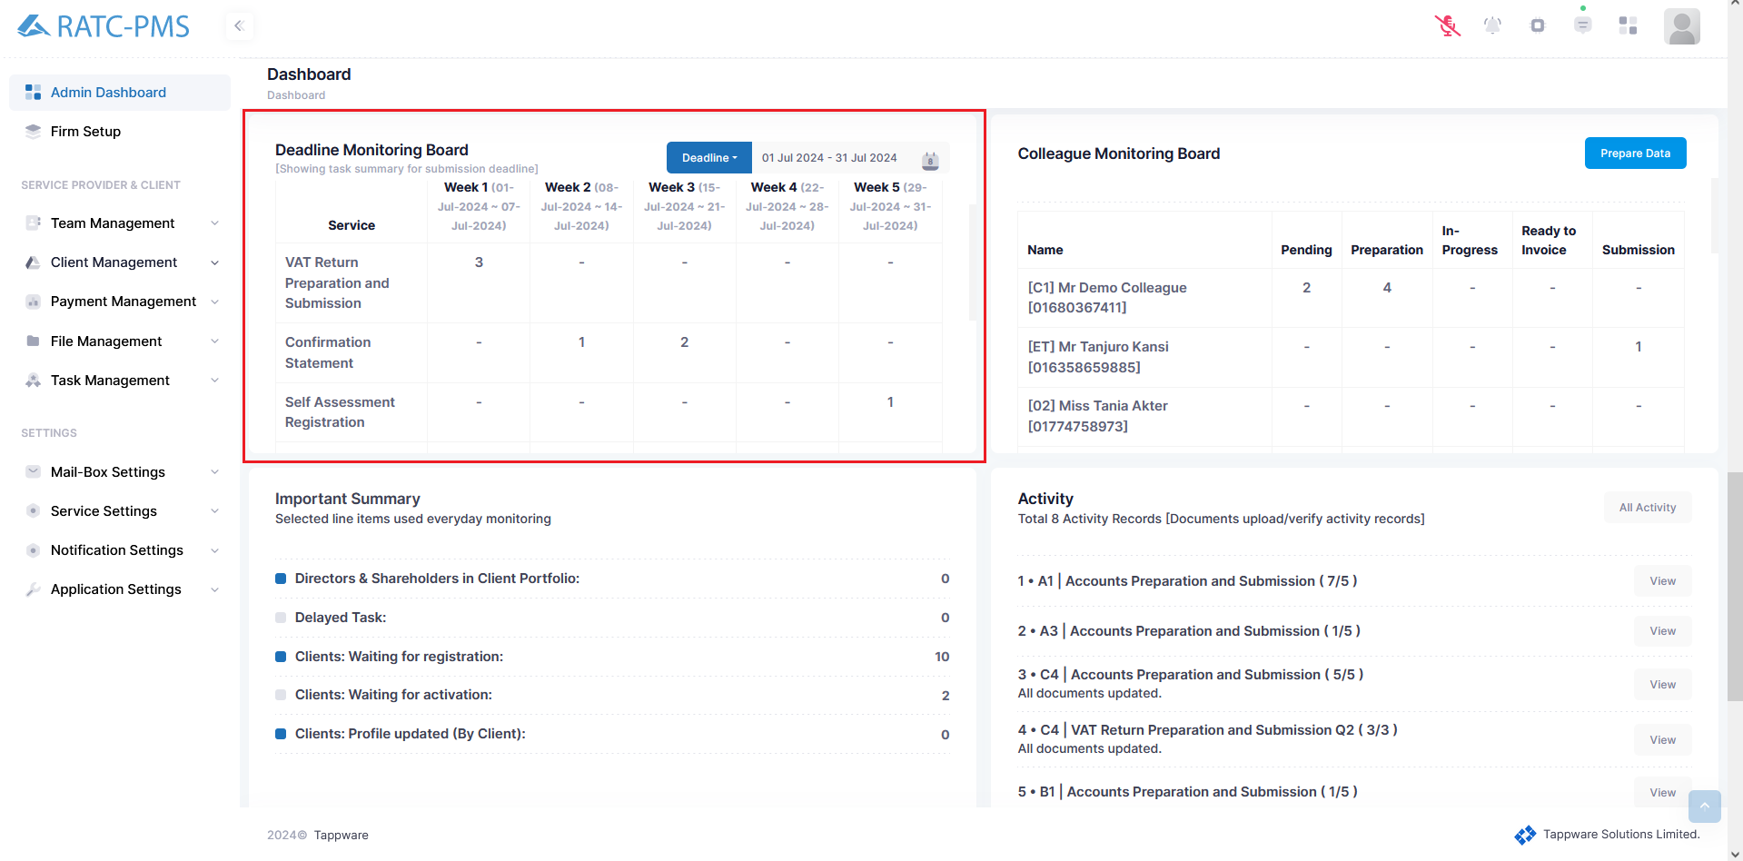

Fig: Deadline Monitoring Board

## 2.12 Colleague Monitoring Board

This board shows all the colleagues names and their progress of tasks.



Fig: Deadline Monitoring Board

## 2.13 Important Summary

This board shows the count of some important work to be done so that users can get a glimpse of what needs to be done. The board shows the count of Directors & Shareholders in Client Portfolio, Delayed Task. Clients: Waiting for registration, Clients: Waiting for activation, Clients: Profile Updated (By Client).

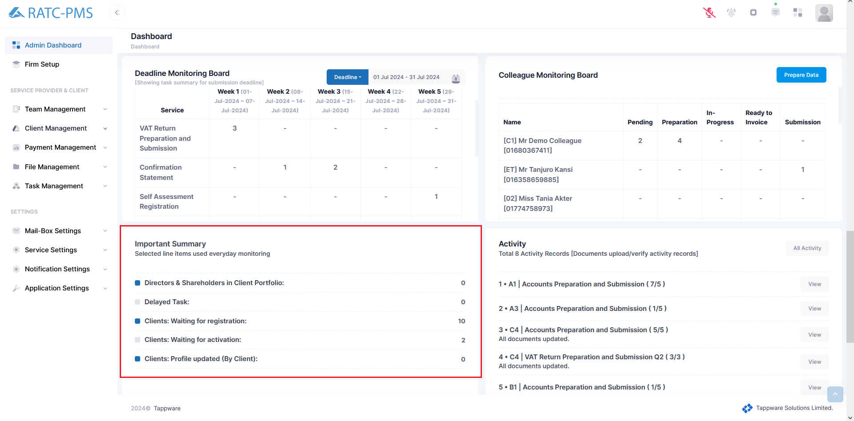

Fig: Important Summary Board

## 2.14 Activity Board

This board allows users to view activity records of any service for document upload of any task. The view button will open the task documents to view which documents are uploaded and which did not.

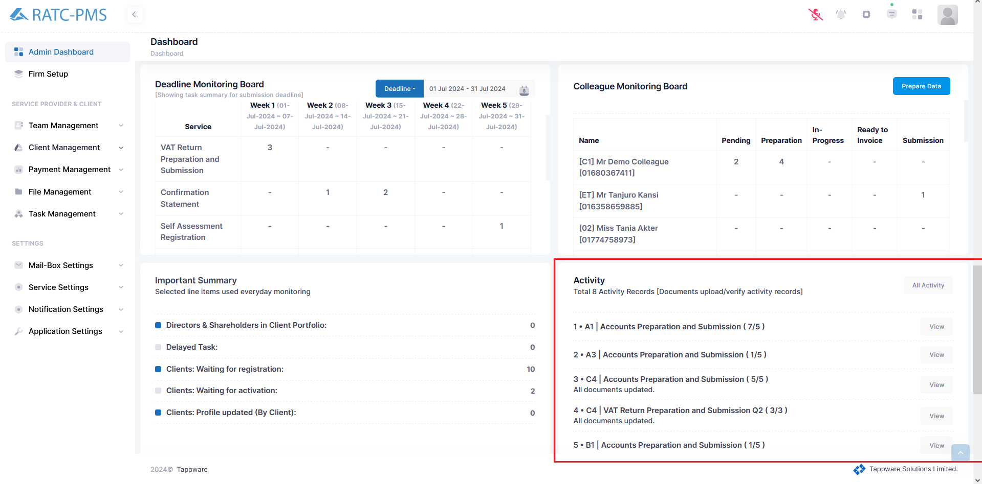

Fig: Activity Board

## 2.15 Client Onboarding Summary

This board shows the user a graph which denotes, in which month how many clients onboarded.

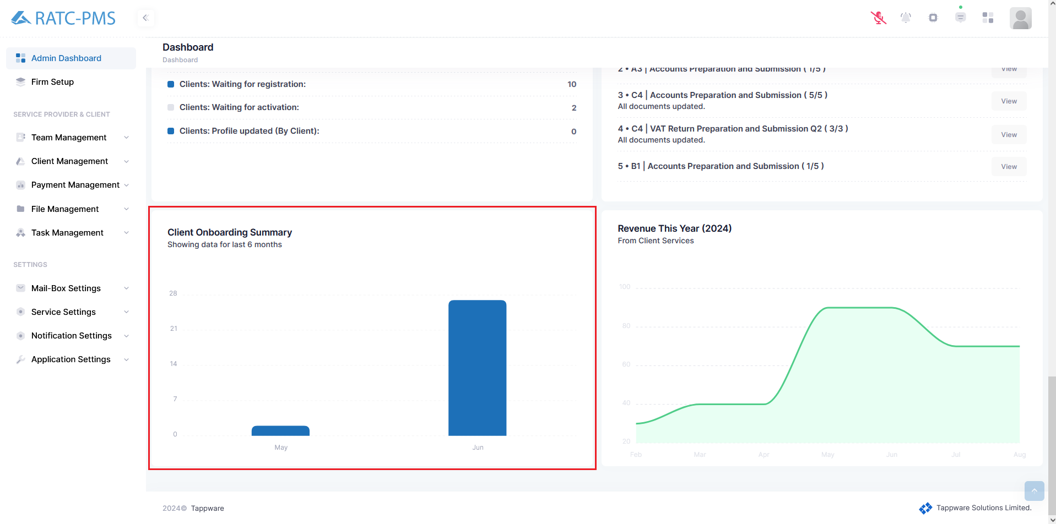

Fig: Client Onboarding Summary Board

## 2.16 Revenue This Year

This board shows the user a graph which describes the amount of revenue in each month of the year.

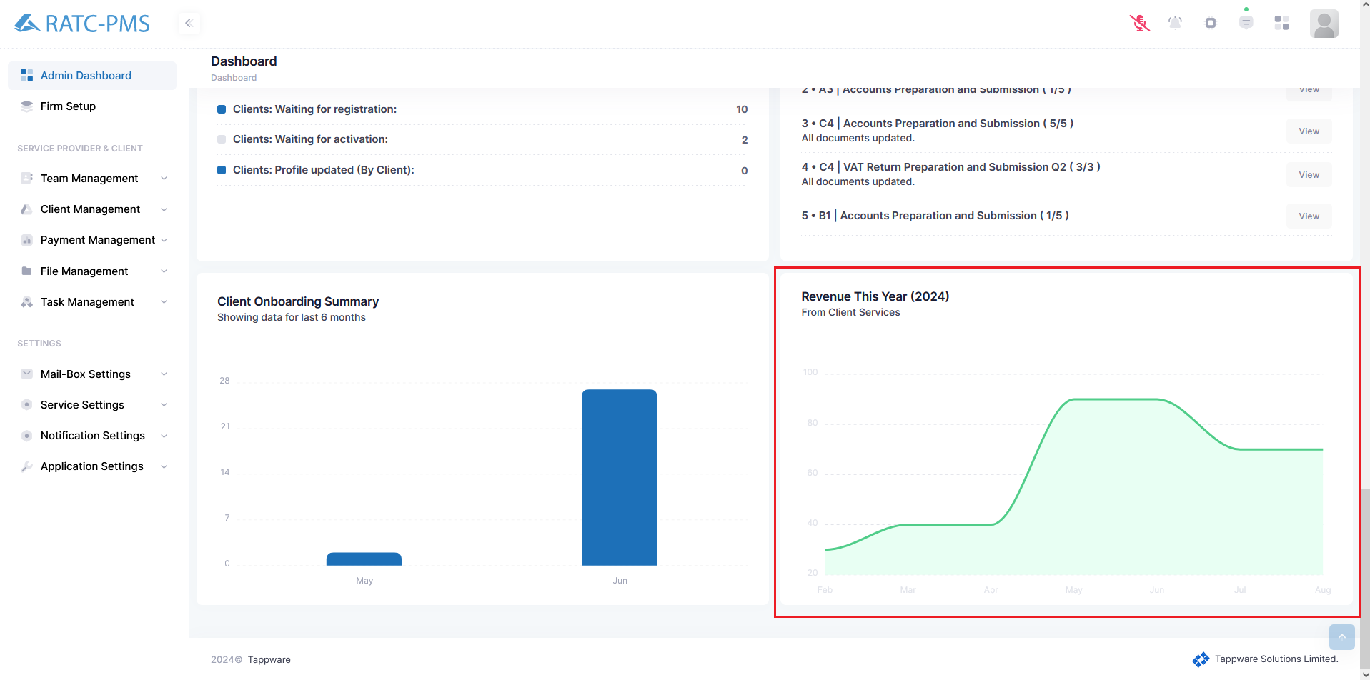

Fig: Revenue Board

# 

# 3. Firm Setup

Firm Profile holds all the information about the firm. Users can edit the firm information from this page.

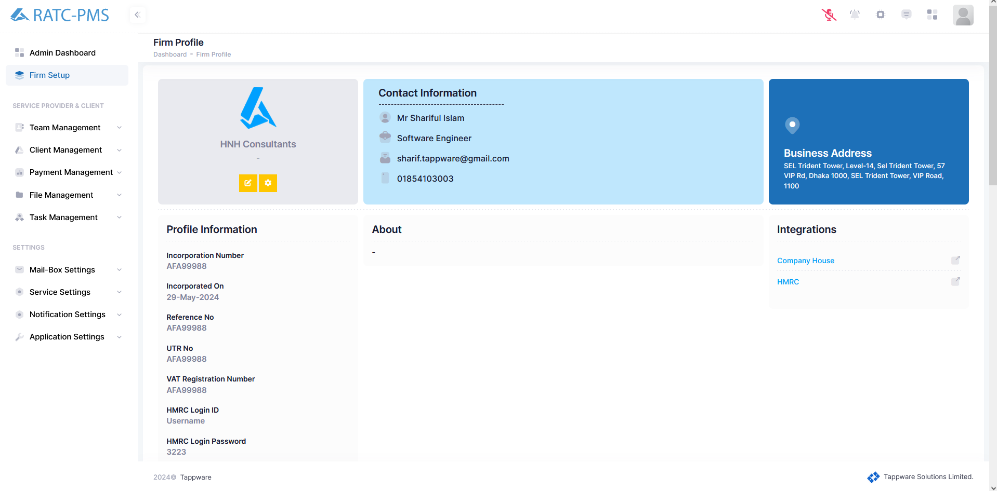

Fig: Firm Profile

## 3.1 Firm Profile, Contact & Address Box

The first box shows the logo and name of the firm. It has an edit and settings button. Users can change or input different information from the edit Firm Profile page. The settings button is used to change Accountancy firm logo, Letter header and Letter Footer. The second box holds contact information of the firm and the third box displays the address of the firm.

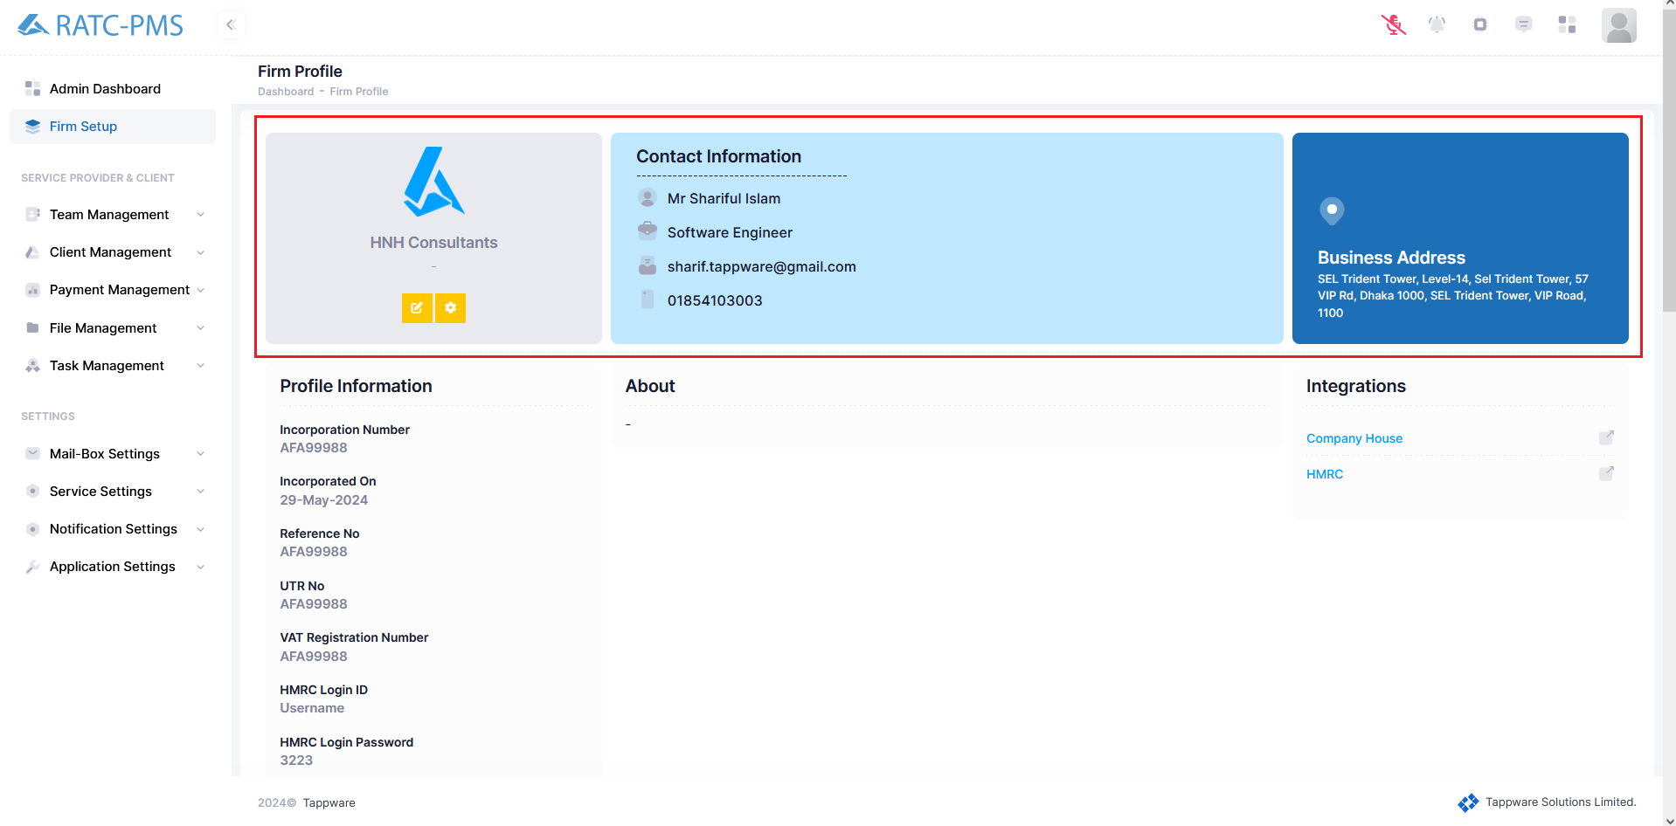

Fig: Firm Profile, Contact & Address Box

## 3.2 Profile Information, About & Integrations

The Profile Information Displays key information of the company. The About section shows basic information of the company and Integration Links shows the companies PMS is integrated with.

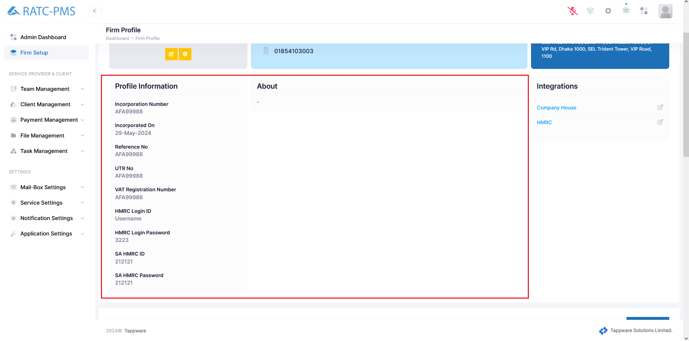

Fig: Profile Information, About & Integrations

## 3.3 Bank Account Information

Users can find bank account information from this section. Users can add a bank account using the ‘Add Bank’ button. Users can also edit or delete an existing bank account.

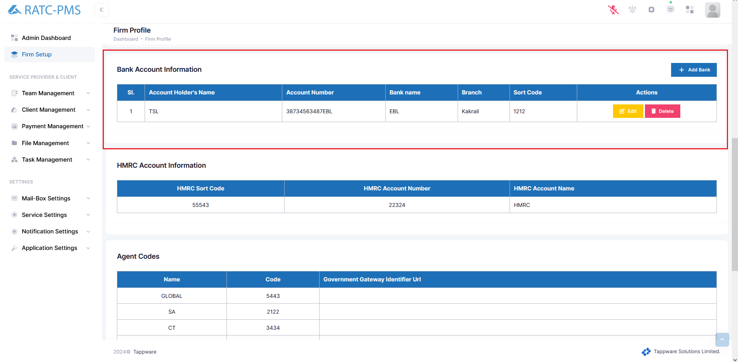

Fig: Bank Account Information

## 3.4 HMRC Account Information

This Section displays HMRC Account Information. This includes HMRC Sort Code, HMRC Account Number and HMRC Account Name.

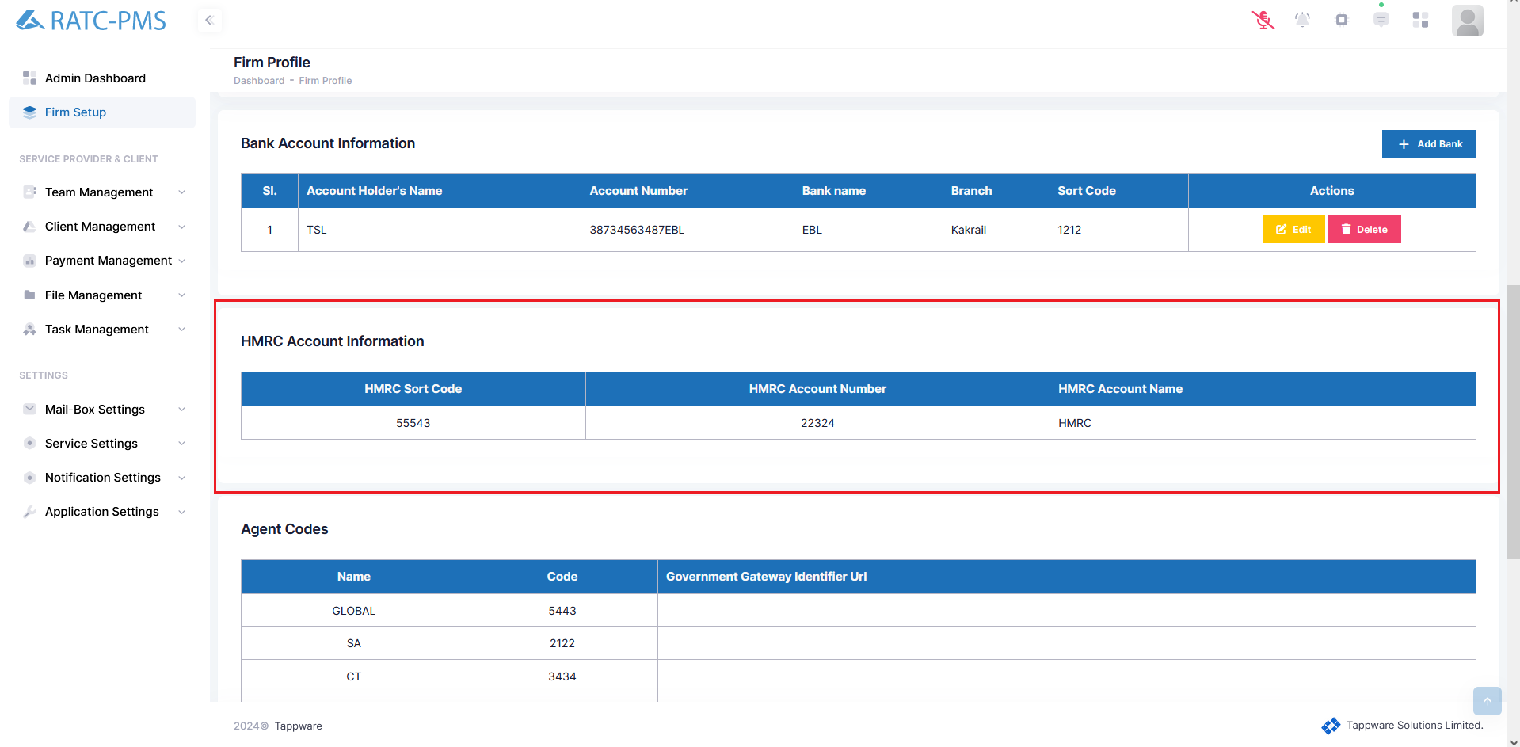

Fig: HMRC Account Information

## 3.5 Agent Codes

This Section displays the Agent Codes.

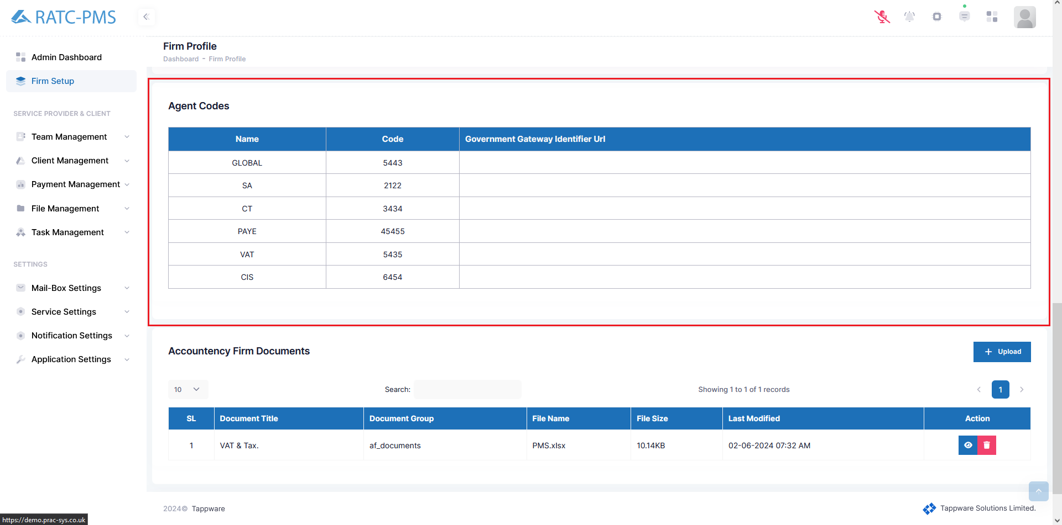

Fig: Agent Codes

## 3.6 Accountancy Firm Documents

Users can view Accountancy Firm Documents from here. Users can Upload two types of documents. First one is ‘VAT & TAX’ and the second one is ‘Incorporation’. Users can view or delete an existing document.

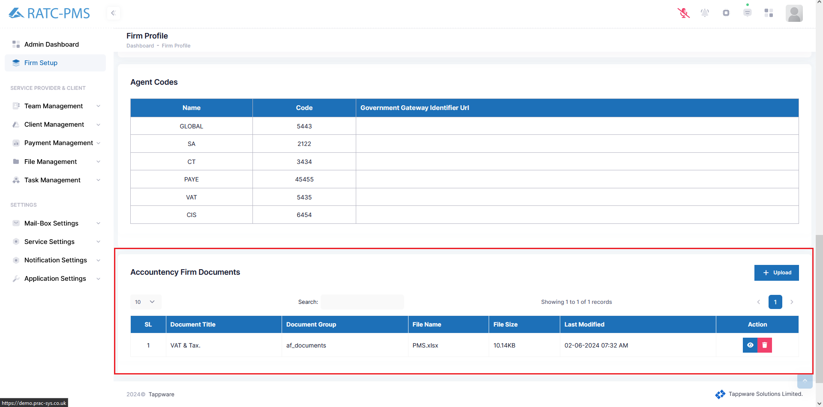

Fig: Accountancy Firm Documents

## 3.7 Transaction History

Users search transaction history from here.



Fig: Accountancy Firm Documents

# 4. Team Management

## 4.1 Overview

This page shows the user an overview of Managers and Colleagues. This page indicates which Colleagues report to which Manager. The user may examine Employee code, name, and email for each individual and modify their profile using the action button.

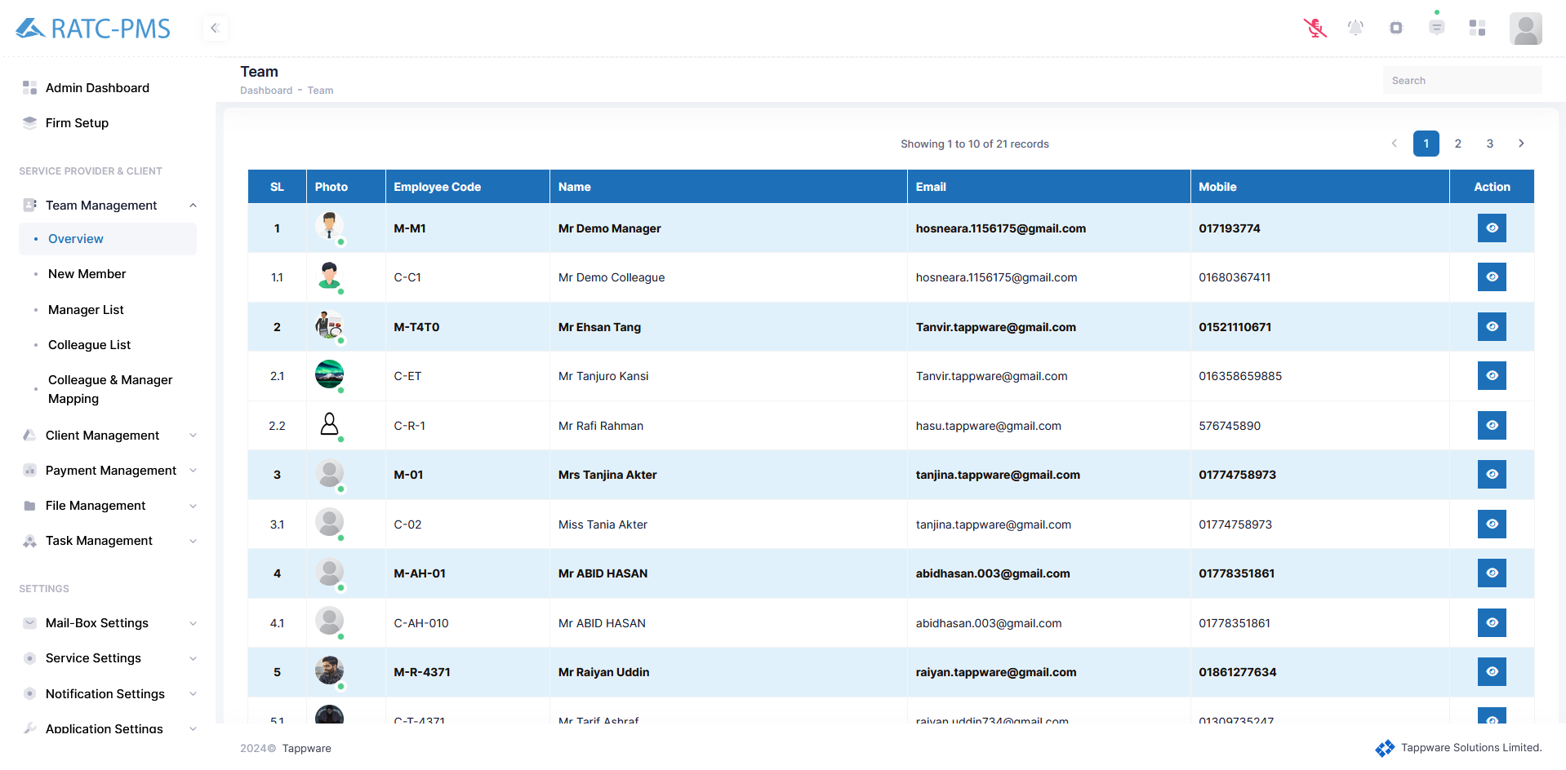

Fig: Team Overview

## 

### 4.1.1 Profile Overview

After pressing the view button, the administrator will be sent to the profile overview page. Admin may now see and change Profile Details, Profile Identification Image, Signature Image, and Login Credentials. This page also allows the user to view the member's recent activity as well as Monthly Performance Statistics.

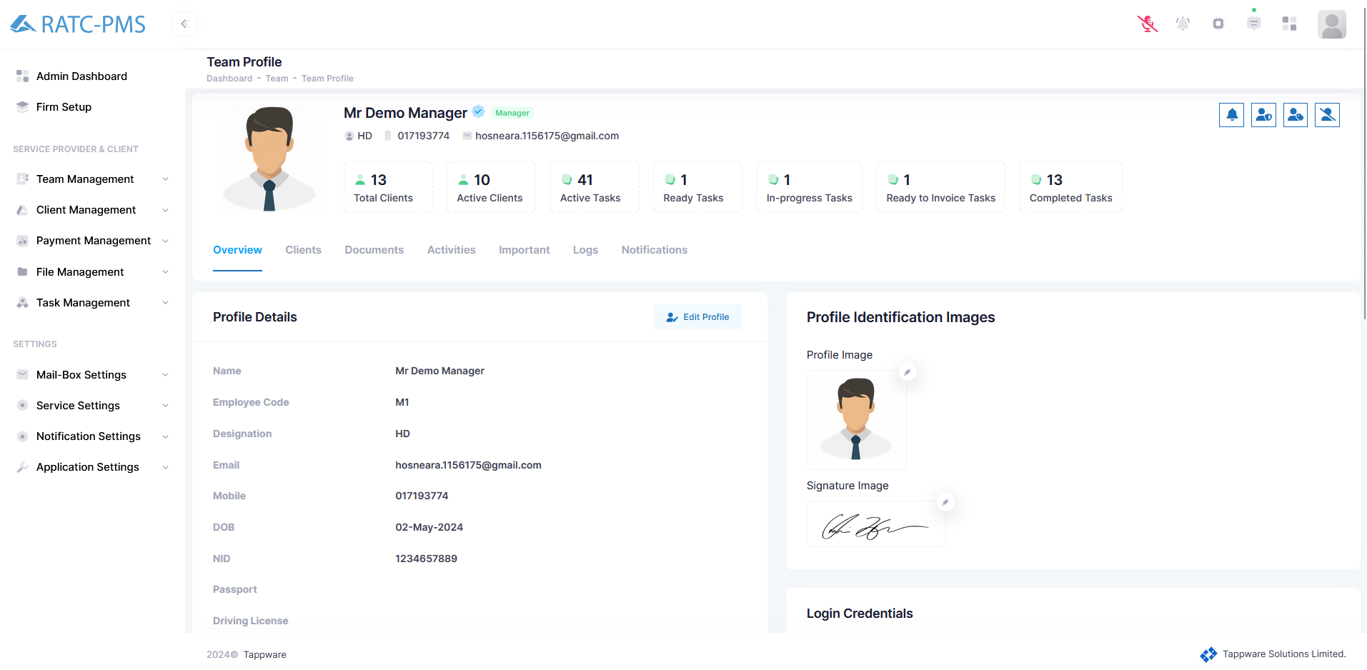

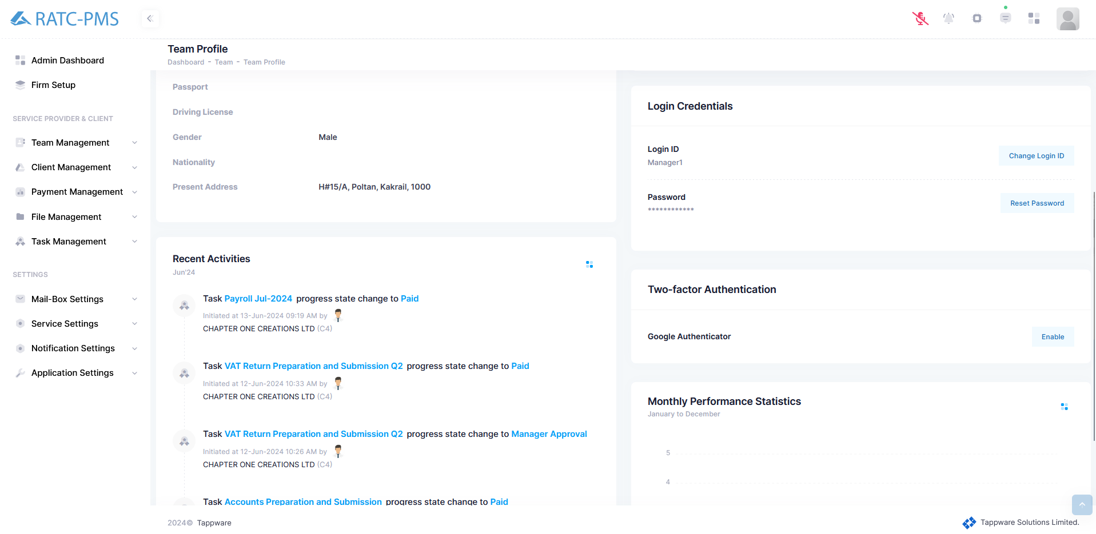

Fig: Profile Overview

### 4.1.2 Clients

This page allows the user to view all of the clients assigned to this team member. This page provides users with information such as the client's name, business type, email address, phone number, incorporation number, and incorporation date. Also, admin can active/deactive the status of the client. Users can also examine client details using the view button or edit client information using the edit button from the Action menu.

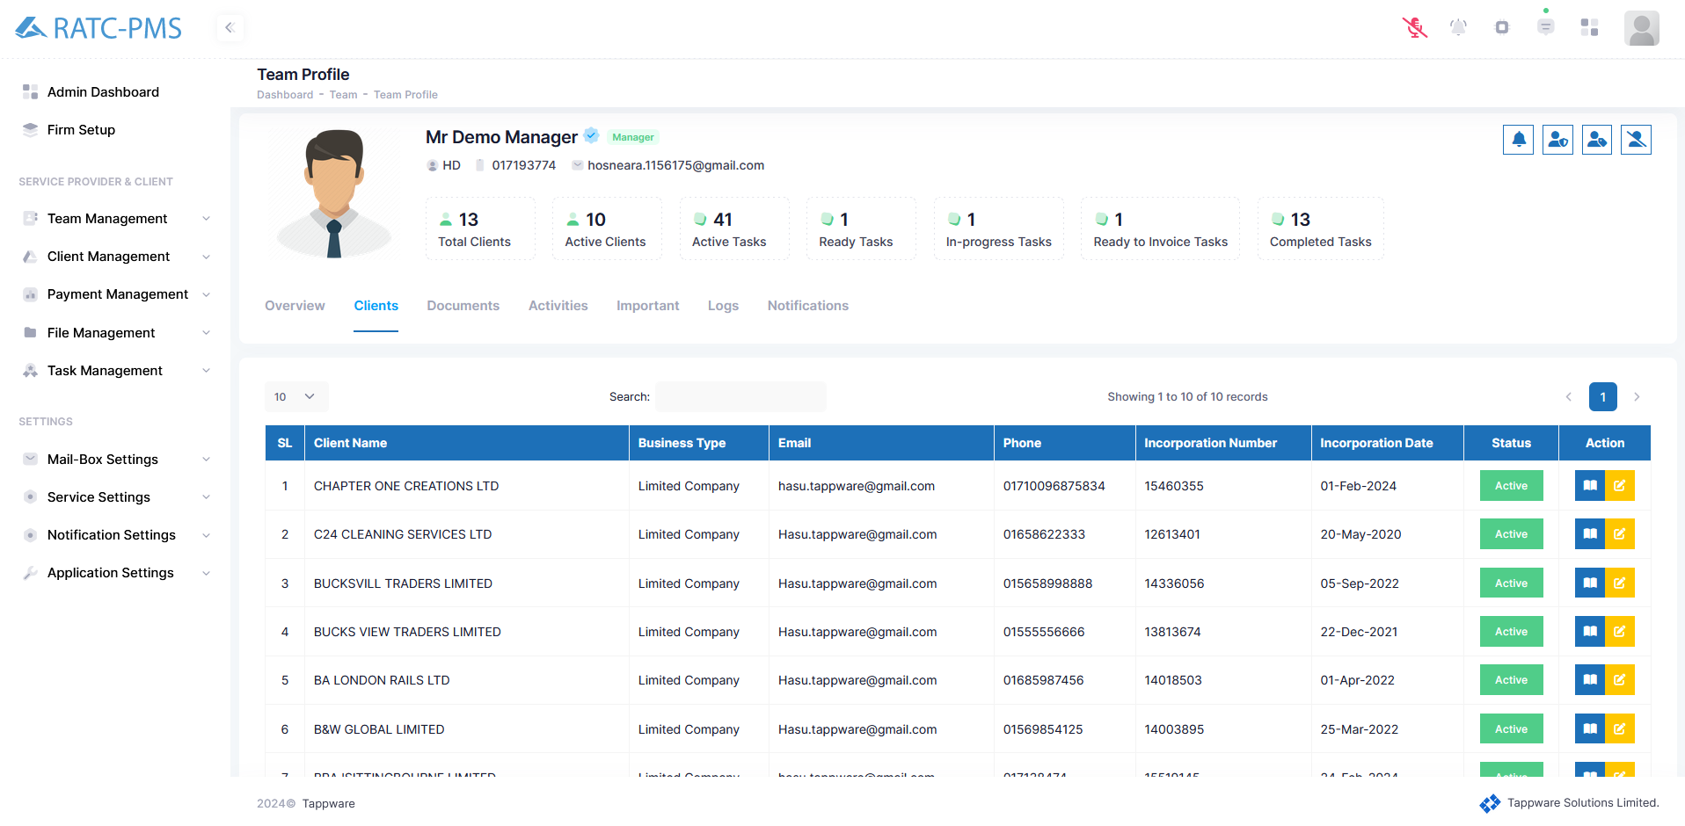

Fig: Clients under Member

View:

After clicking the view button, the client's details page will appear. Users may receive an overview of customers here and access several navigation choices such as Directors & Stakeholders, Contracts, Services, Application Users, Client Documents, Service Documents, and Notification. Users may notify the client by clicking the bell icon.

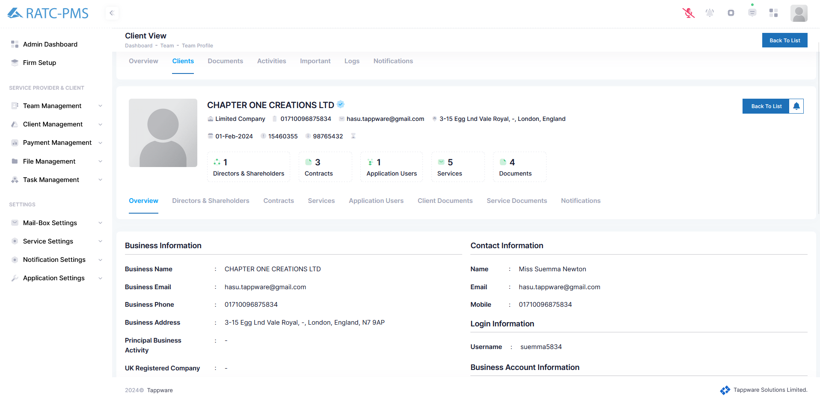

Fig: View page for client details

Edit:

This page allows users to edit the client profile in three stages. First stage is profile details where the user can change the profile information of the client. Second stage lets users edit or add Directors & Stakeholders. Third and last stage lets users upload, view, reject, edit or delete any documents of the client.

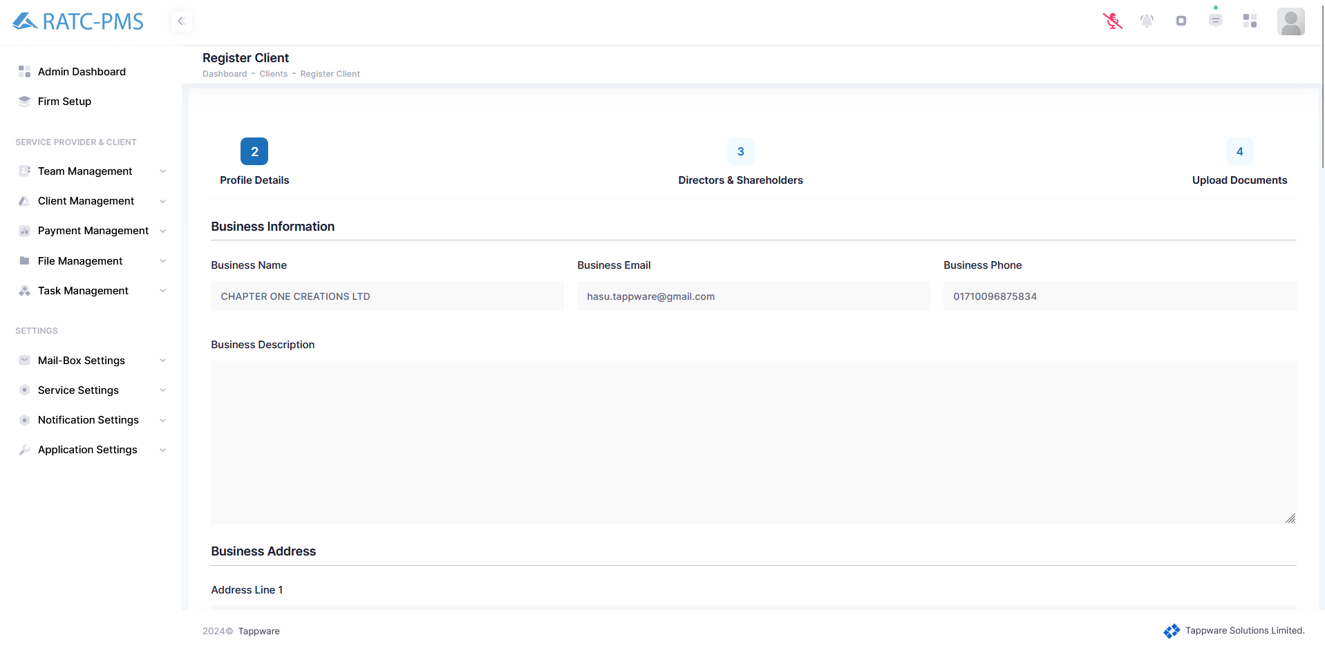

Fig: Edit page to edit client Details

### 4.1.3 Documents

From here, the User may review all of the documents supplied by any client to this member. Users can download, reject, or delete the document from the action menu.

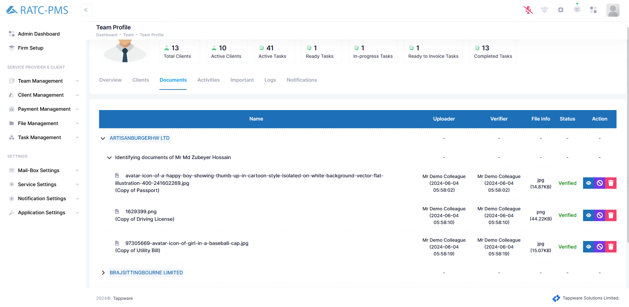

Fig: Documents from every Clients

### 4.1.4 Activities

The users may keep track of all the activity of the specified team member. Additionally, the users may filter tasks by ‘Client’, ‘Contract’, and ‘Service’ to determine the specific service activity.

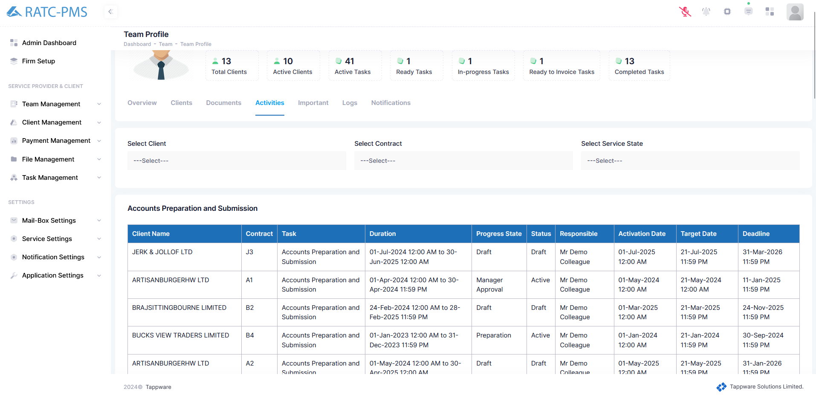

Fig: Activities

### 4.1.5 Important

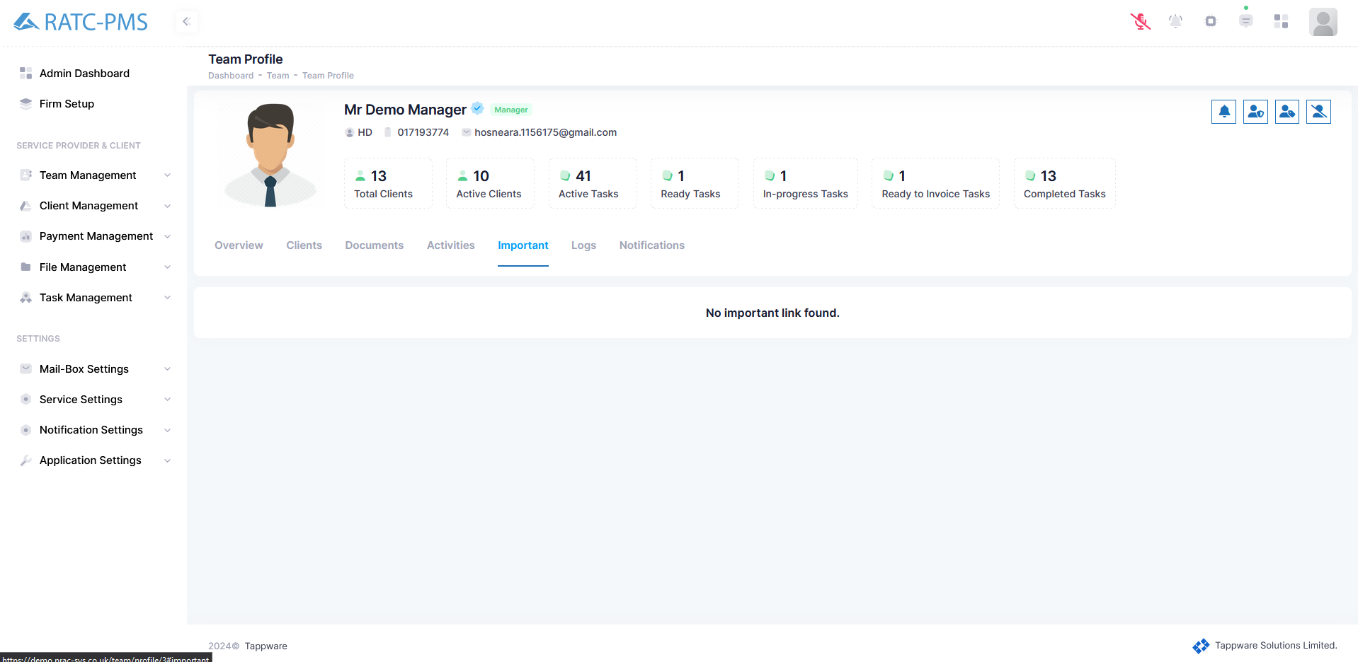

Fig: Important

### 4.1.6 Logs

Users can keep track of the activity of a certain member using the logs page.

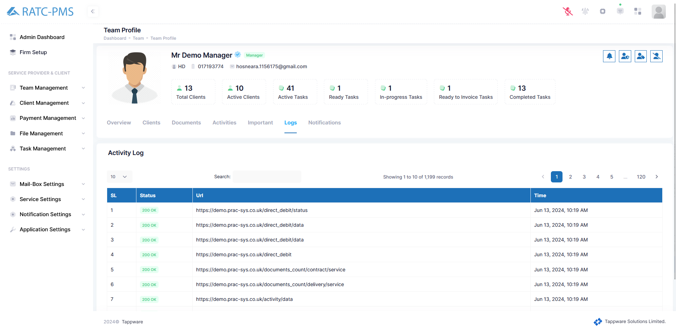

Fig: Logs

### 4.1.7 Notifications

Users can keep track of all the notifications of a team member from the notification panel. User can also determine which notification he wants to get using the configuration tab.

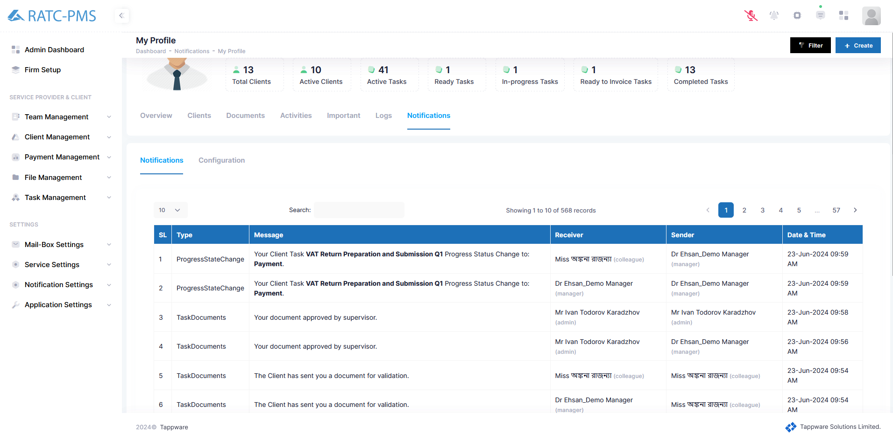

Fig: Notifications

Configuration:

Users may select or deselect which notifications the team member will receive. Users may also select all, which selects all available options. The user must click save to save the setup. Users can also reset their preferences.

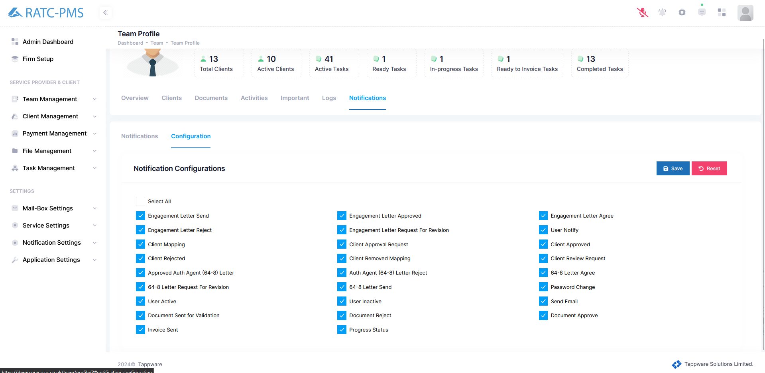

Fig: Configuration

### 4.1.8 Control Access

1. **Notify User:** User could be notified by 3 types of notification.
   1. Email Notification
   2. System Notification and
   3. SMS Notification
2. **Remove Admin Access:** If a team member wants, they can have both manager and admin roles. If an admin wants to remove admin access from any manager who also has admin role, they can do so by clicking this button.
3. **Add Restriction on Manager Role:** Some tasks in the system are only allowed to be performed by managers. Without manager permission, no approval can be obtained for any task in the system. Admins can use this button to revoke permissions for certain tasks from any manager.
4. **Make this profile in-active:** If any team member or employee resigns or takes leave, or if an admin wants to prevent any team member from working on tasks, then by clicking this button, the team member will transition from active to inactive status.

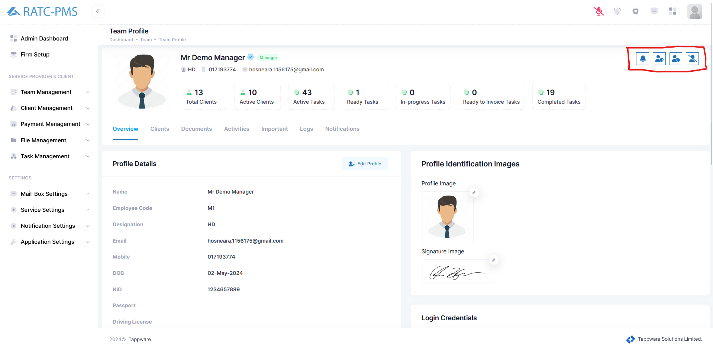

Fig: controls

## 4.2 New Member

An user uses this page to build manager and colleague profiles for the system. This page has three different sections. The '**Profile Details**' section contains the basic and essential information necessary to add an employee to the system. There are several required fields; without these, a manager or colleague profile cannot be established. Furthermore, via the ‘**Profile Identification Images**’, the user may submit the employee's photograph and signature. While the image may not be necessary, the signature must be supplied. We need signatures for various forms to be accepted, therefore having them is critical. Another section displays ‘**login credentials**’. From this section, the employee's login and password are produced automatically. The user’s role is crucial here because it will determine if the new member is a manager or a colleague. Username is auto generated but admin can make changes to username. The user's credentials and password are automatically sent to the email address of the new member when the user clicks on the save button. Users can reset all the progress using the reset button.

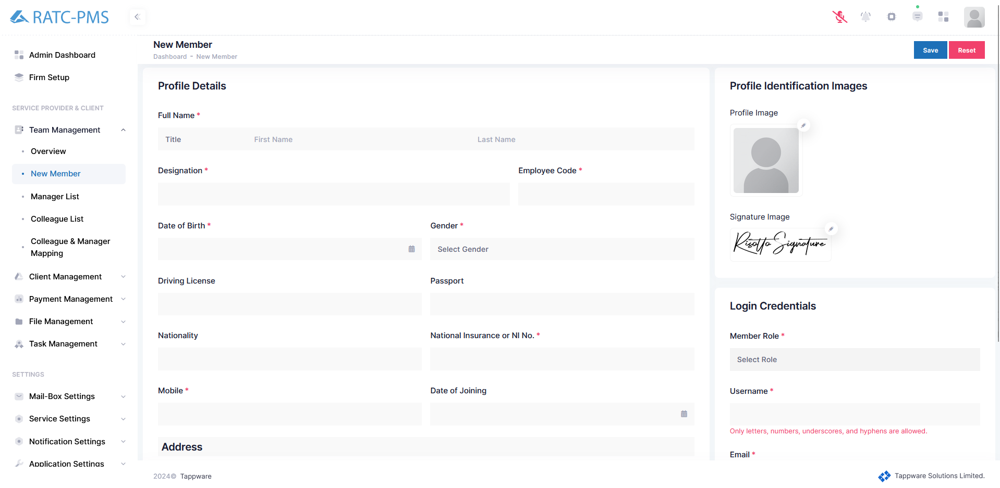

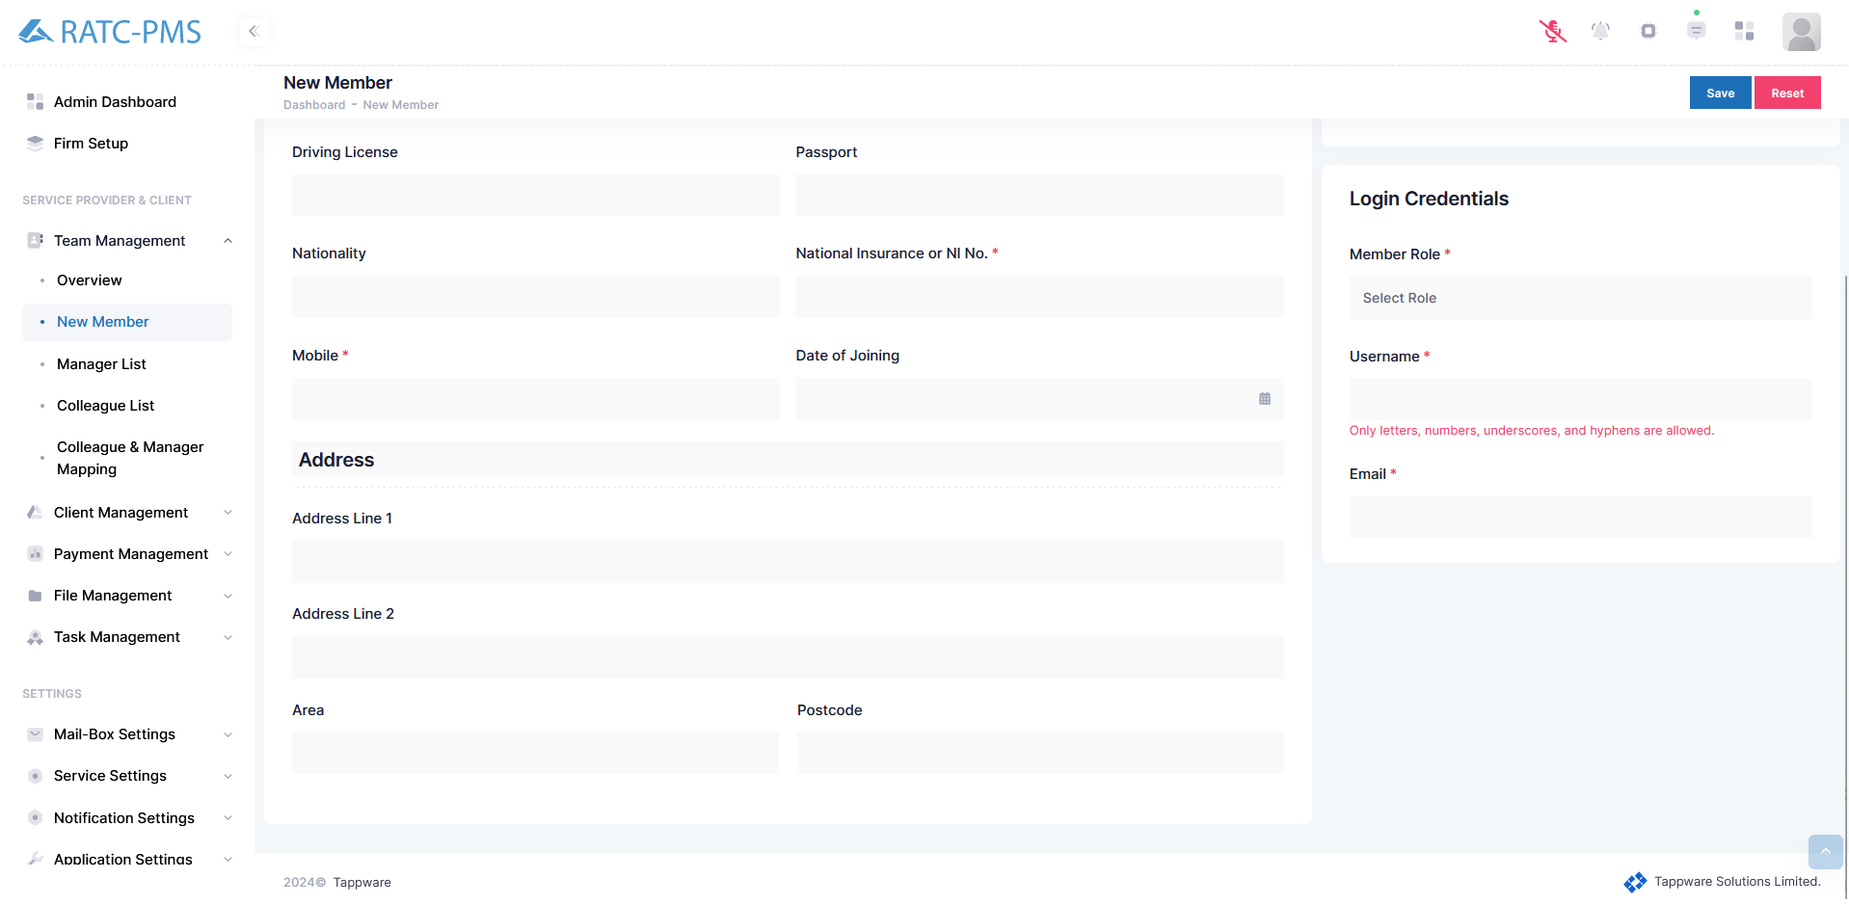

Fig: Adding new member

## 4.3 Manager List

This page provides a list of all managers in the system. Users can easily get information about any manager from this page. Furthermore, by clicking the 'View' button beside each manager on the Action panel, the user will be directed to the ‘Profile Overview’ page of the manager where the user can find all the information about the manager. Also, by clicking the send button, user can send any notification to any manager via Push Notification or Send Email or Send SMS.

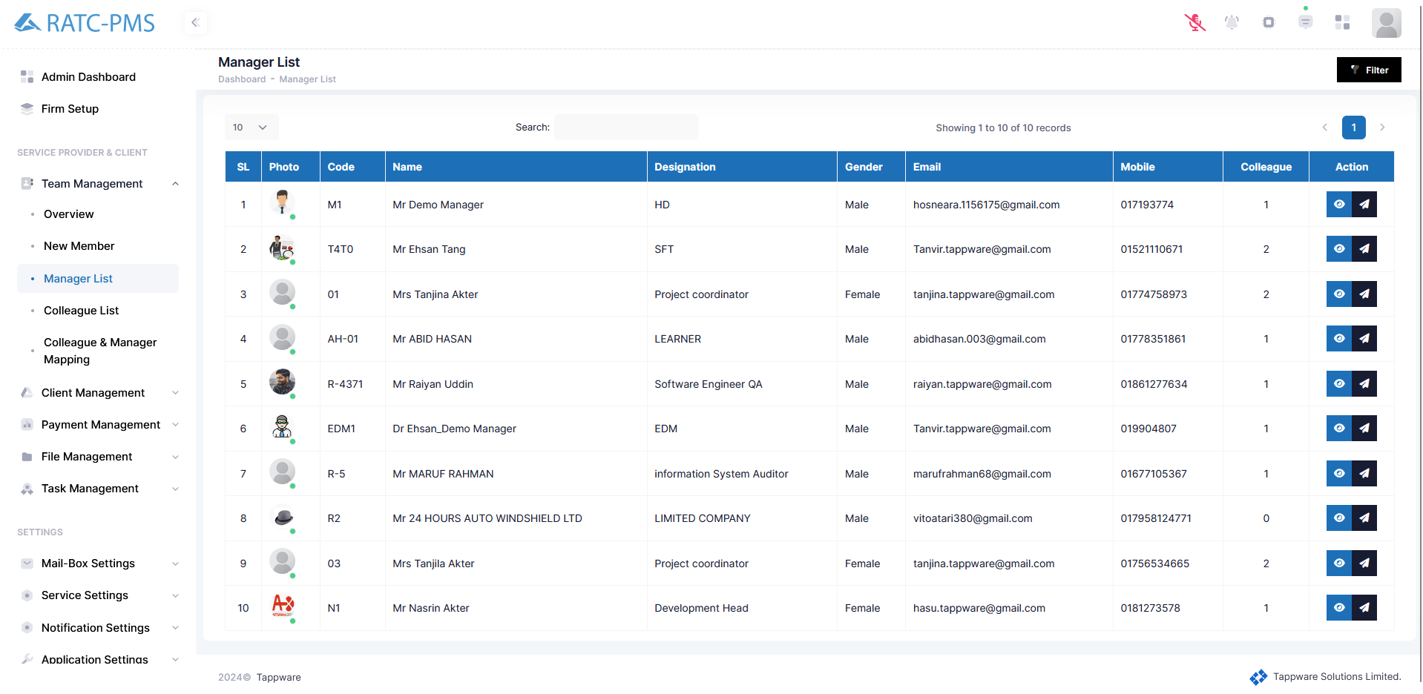

Fig: Manager list

## 4.4 Colleague List

This page provides a list of all colleagues in the system. Users can easily get information about any colleague from this page. Furthermore, by clicking the 'View' button beside each colleague on the Action panel, the user will be directed to the ‘Profile Overview’ page of the colleague where the user can find all the information about the colleague. Also, by clicking the send button, user can send any notification to any colleague via Push Notification or Send Email or Send SMS.

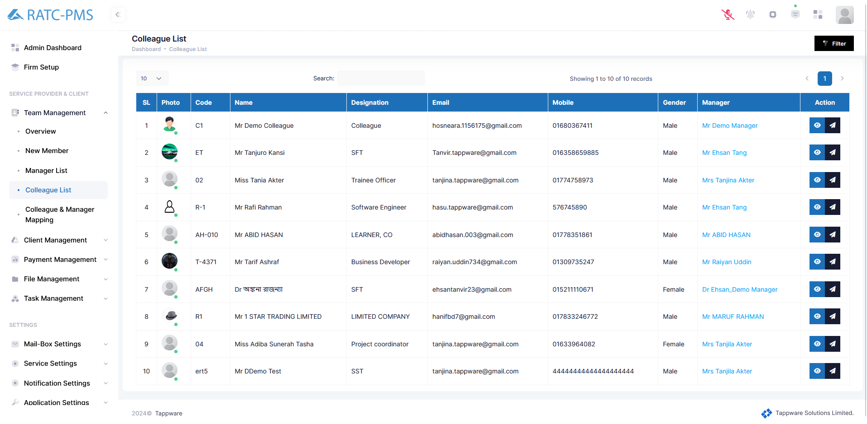

Fig: Colleague List

## 

## 4.5 Colleague and Manager Mapping

During client onboarding, the system admin assigns the client to a manager, and any colleague under that manager can be made responsible for that client. From the 'Select manager' option on this page, when a user chooses a manager, the list of colleagues under that manager appears on the right-hand section. Additionally, users can view the list of unassigned colleagues on the left-hand section below manager selection. From this page, users can dissociate a colleague under one manager and assign them to another manager. Moreover, users can assign any colleague from the unassigned colleague list to a manager under the system admin.

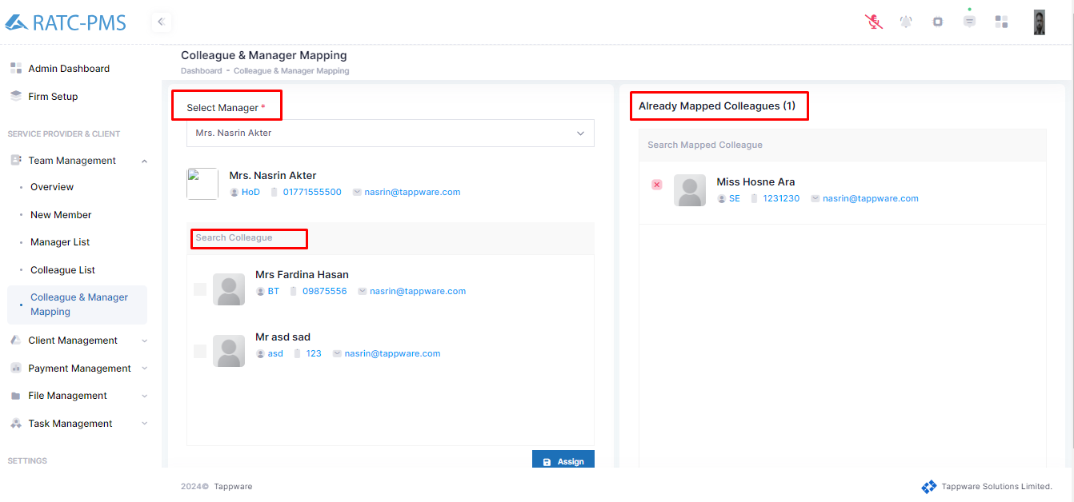

Fig: Colleague and Manager Mapping

# Client Management

## 5.1 Overview

In this section, the user may observe which clients are not assigned yet. User can initiate client mapping using the client mapping button.

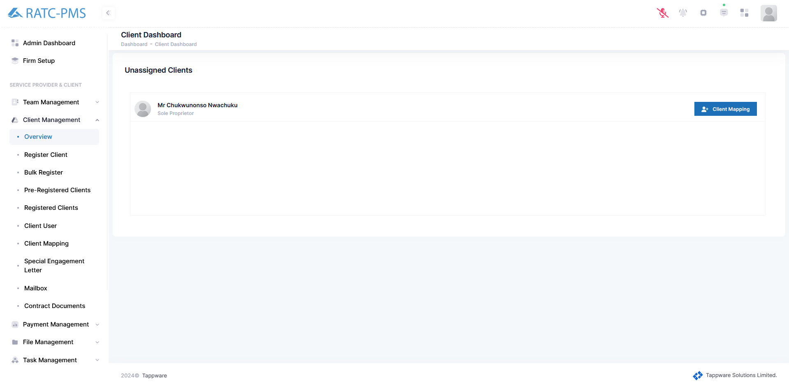Fig: Client Overview

### 5.1.1 Client Mapping

User will select the unassigned client. Following that, on the right panel, user will choose one manager and one colleague for that client and click the Assign client button.

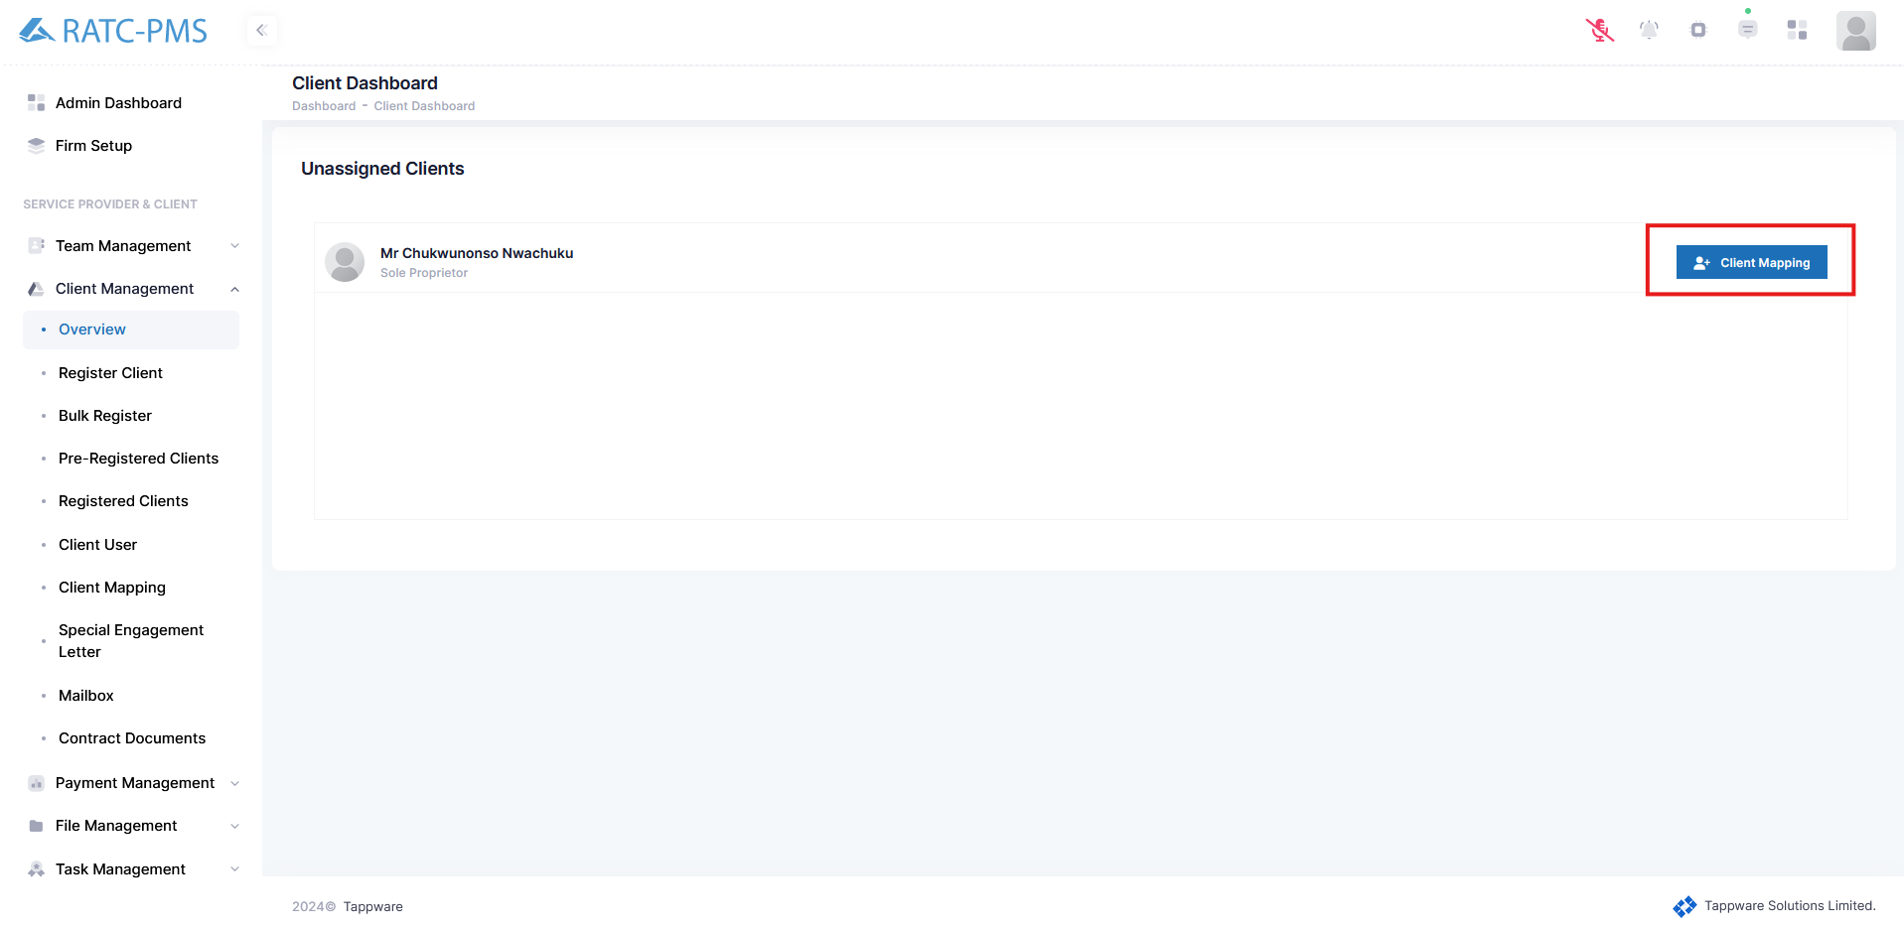

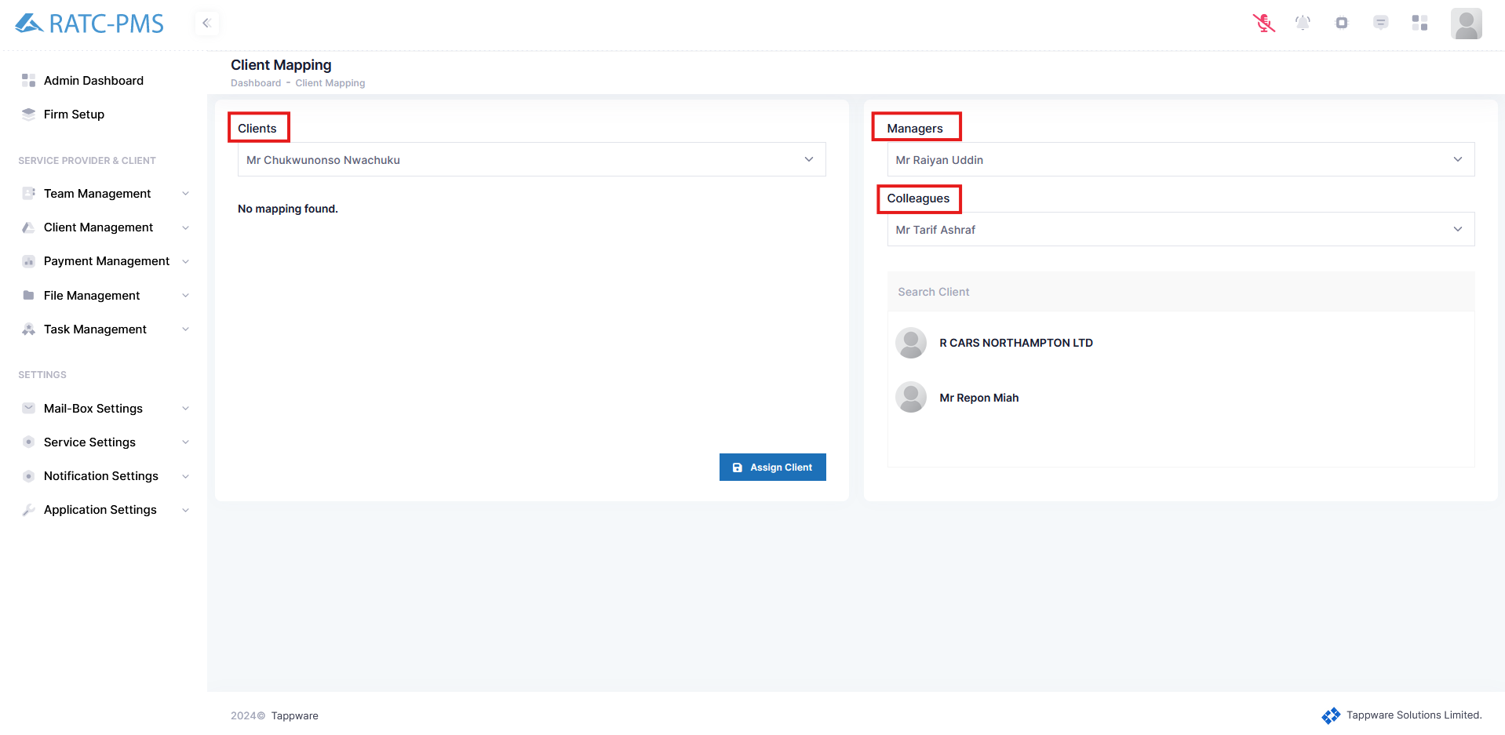

Fig: Client Mapping

## 5.2 Register Client

Registering a client has 5 crucial steps. Basic Profile → Profile Details → Upload Documents → Map Manager & Colleague → Completion. All the steps are shown below. Users can save the progress anytime and continue registering the client from Pre-Registered Clients. Save and Continue will continue the registering progress.

### 5.2.1 Basic Profile

In this section, the user has to input all the basic and necessary information about the company. Business type, Registration Type (Click Registered if the company is already registered in the UK Business House), Incorporation Number (Only needed for the clients who’s registration type is registered), Contact Person Name (Auto filled if incorporation number is given), Contact Person Email, Contact Person Mobile, Business Name (Auto filled if incorporation number is given).

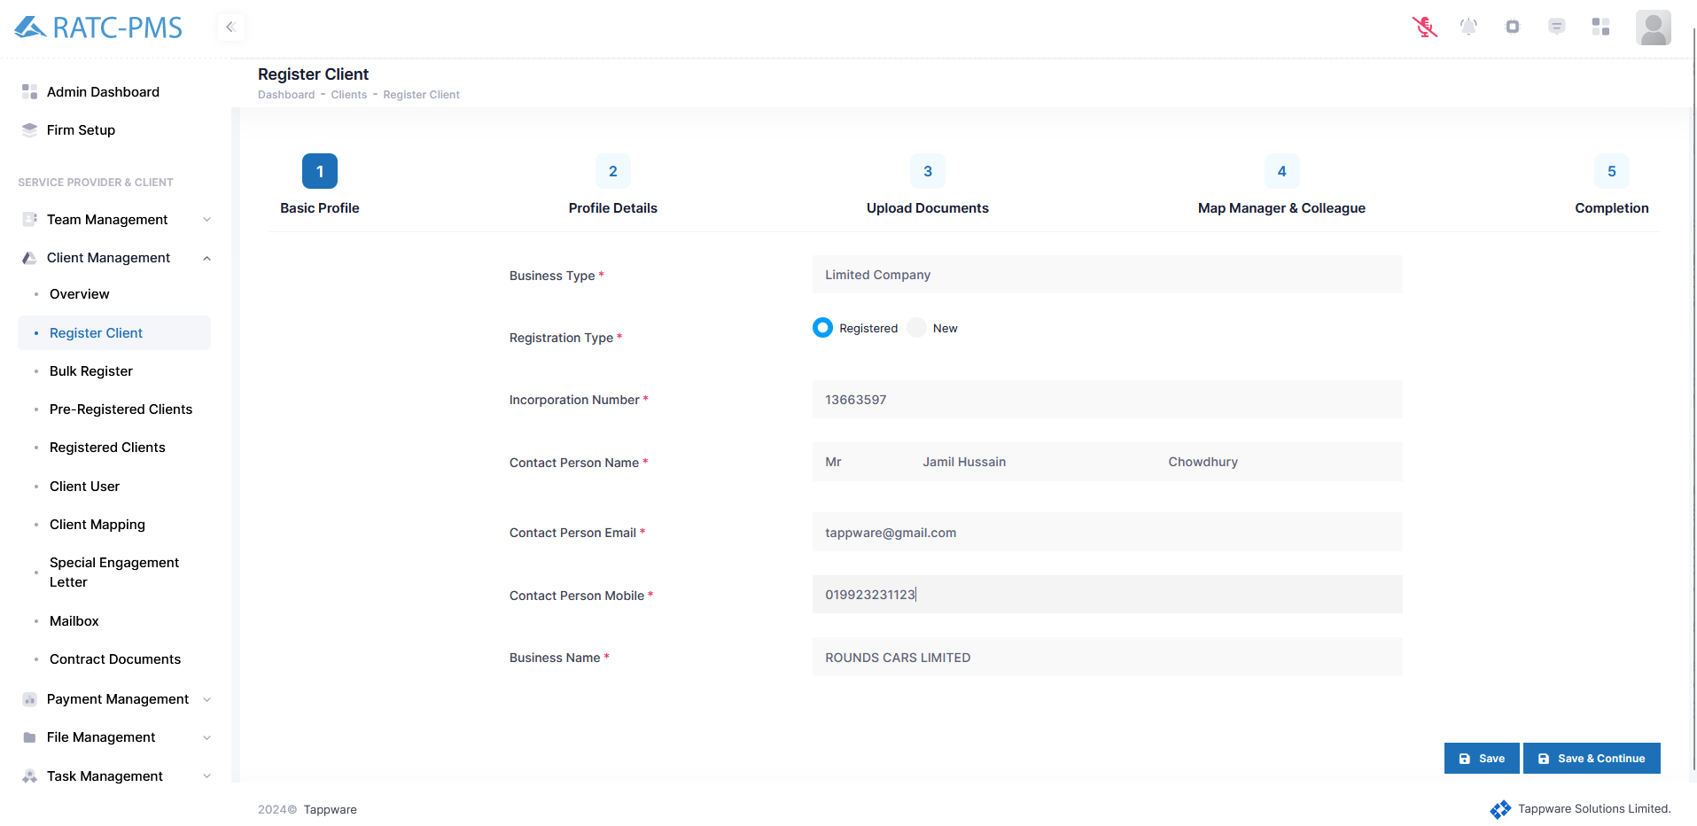

Fig: Basic Profile

### 5.2.2 Profile Details:

In profile details a lot of information is auto filled from Uk business house. If the company has a Unique Tax Reference (UTR) number it has to be submitted. Also, if the company is VAT registered, VAT profile information should be given. Furthermore, if the company is registered for Payroll, Payroll information should be given and payroll documents should be uploaded.

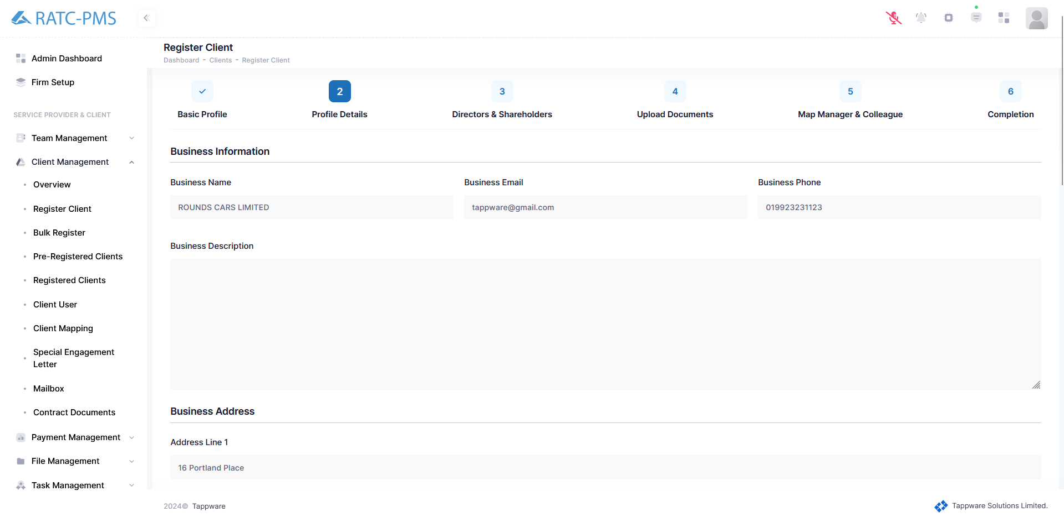

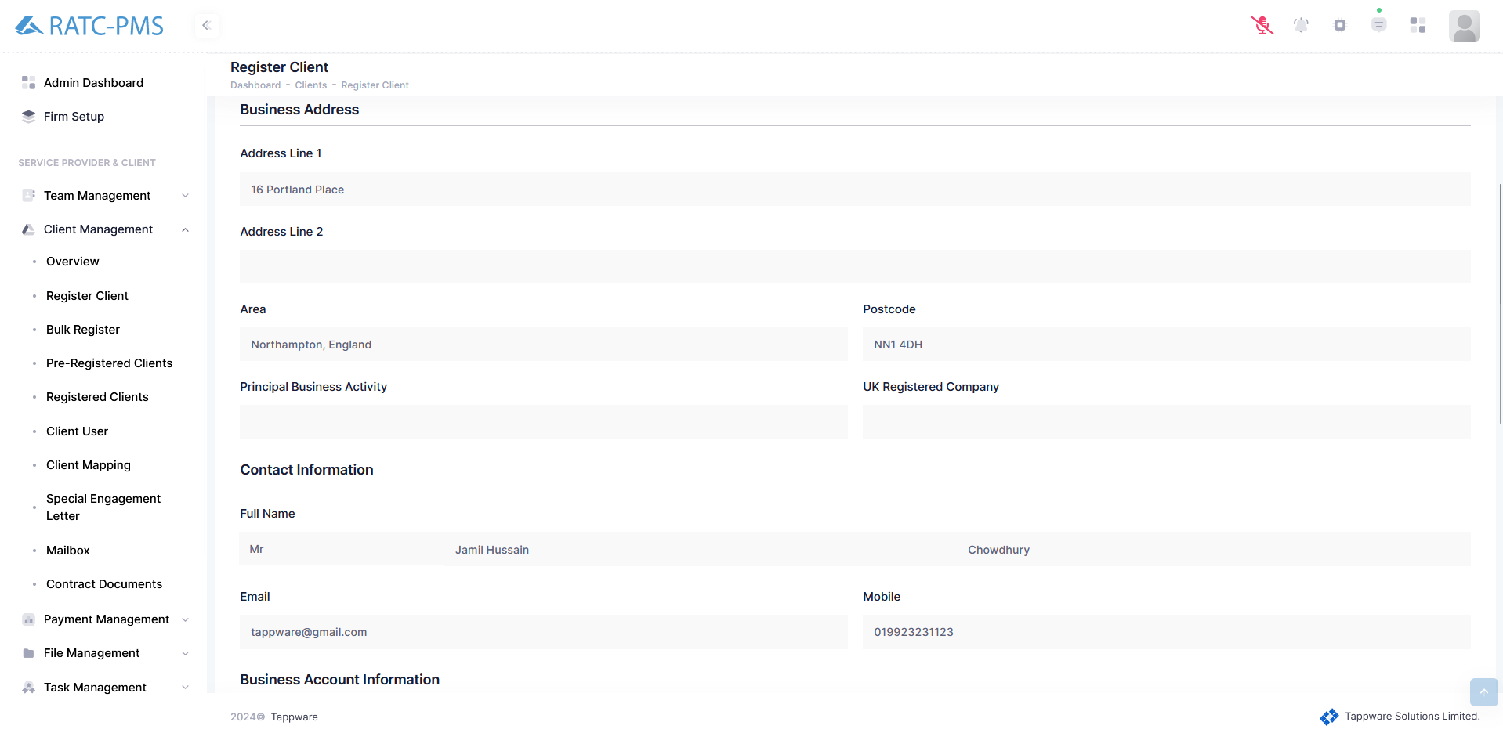

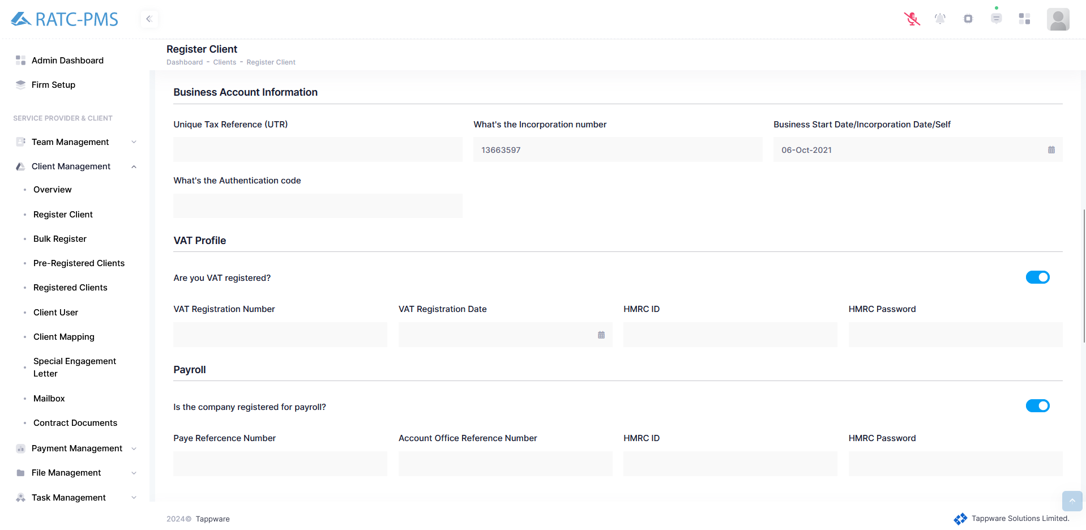

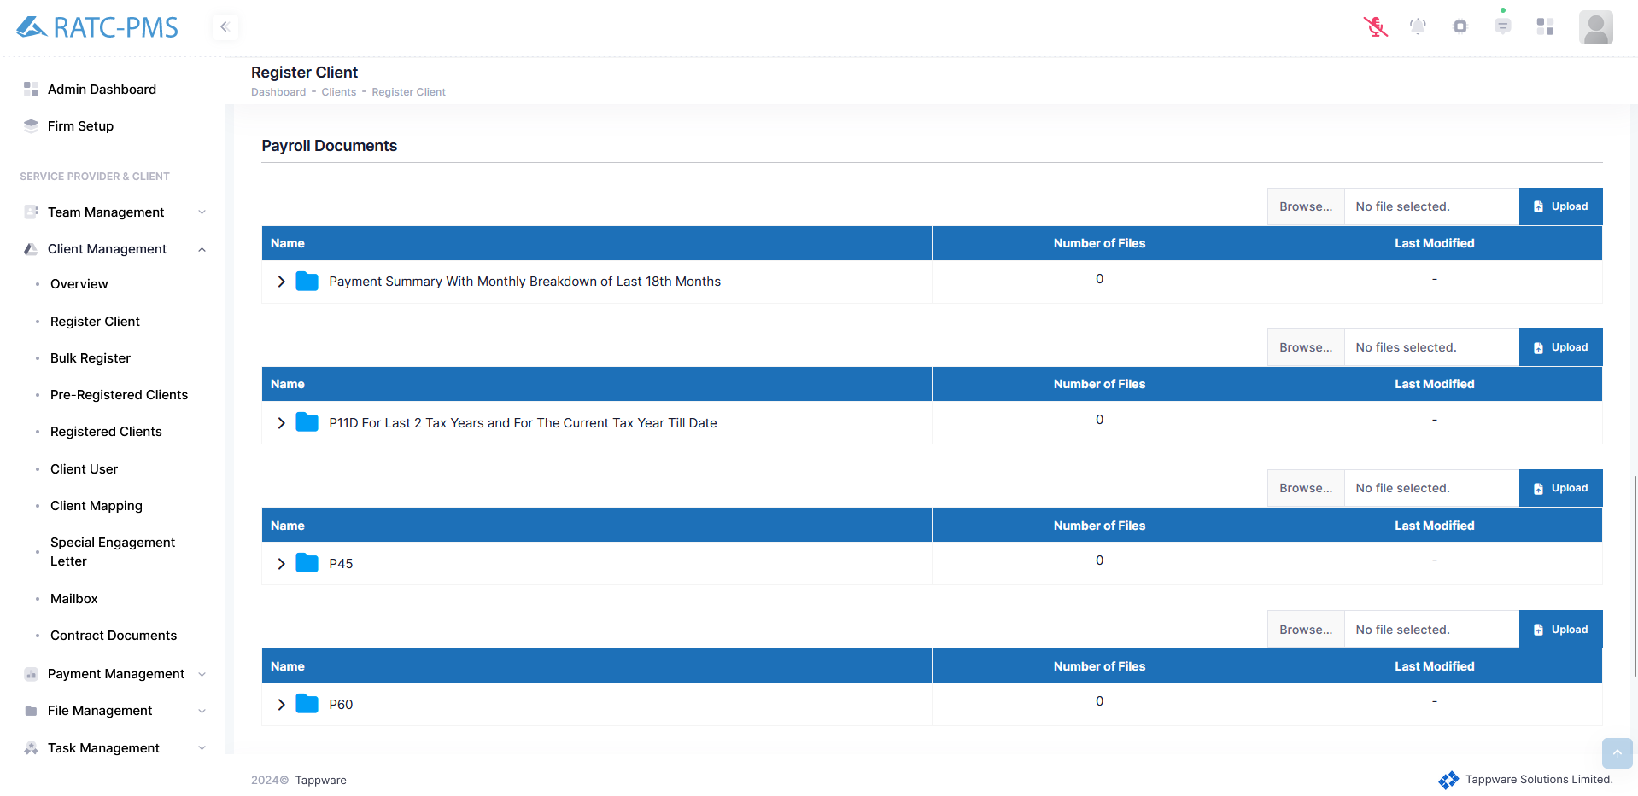

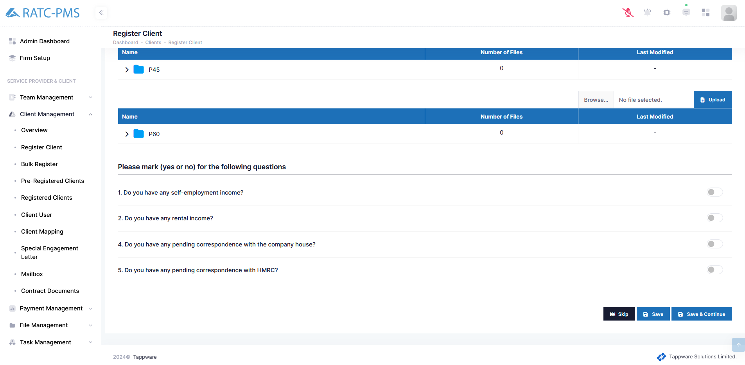

Fig: Profile Details

### 5.2.3 Directors and Shareholders

Here user can provide the number of Directors and Shareholders of the company and fill the information for all the directors and shareholders.

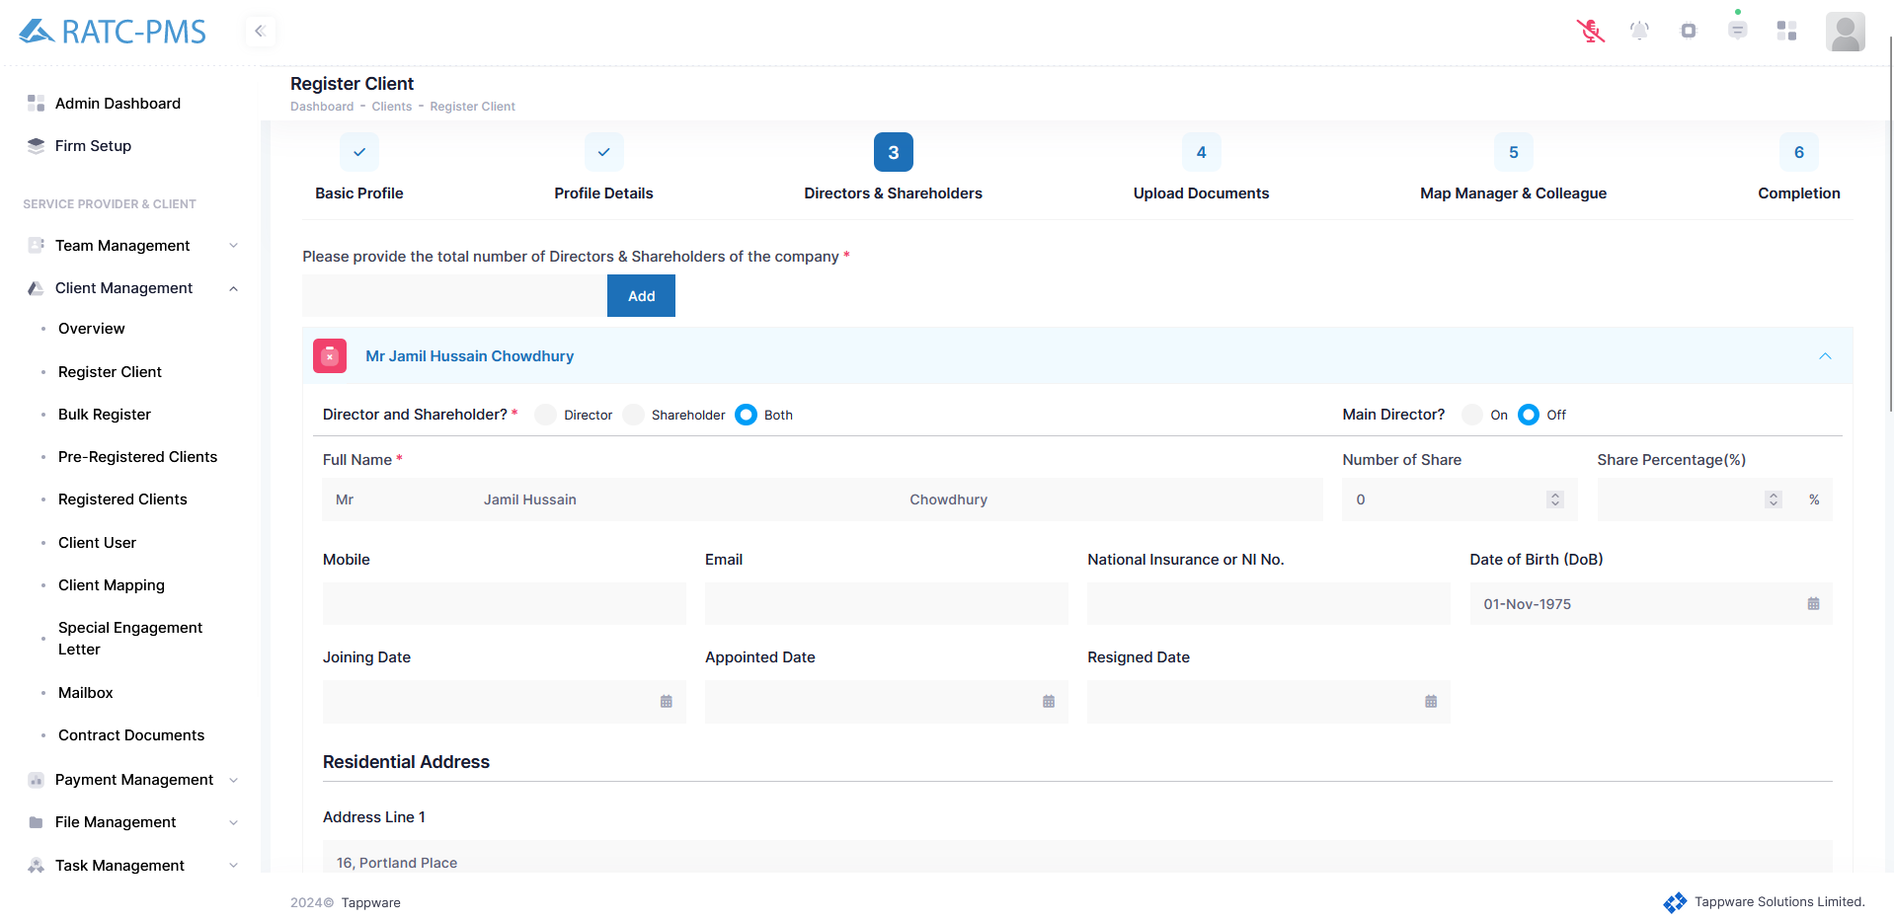

Fig: Directors and Shareholders

Sole Proprietor:

This check box will determine whether the user should be a sole proprietor or not. If not, then the Unique Tax Reference Number should be given.

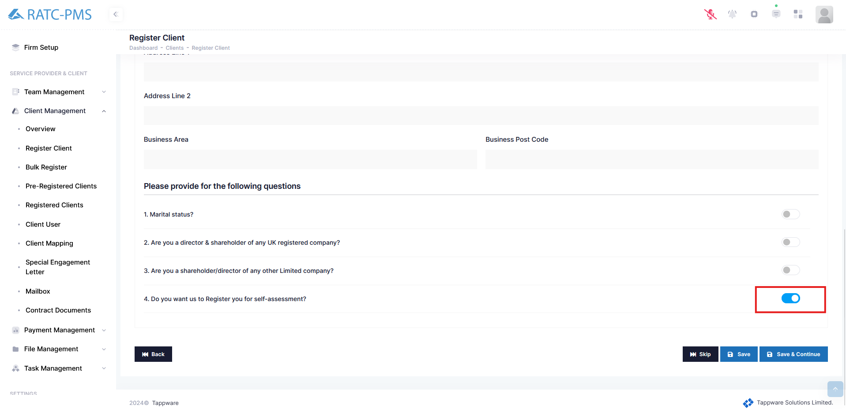

Fig: Check box for Sole Proprietor

### 5.2.4 Upload Documents

Here user has to upload Copy of Passport, Copy of Driving License, Copy of Utility Bill. Also, users can ‘view’, ‘reject’, ‘change’ and ‘delete’ any following document.

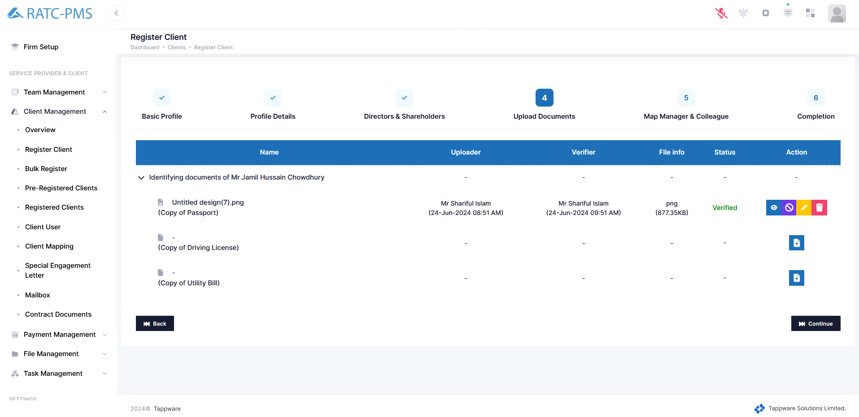

Fig: Upload Documents

### 5.2.5 Map Manager and Colleague

User can select any manager and colleague for this particular client.

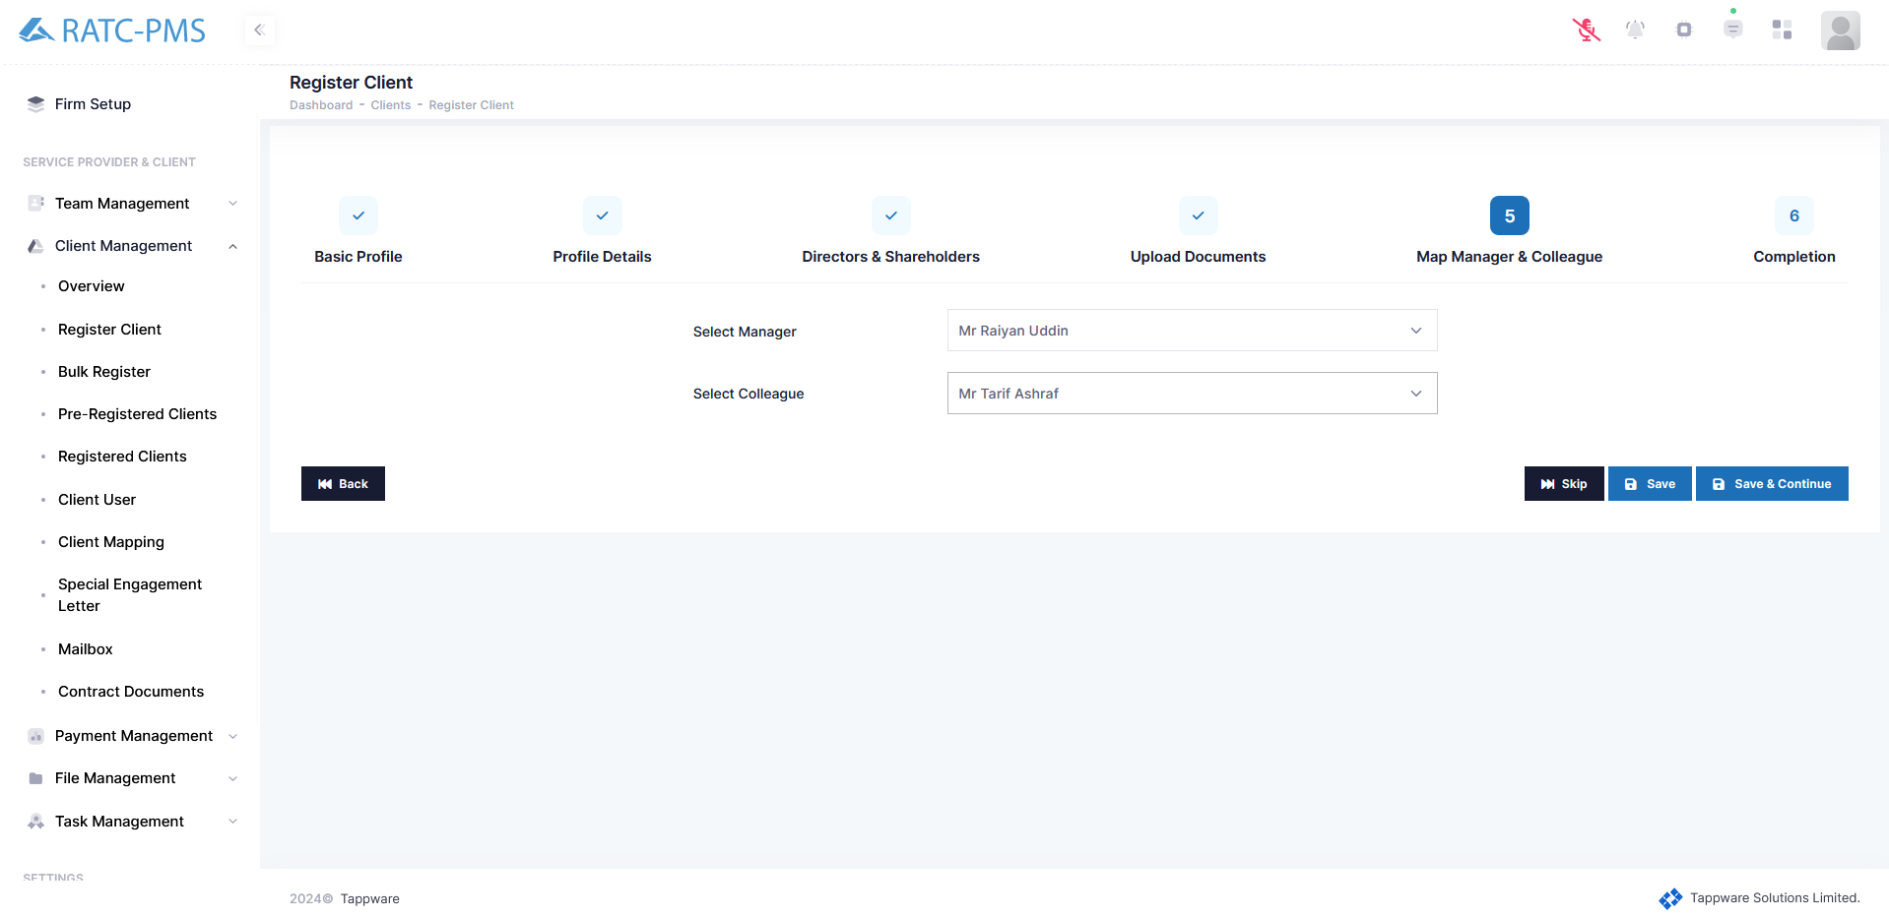

Fig: Map Manager & Colleague

### 5.2.6 Completion

Users can see all the information given to check if all the information is right. Then the admin can share the profile with the client if the user wants and approve the client. Sharing the profile with the client will send an Email to the clients email inbox with account information.

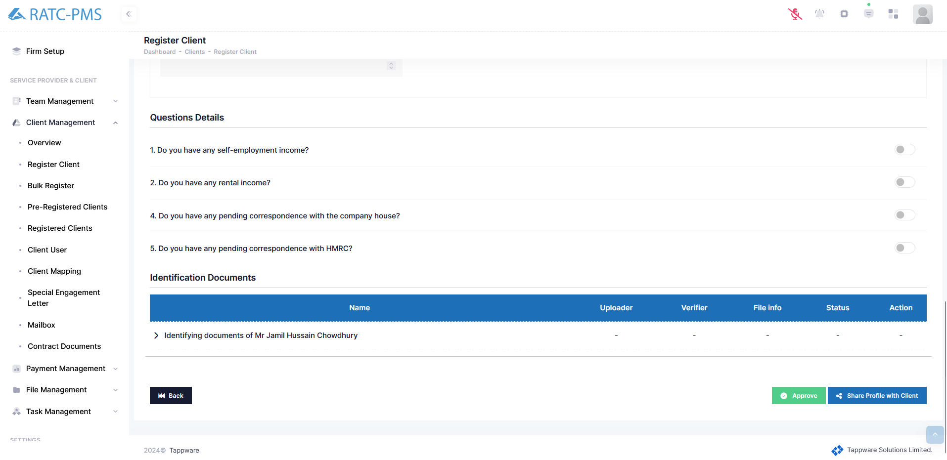

Fig: Completion

## 

## 5.3 Bulk Register

Users can register a bulk amount of clients from this panel using a particular excel format.

## 

Fig: Bulk Register

## 5.4 Pre-Registered Clients

Users can see all the pre-registered clients from this page. Users can approve or reject any selected clients. Admin can also edit or delete any client he wants. Admin can export all the pre-registered client information through an excel file.

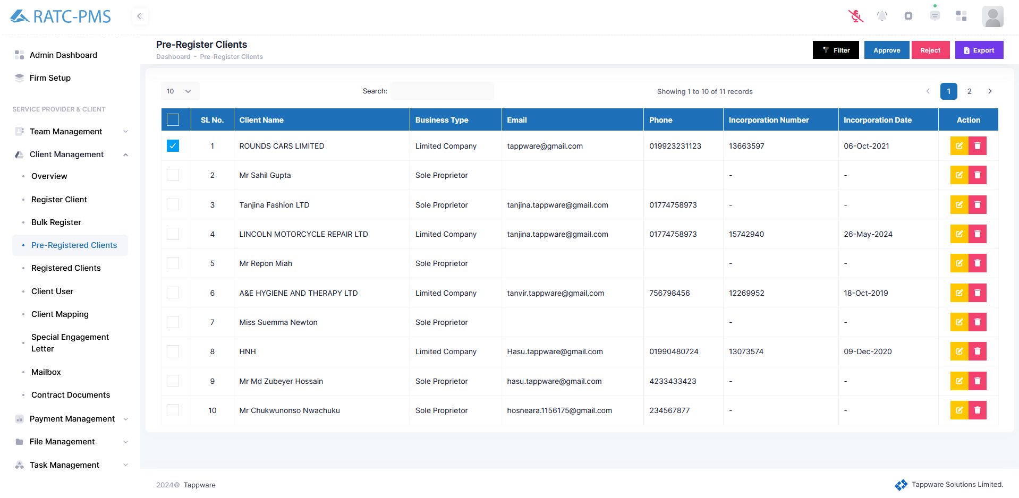

Fig: Pre-Register Clients

## 5.5 Registered Client

All registered clients are listed here. The user can activate or deactivate a client's status. Additionally, from the action column, using the view button the user will be directed to the client view page where the user gets all the information of the client. User can modify the client information by clicking the edit button.

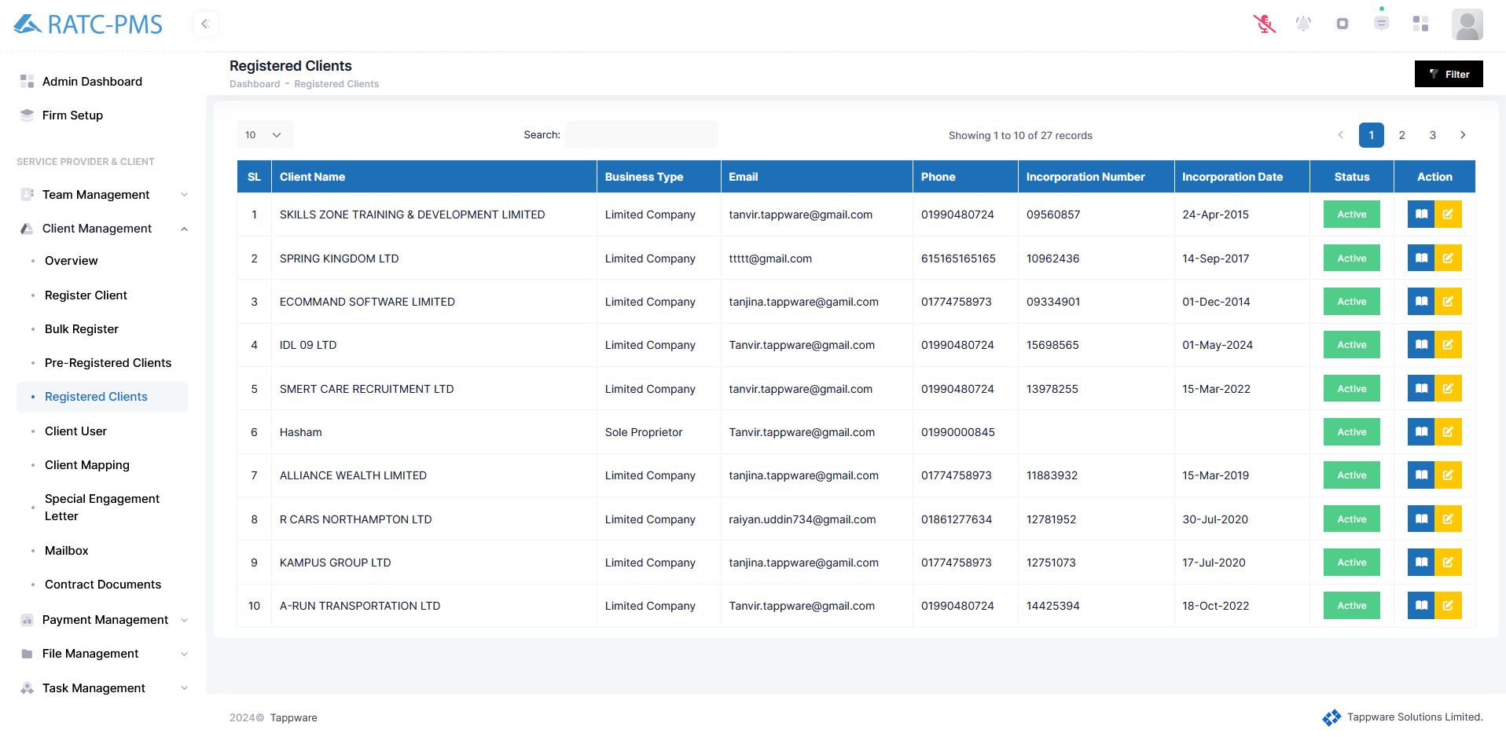

Fig: Registered Clients

### 5.5.1 View

#### 5.5.1.1 Overview

After clicking the view button, the overview page will open with all the details of the client.

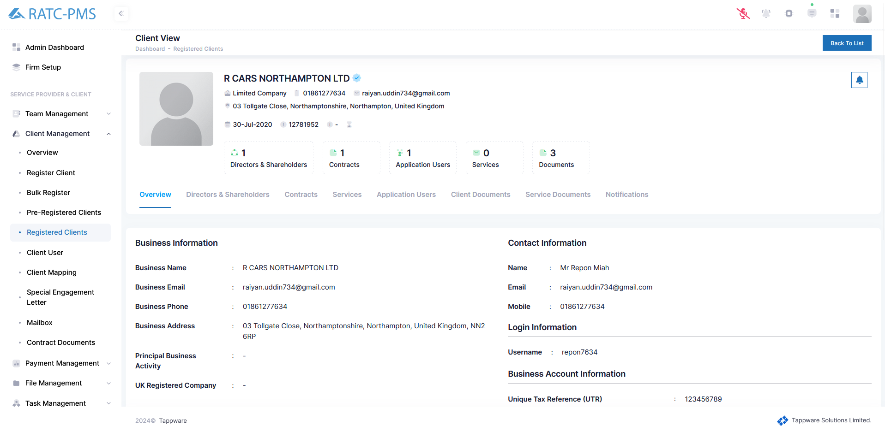

Fig: Clients Overview Page

#### 5.5.1.2 Directors and Shareholders

Users may view all of the directors and shareholders here. There are three buttons beneath each name. The first button displays the passport, the second button displays the driver's license, and the final button displays the Utility bill.

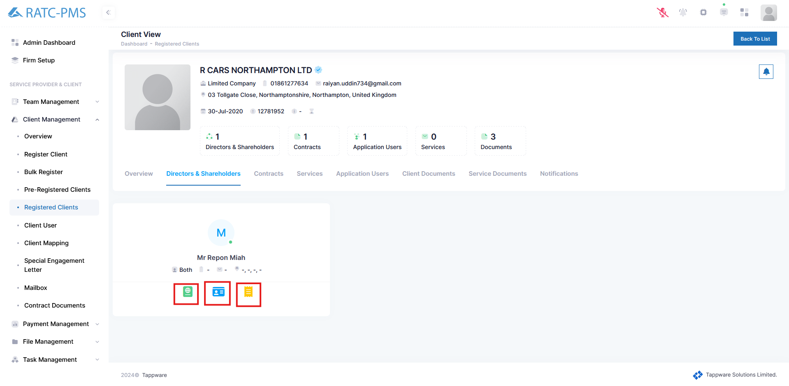

Fig: Directors & Shareholders

#### 5.5.1.3 Contracts

Users may view all contracts from here. Users can also create contracts by clicking the add contract button. Admin may enable auto renewal for any contract by clicking the auto renew button. This helps the users from creating the new contract everytime. The action box contains four buttons. The first button displays the contract paperwork. The second button will activate the contract for services. The third button displays all of the contract's data, and the fourth button allows you to update that data. The last button will delete the contract.

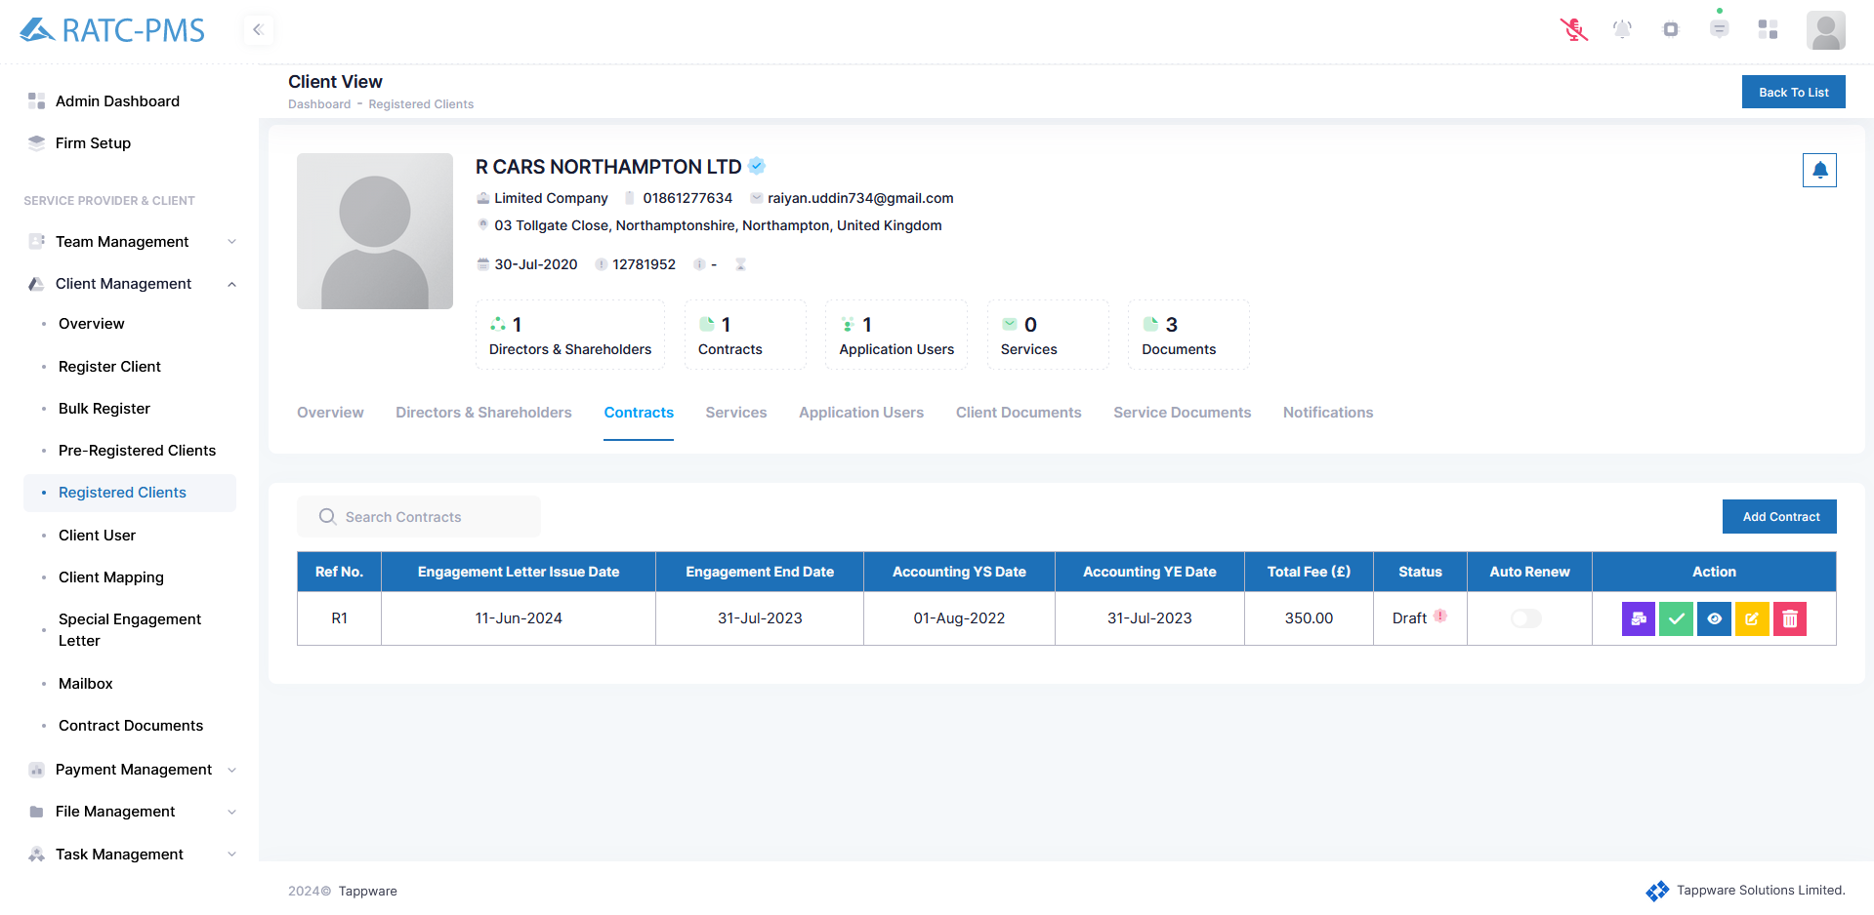

Fig: Contracts

Add Contract:

Users can create a contract here. Users have to carefully input Engagement Letter Issue Date, Engagement End Date, Accounting YS Date, Accounting YE Date, Accounting Due Date, Confirmation Statement Start Date, Confirmation Statement Date, Confirmation Statement Next Due. After that, users will select the services the client wants. After selecting the services, users can change the start date, Submission Validity Days, Unit, Per Fee (£), Unit Discount (£). Fee Total (£) column will show the total fee. Users can edit the Total Discount Fee and VAT Percentages. From the action column, users can delete an unwanted service. Clicking the submit button will create a contract.

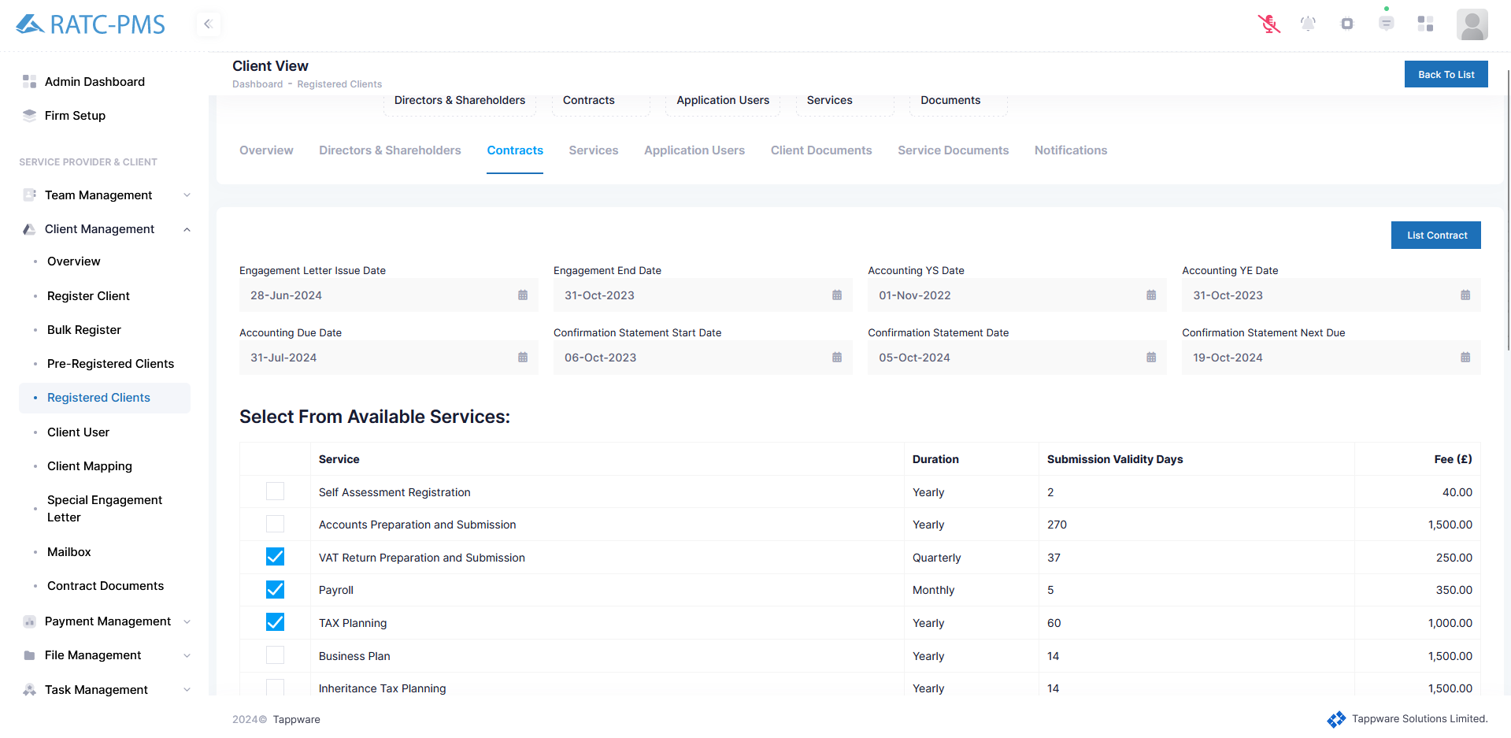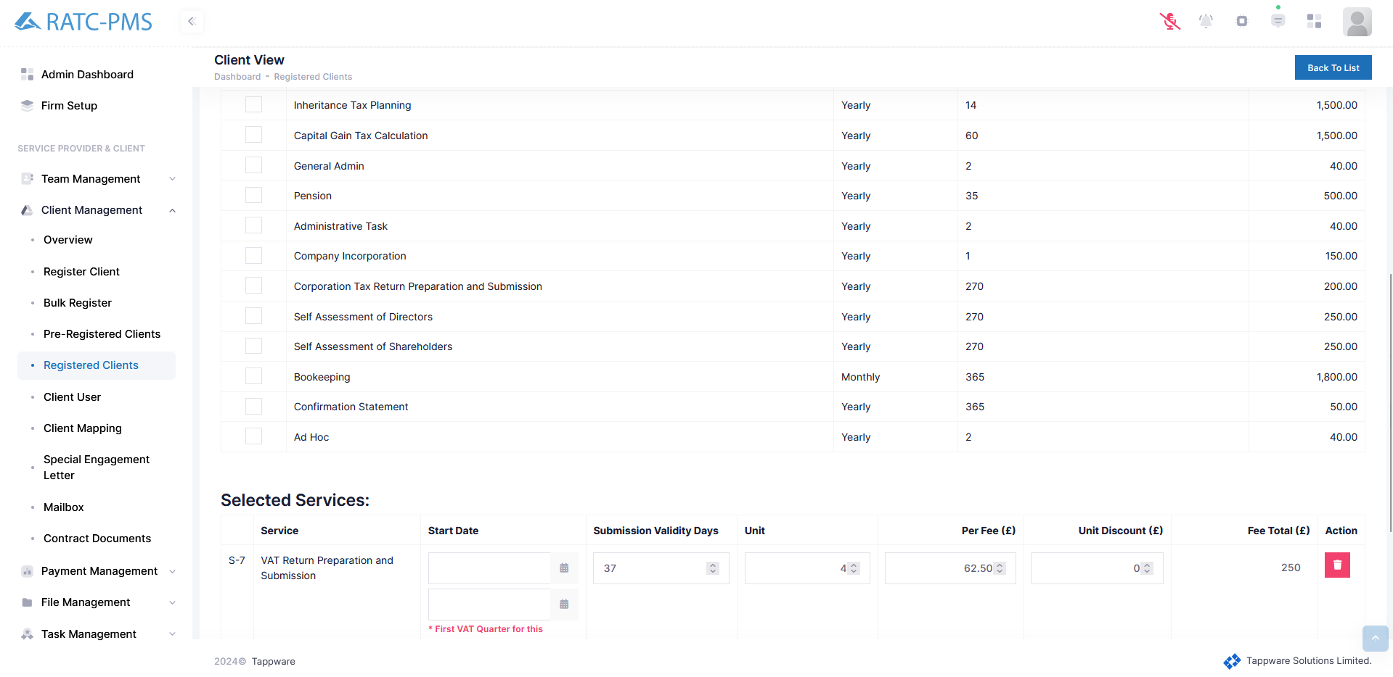

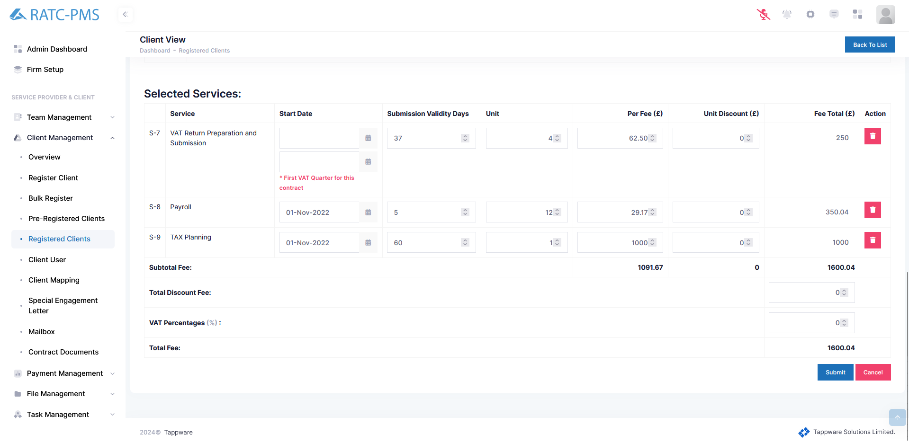

Fig: Add Contract

#### 5.5.1.4 Services

Services show all the tasks for the certain client. This task can be found in the task page.

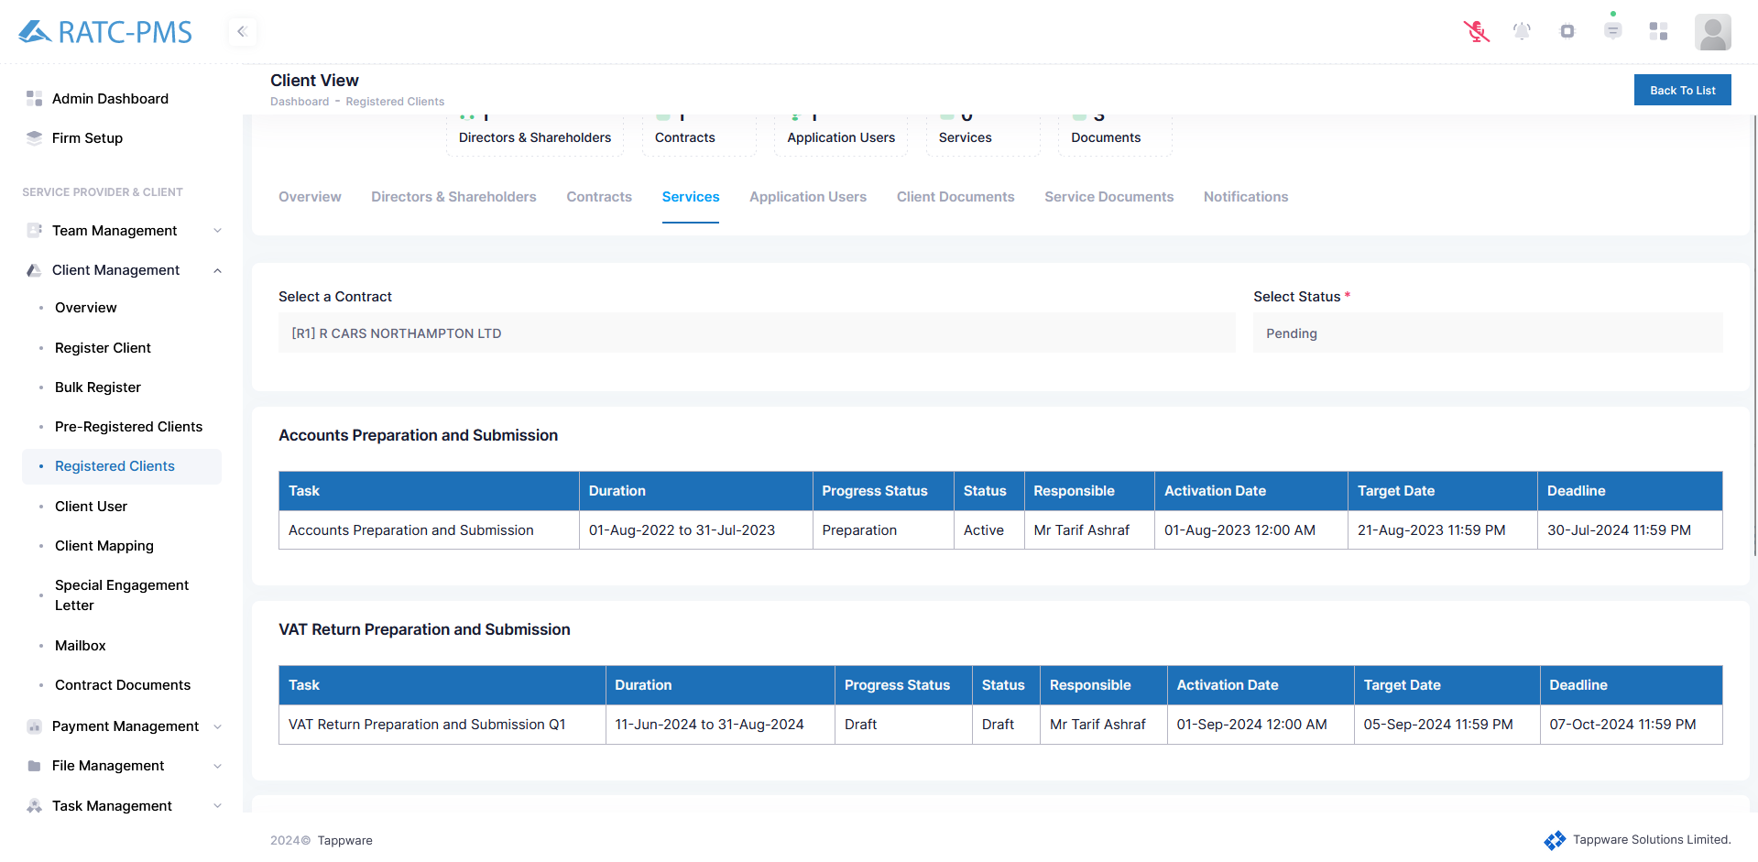

Fig: Services

#### 5.5.1.5 Application Users

User can view the application user from this page and share the profile with the client using the share profile button (This will reset the password).

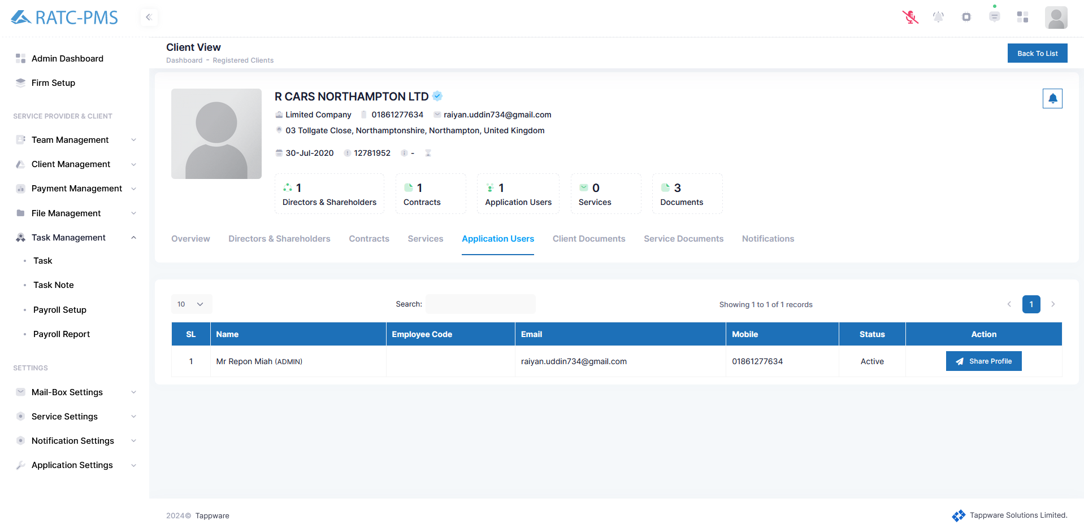

Fig: Application Users

#### 5.5.1.6 Client Documents

The User may view all of the client's documents that have been uploaded here. The action column has four buttons. The first button allows the user to view the document. The second button is for rejecting the document. The third button is used to update the document. The last button is used to remove the file.

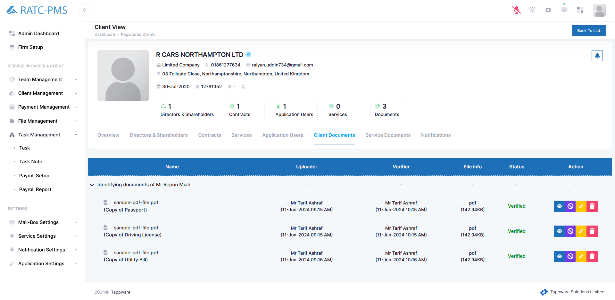

Fig: Client Documents

#### 5.5.1.6 Service Documents

Users can see all the service document lists from this page. Users can also filter the document he wants to view. The view button will open the document. Users can upload other documents using the upload button.

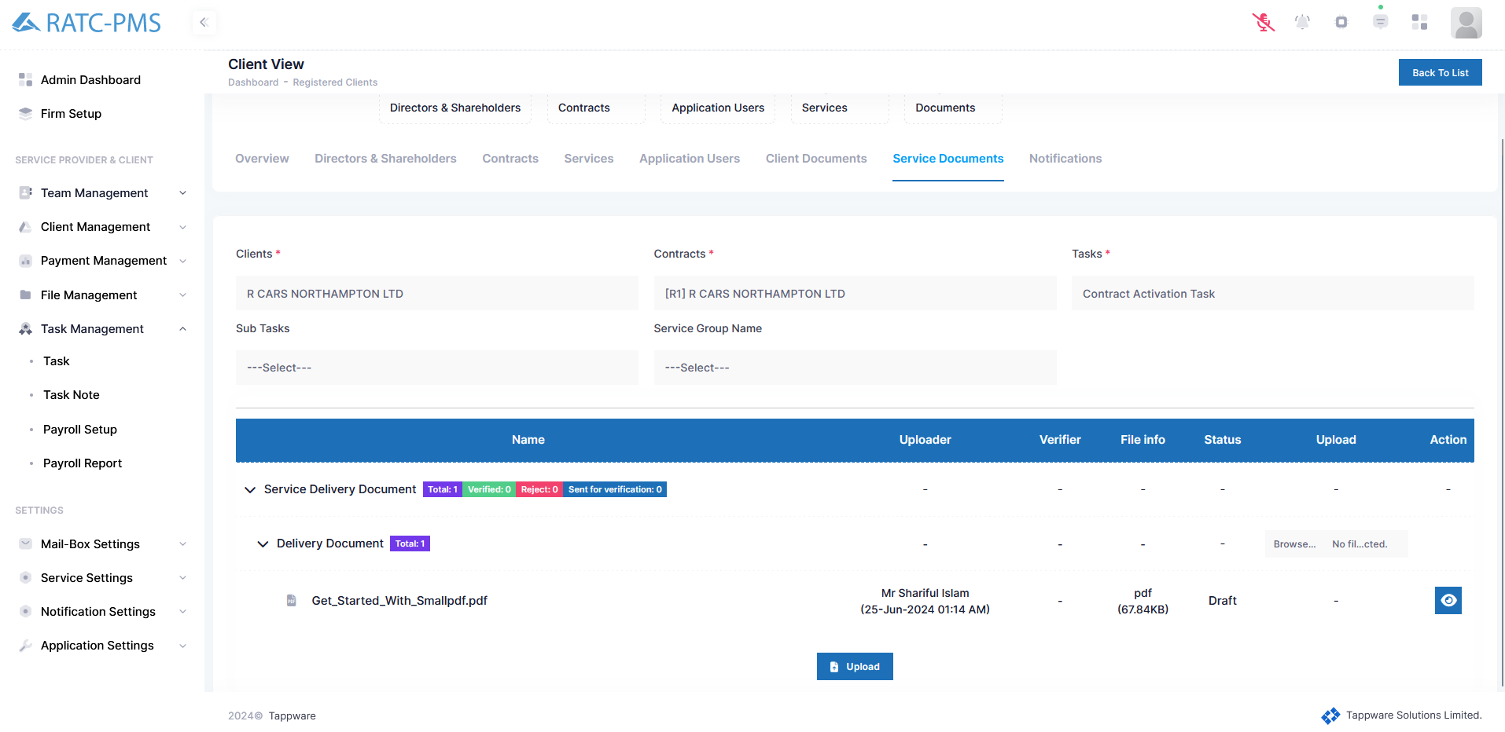

Fig: Service Documents

#### 5.5.1.7 Notifications

There are four components on the notification page. The email inbox displays all incoming emails. The email outbox displays all of the outgoing emails. Notifications displays all notifications of that client. SMS shows all sms of that client.

Email-Inbox:

The email inbox displays all incoming emails. The view button open the email in a side window

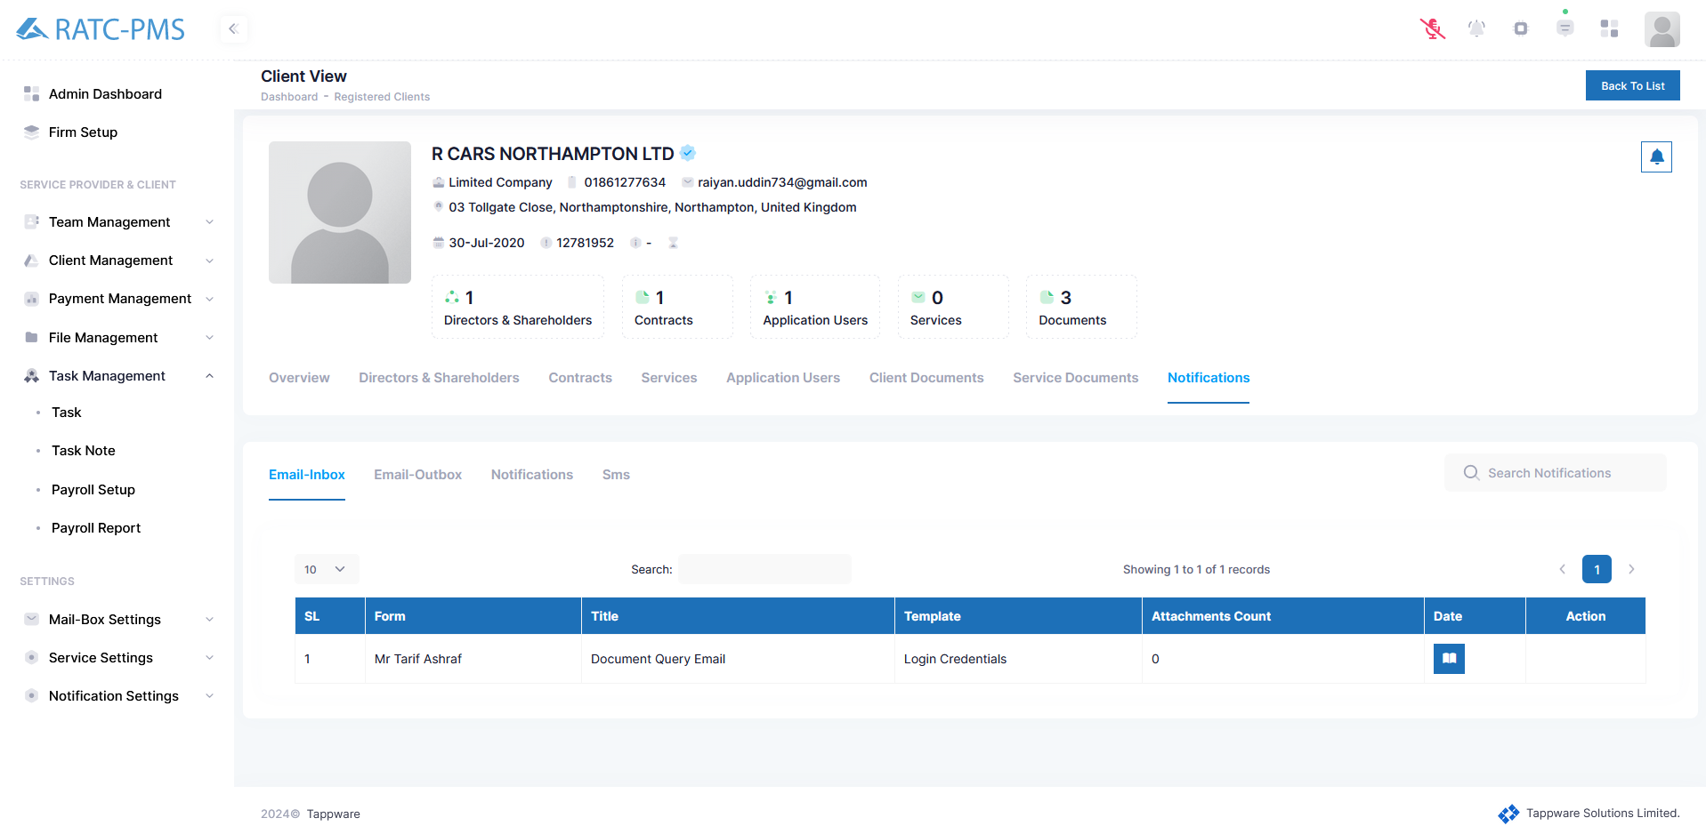

Fig: Email-Inbox

Email-Outbox:

The email outbox displays all outgoing emails. The view button opens the email in a side window.

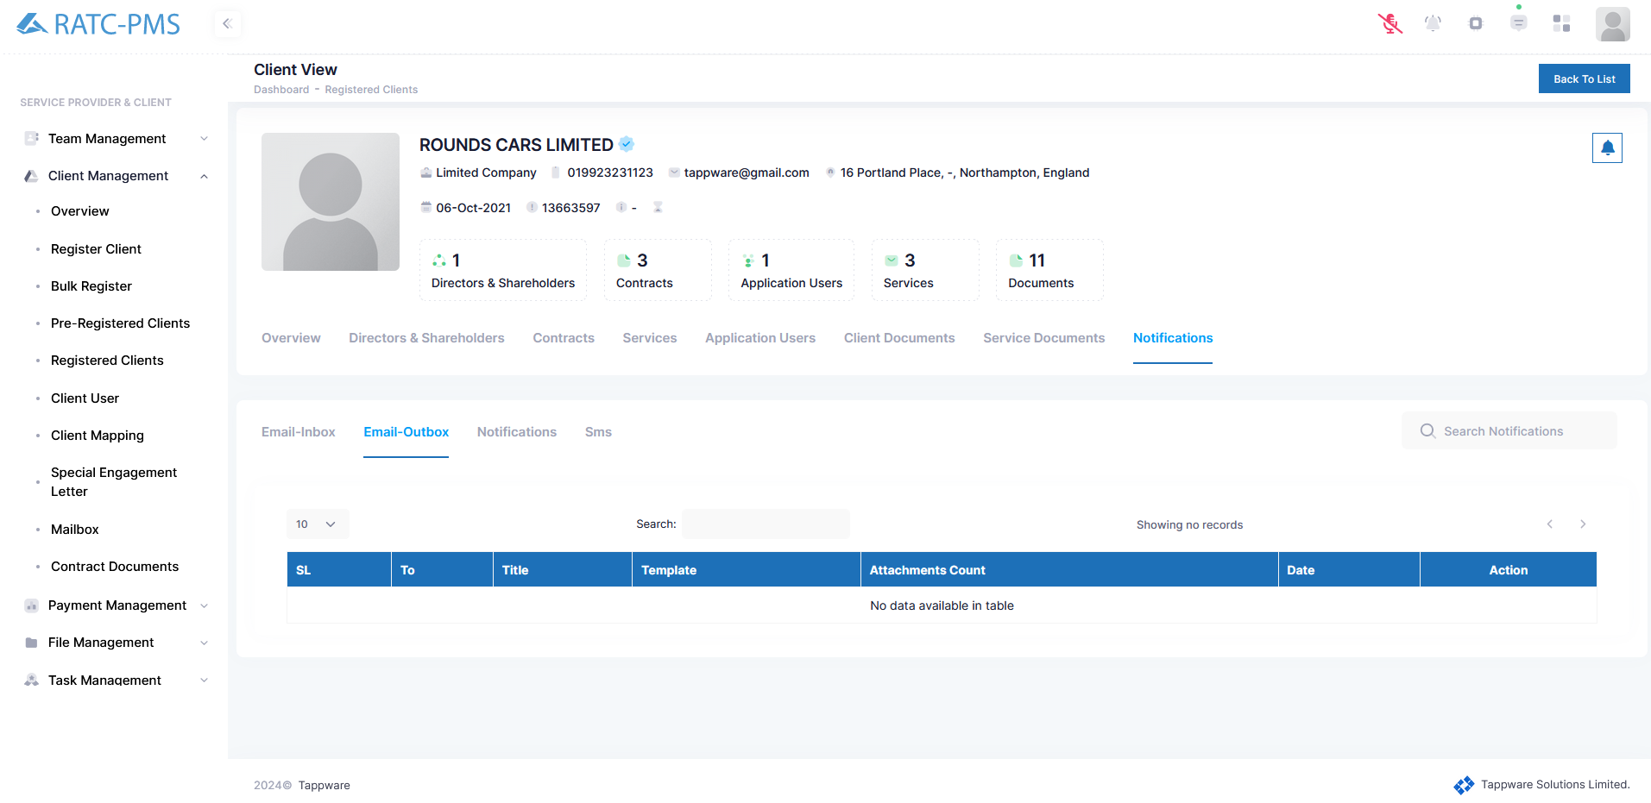

Fig: Email-outbox

Notifications:

The Notifications panel displays all the clients notification.

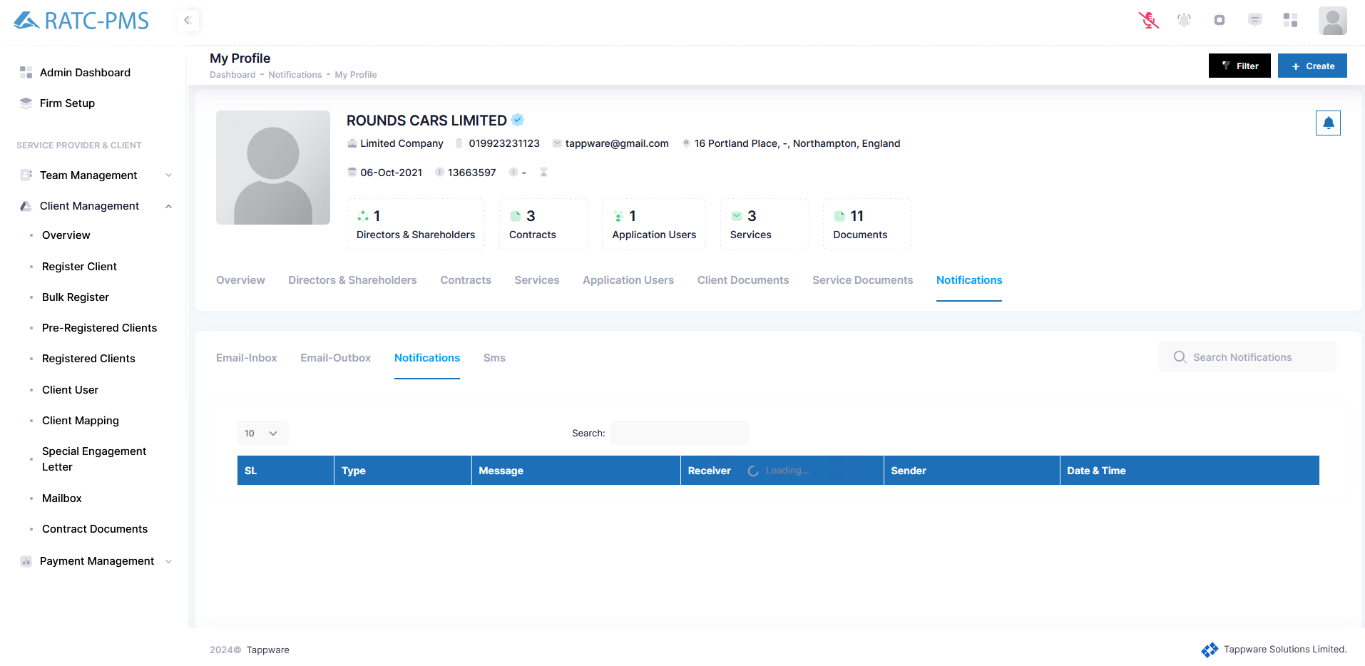

Fig: Notifications

SMS:

The SMS panel displays all the clients SMS.

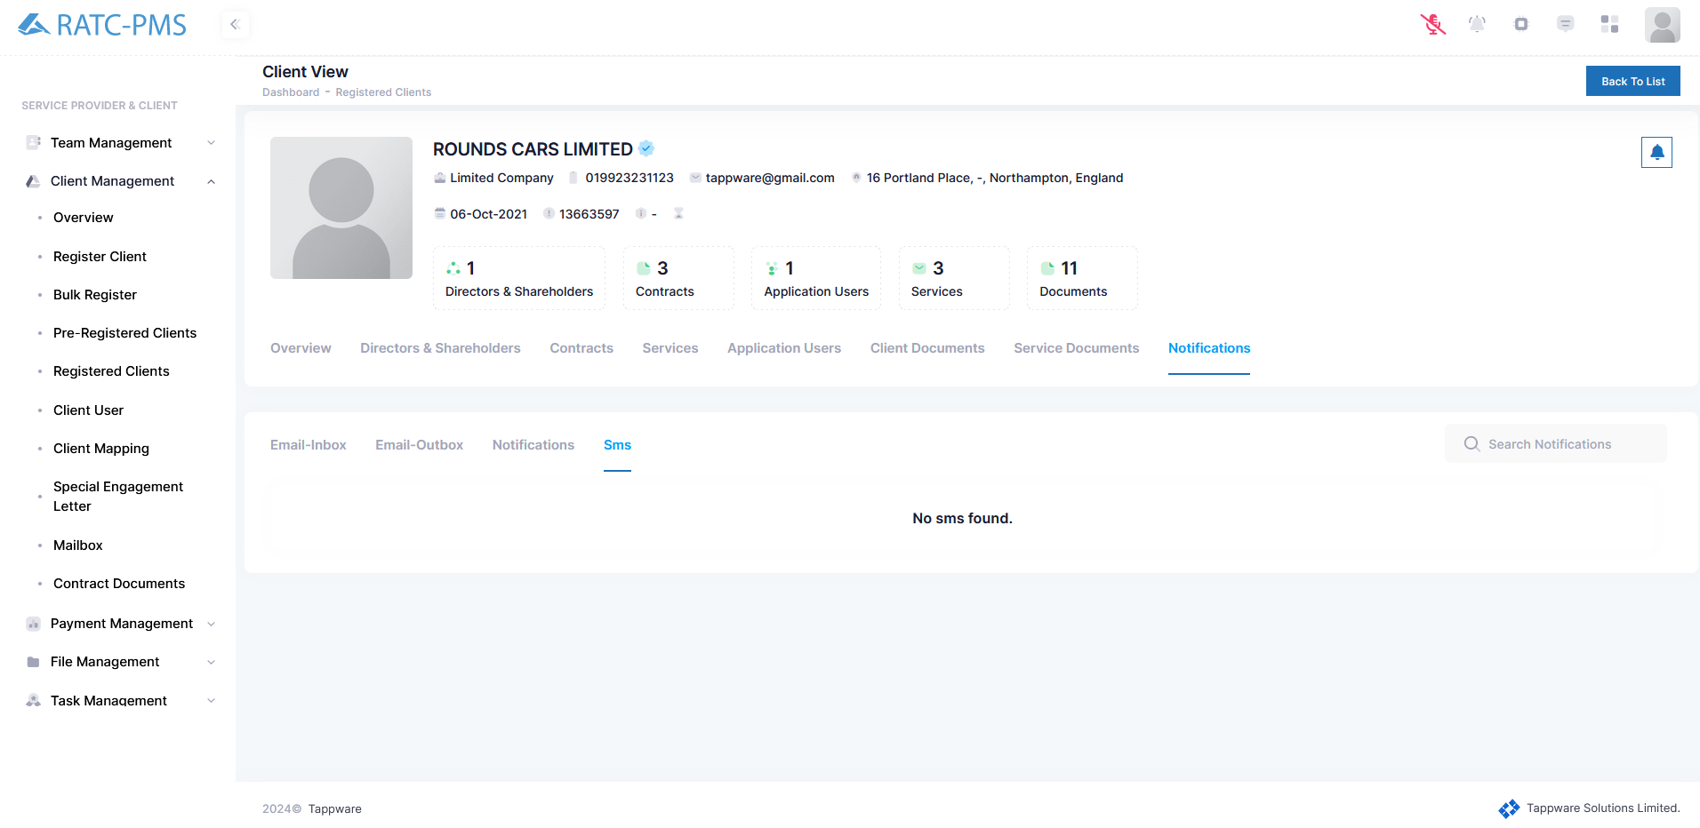

Fig: SMS

## 5.6 Client User

Clients can add users for their benefit from here. It is similar to adding new members.

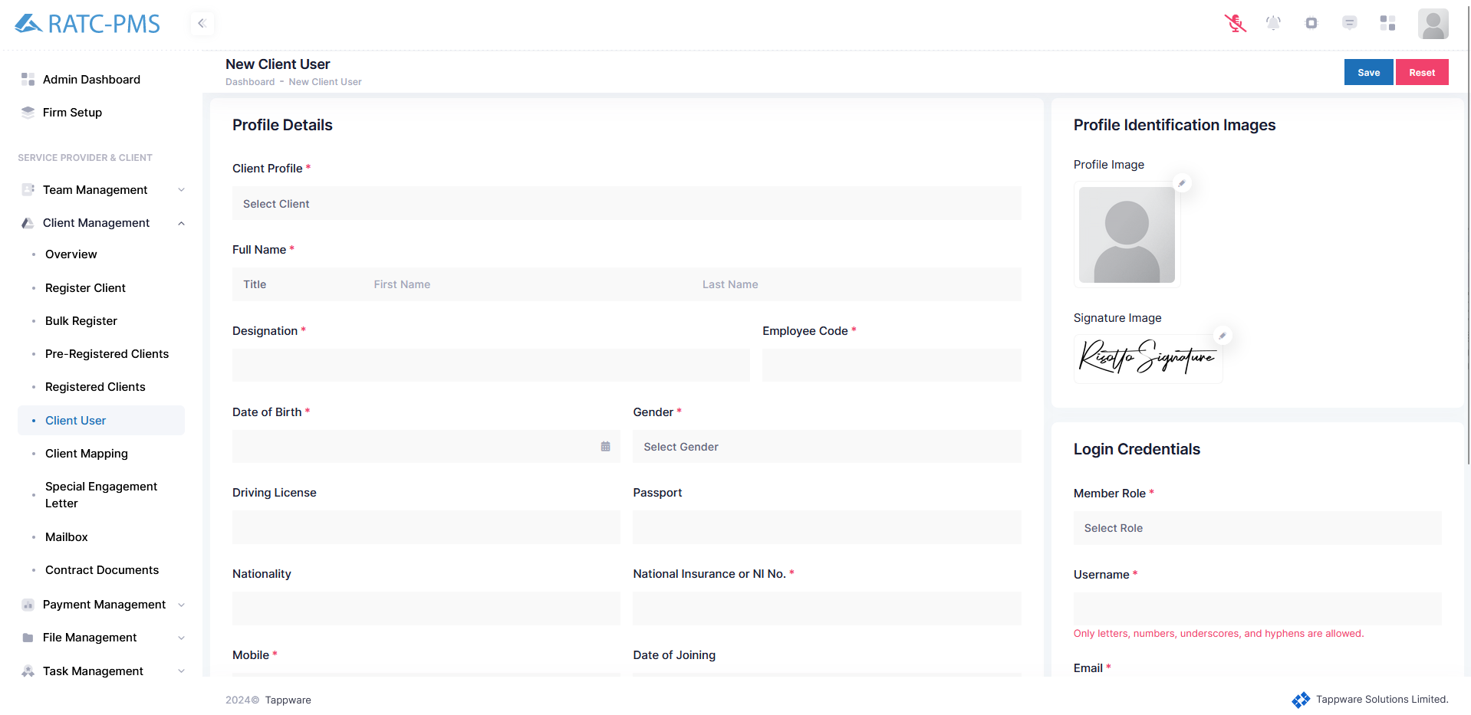

Fig: Client User

## 5.7 Client Mapping

User can assign any selected client to any manager and colleague.

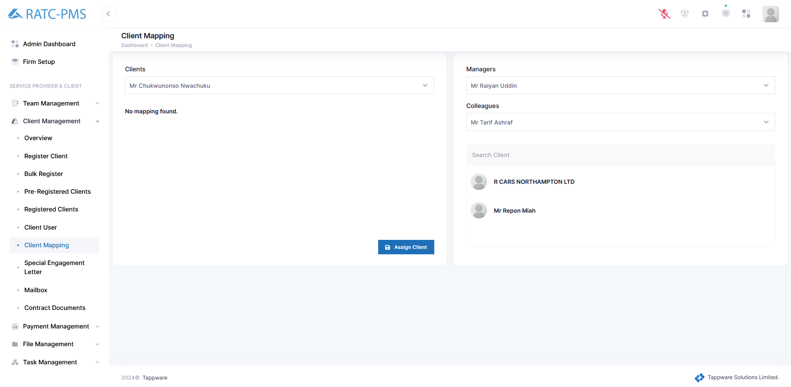

Fig: Client Mapping

## 5.8 Special Engagement Letter

## 5.9 Mailbox

## 5.10 Contract Documents

Users can see all the contract information from this page. Users can also view engagement letters from the action panel using the view button and edit if needed. Users can approve or reject any contract or send a contract for a query.

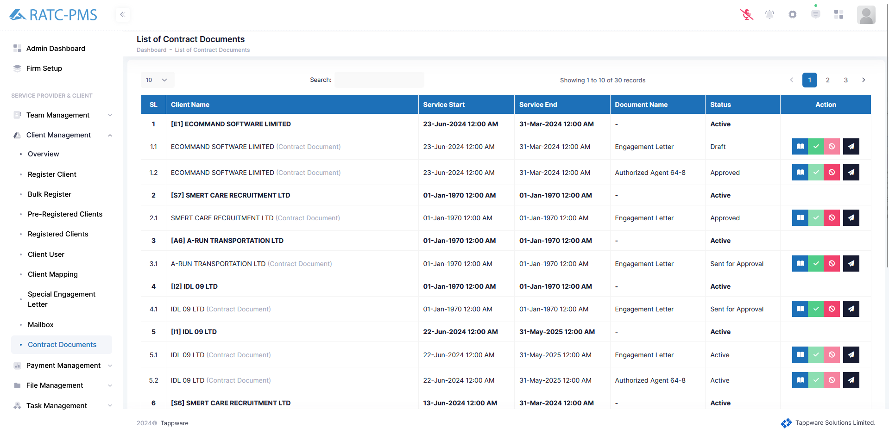

Fig: Contract Documents

# Payment Management

## 6.1 Ledger

### 6.1.1 Ledger Book

In the ledger book, Users may view a client's name, received amount, paid amount, current balance, last updated time, and status. The view button allows the users to inspect the client's ledger in detail.

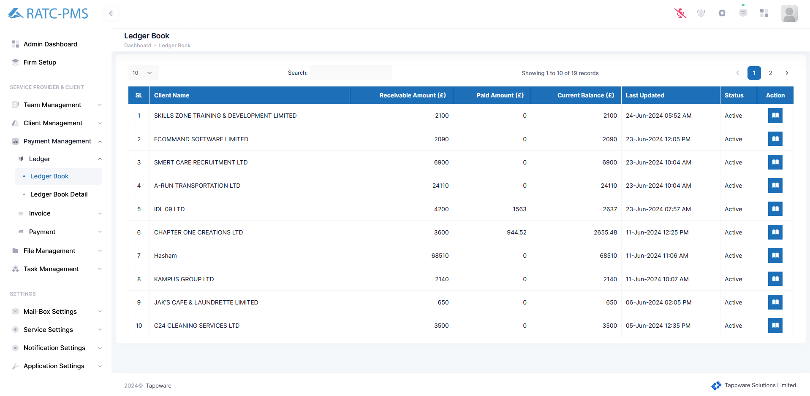

Fig: Ledger Book

### 6.1.2 ledger Book Detail

Ledger Book Detail is similar to ledger book but shows more detail.

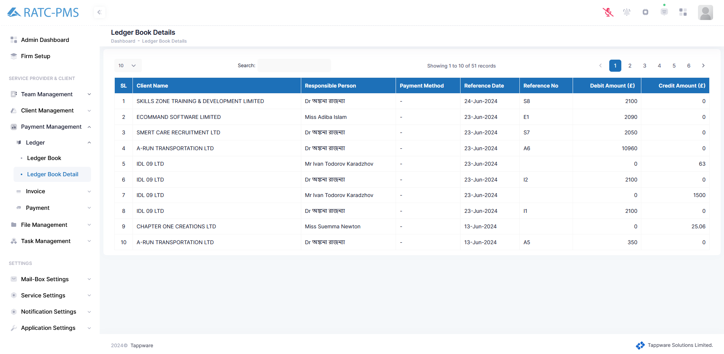

Fig: Ledger Book Detail

## 

## 6.2 Invoice

### 6.2.1 Generate Invoice

The user must first pick the 'client', then the 'contract' for that client, and finally the 'task'. The 'Attention To' field will be auto-filled with our client's information. The term 'adjust discount' refers to the amount of the discount. The invoice date is auto-filled. The term "payment days" defines before how many days the client has to pay. 'Reminder Days' specifies how many days before the system should remind the customer to pay. 'Bank Accounts' refers to the account into which the client must make payments. User has to fill in the Bill address or he can click the check box which says ‘Same as Client Business Address’. This means the client business address and billing address are the same. At last, the user has to click generate invoice to create the invoice.

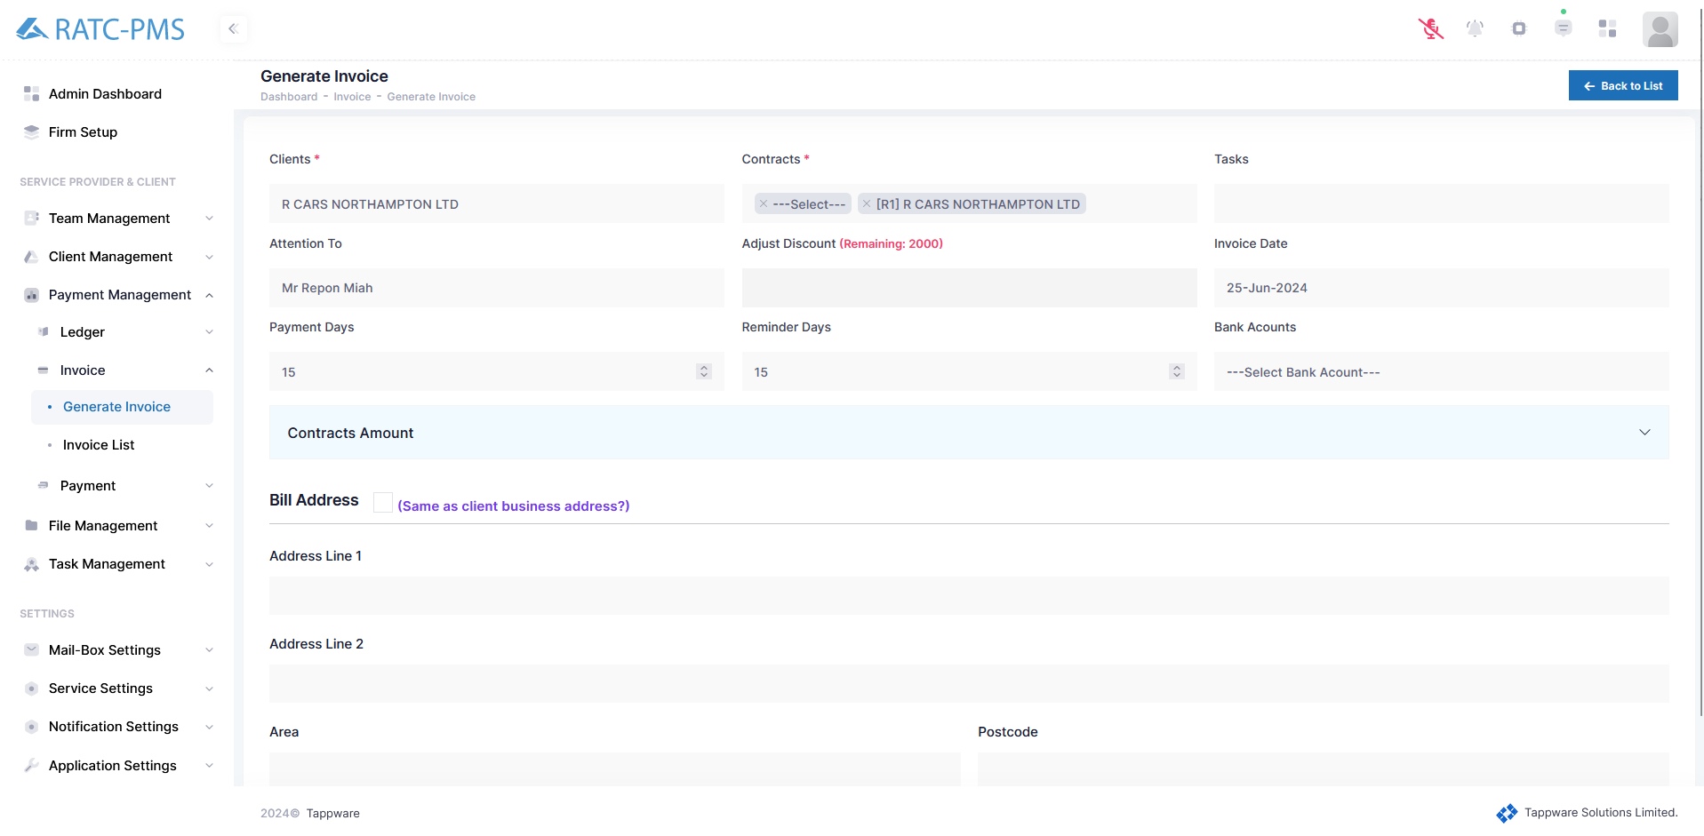

Fig: Generate Invoice

### 6.2.2 Invoice List

All generated invoices will be shown on this page for the user to view. In the upper right corner, there are three buttons. The filter options will make it easier for users to discover the correct invoice. Direct debit takes users to the 'Direct Debit' page. Make payment will send users to the 'Make payment' page. In the action column, the view button will open the invoice for the user.

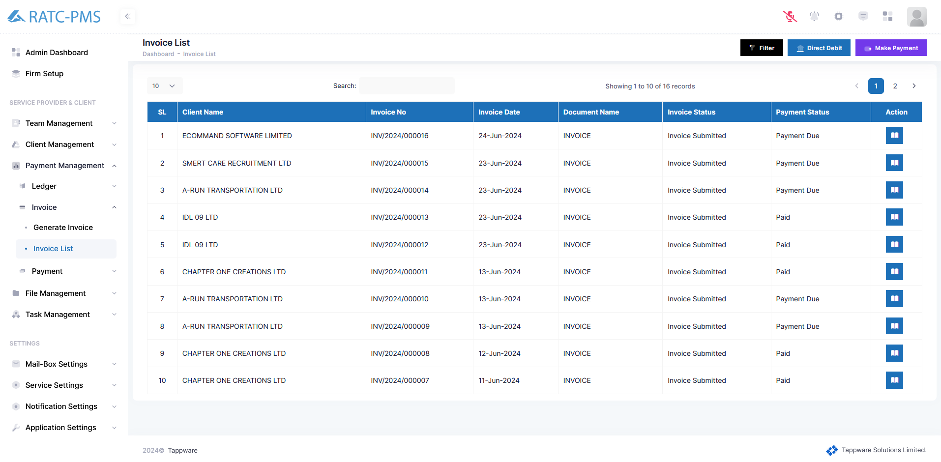

Fig: Invoice List

Invoice:

After clicking the view button, the invoice will open.

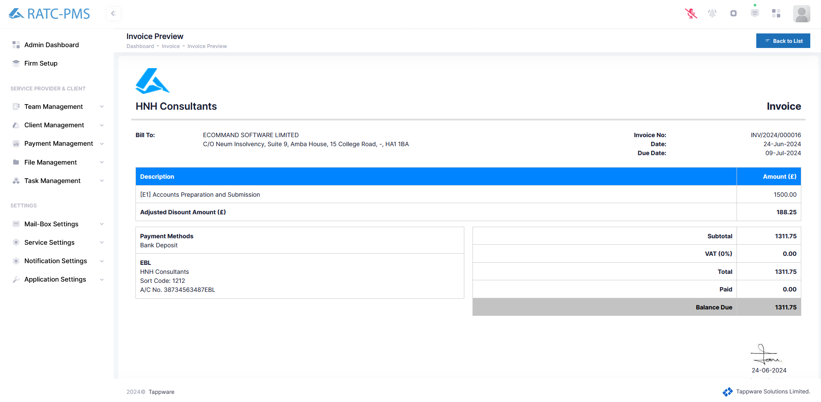

Fig: Invoice View

## 6.3 Payment

### 6.3.1 Direct Debit Verification

After producing the invoice, the client will view the invoice in the invoice list. After that, he may make a payment via 'Direct debit'. Clients must choose an invoice from the first column. Following that, the customer must click the '**Mark as direct debit**' button located in the upper right corner. After clicking the button, the invoice will be sent to the Manager for approval.

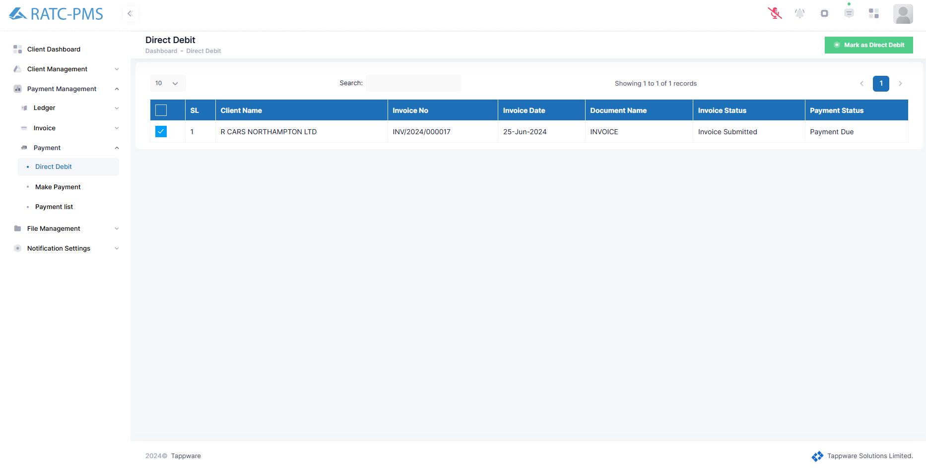

Fig: Direct Debit Verification

### 6.3.2 Make Payment

Clients can pay with cash, a cheque, or a bank transfer. Clients can utilize numerous transactions to make a single payment. If the client does not complete a full payment, the '+ New Payment Option' button will show in the bottom left corner. When the customer makes a complete payment, this button is deactivated, and the client selects the 'Save as draft' option.

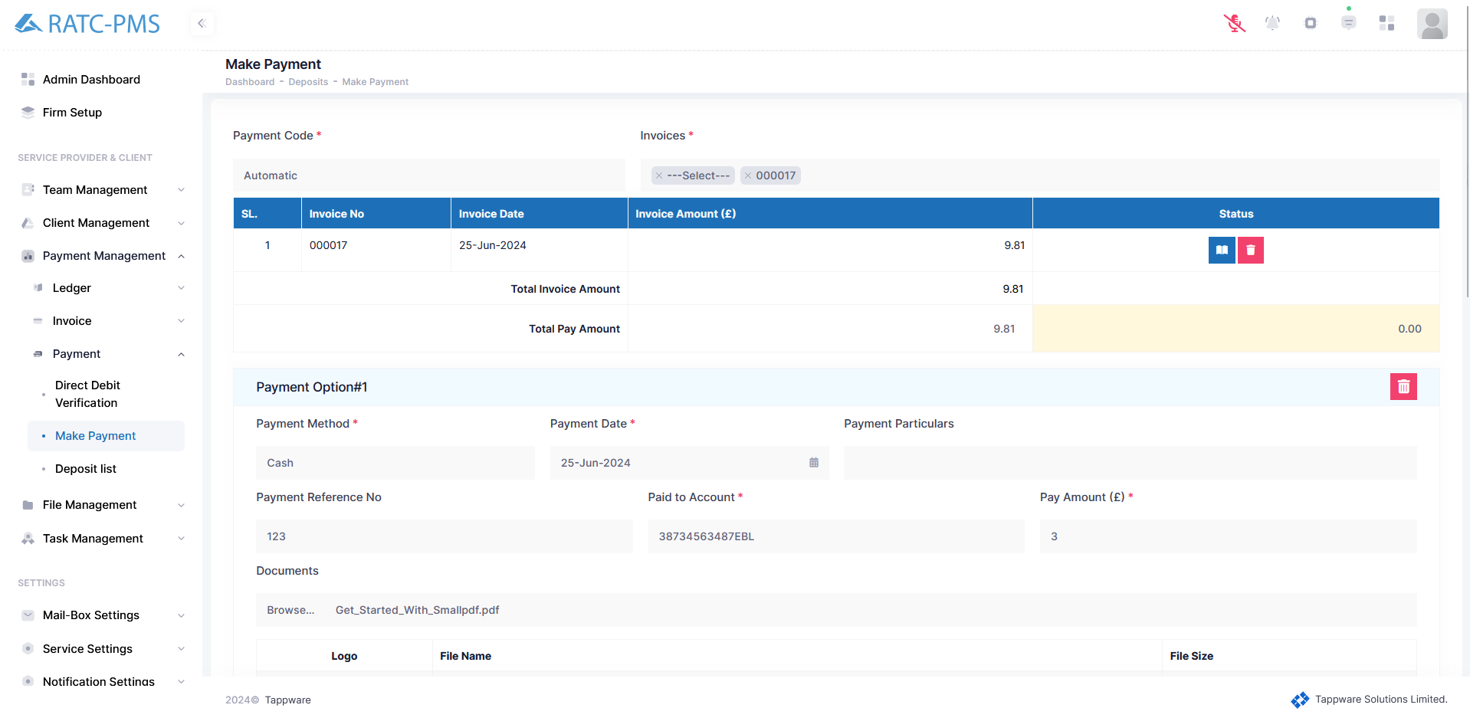

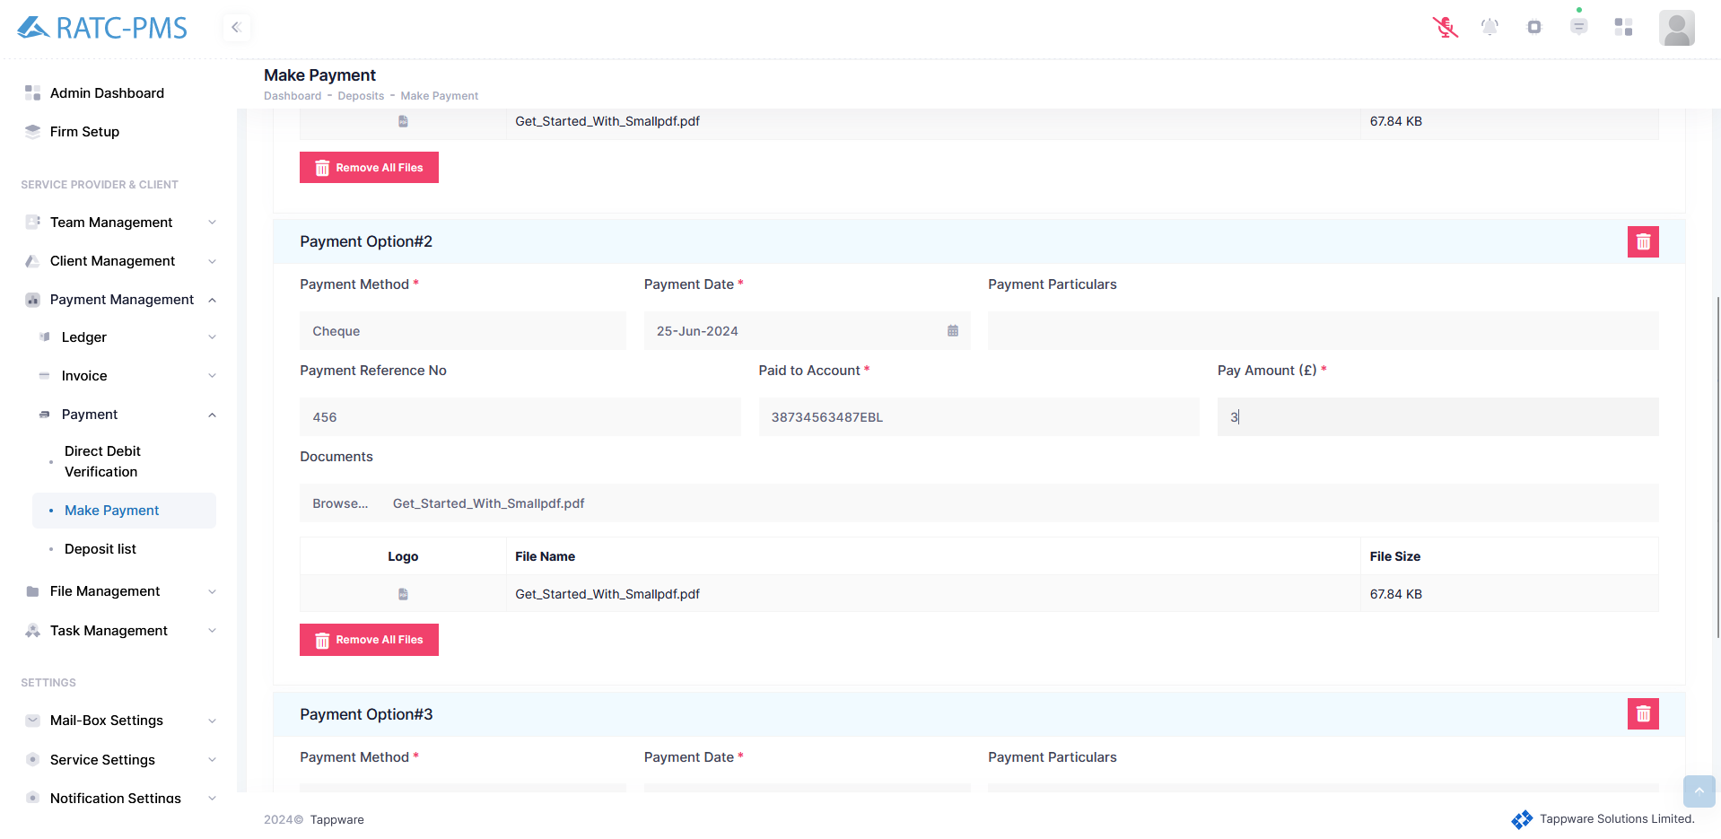

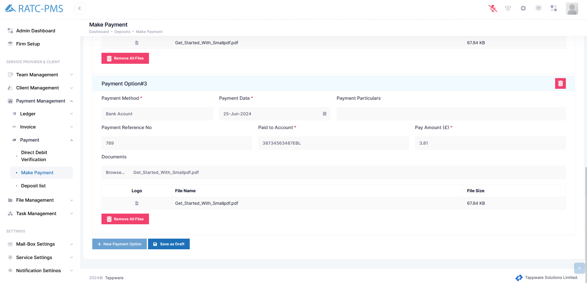

Fig: Make Payment

### 6.3.3 Deposit List

Users can see all the Deposit from this page with information. Users can view the deposit from the action column anytime using the view button. Users can delete the deposit list if it is in draft status. Accept and Reject can be done by the manager.

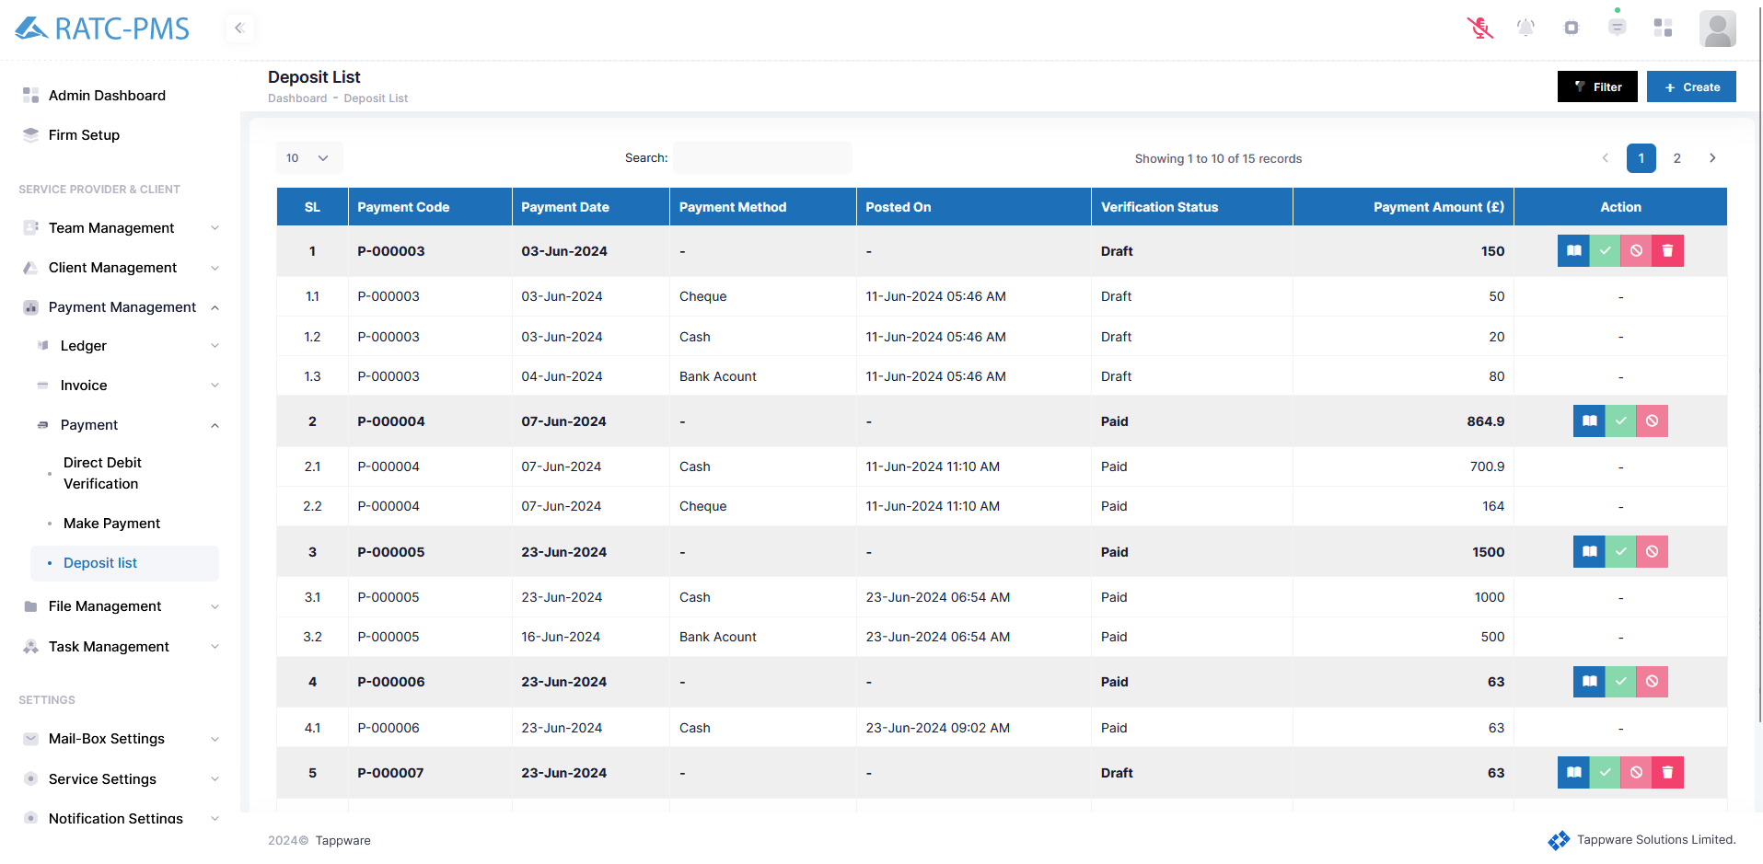

Fig: Deposit List

# 

# File Management

## 7.1 View Documents

In the upper right corner, there are five options: Client, Service, Year, Document, and Document Group. Users can select and click on the one they want to view. After selecting one, the User will click the dropdown option in the middle portion, which displays all of the file folders. After pressing the dropdown button, all of the files in that folder will be displayed, and the action column has the view button, which allows you to examine the document.

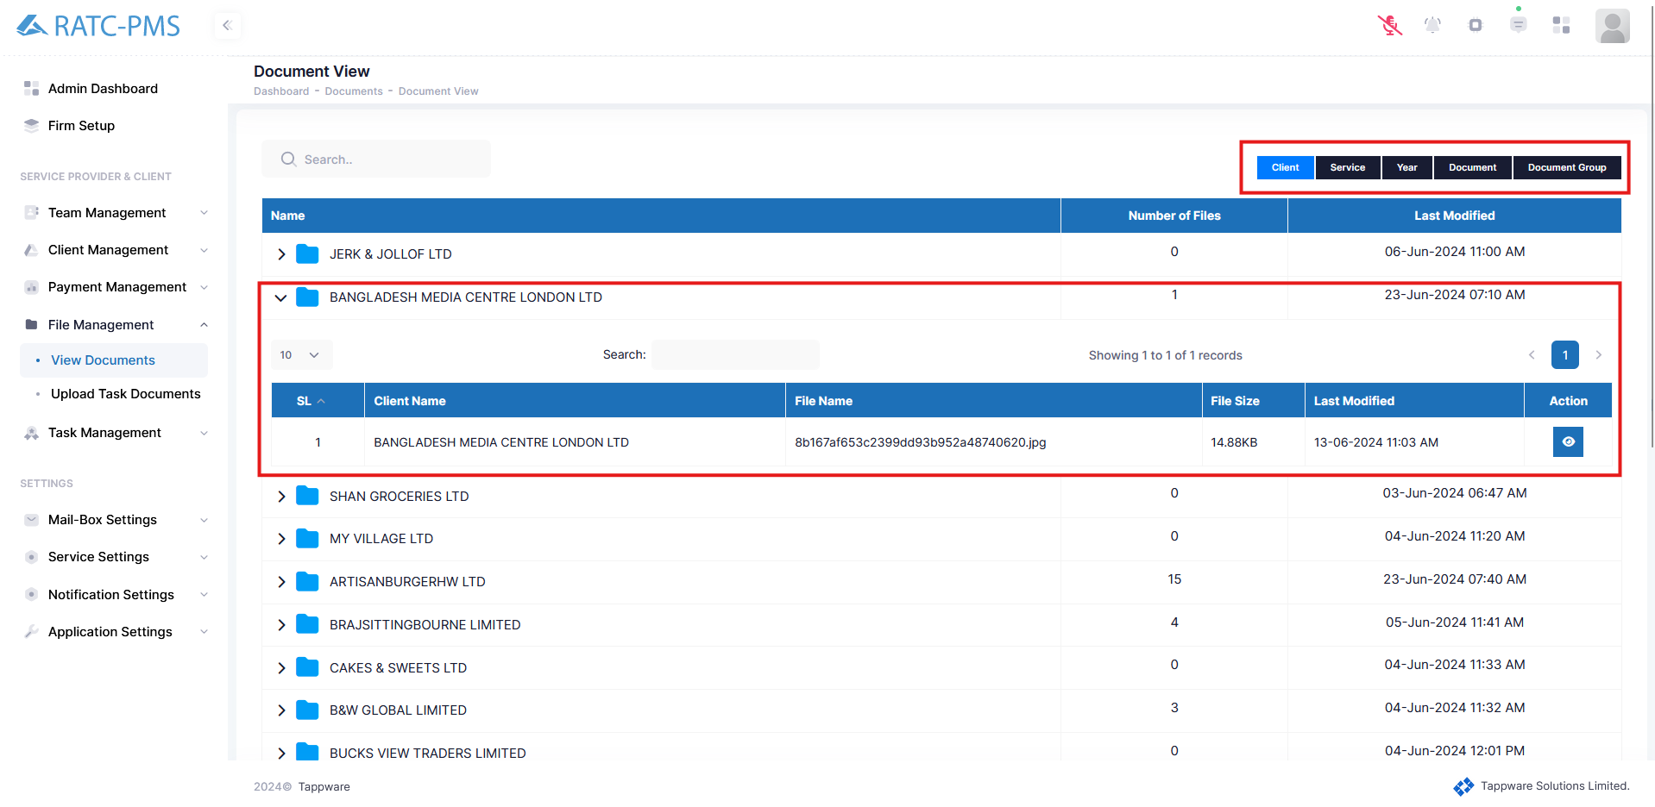

Fig: View Document

## 7.2 Upload Task Documents

Users may simply upload task papers from here. Users must pick Client, Contract, and Task, which are required fields. If the requested job falls under any of the subtasks, the Users will select the subtask. 'Service group name' displays all available service alternatives. After selecting, the file management section will open. From the area below, the Users will select the service dropdown button, which will display the document listings. Users can review or reject the paper from here. The Users can also see and delete the document. Users can also upload files as they see fit.

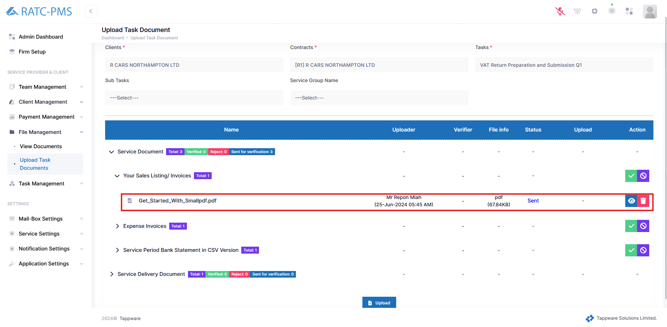

Fig: Upload Task Documents

# Task Management

## 8.1 Task

This page displays all of the tasks. In the upper right corner, there are two buttons: Create and Filter. The Create button will send the user to the task creation page, where they may create a new task. The Filter button is used to filter out tasks for the user's convenience. The notes button will show associated notes with that task. The (+) button in the task column opens a sidebar where you may make a task note for that job. The (+) button in the progress column allows users to track the whole task's progress. The action column contains multiple buttons, including Time Log, Edit, Delete, Create Invoice, Completed, and a Status dropdown button.

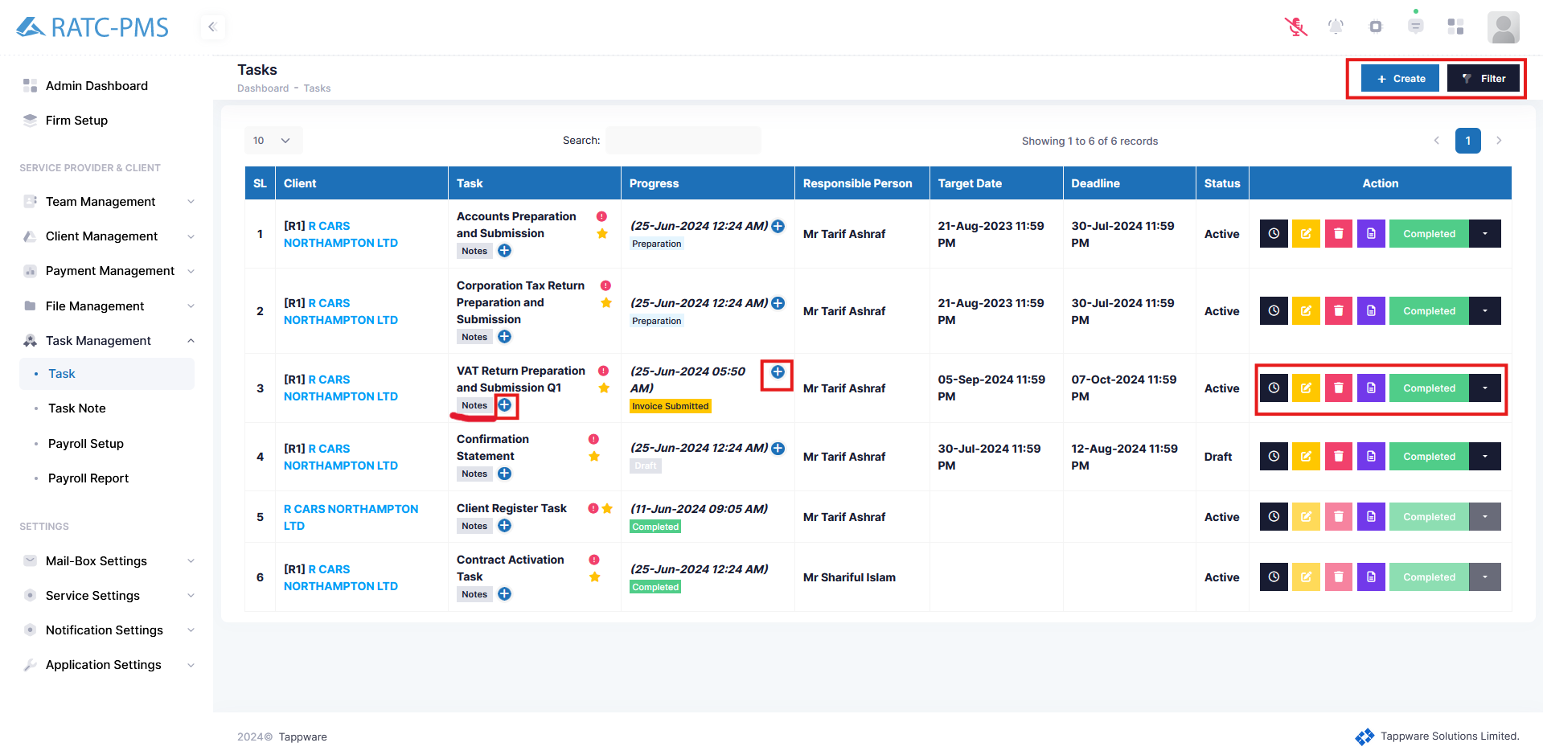

Fig: Task Overview

### 8.1.1 Create

After hitting the Create button, the user will be sent to the task creation page. Here, the user will provide the task name, priority, and description. User has to select a client and select the task which will be followed by that client. The user should give the activation date, target date, scheduled duration, and submission date. Users can select whether to alert the manager, colleague, or client. Users can additionally specify who will be responsible for this task. Users can pick between themselves and others. If the user selects others, a dropdown button will display to pick the responsible person. After selecting, users will submit in the top right corner or users can reset the whole process.

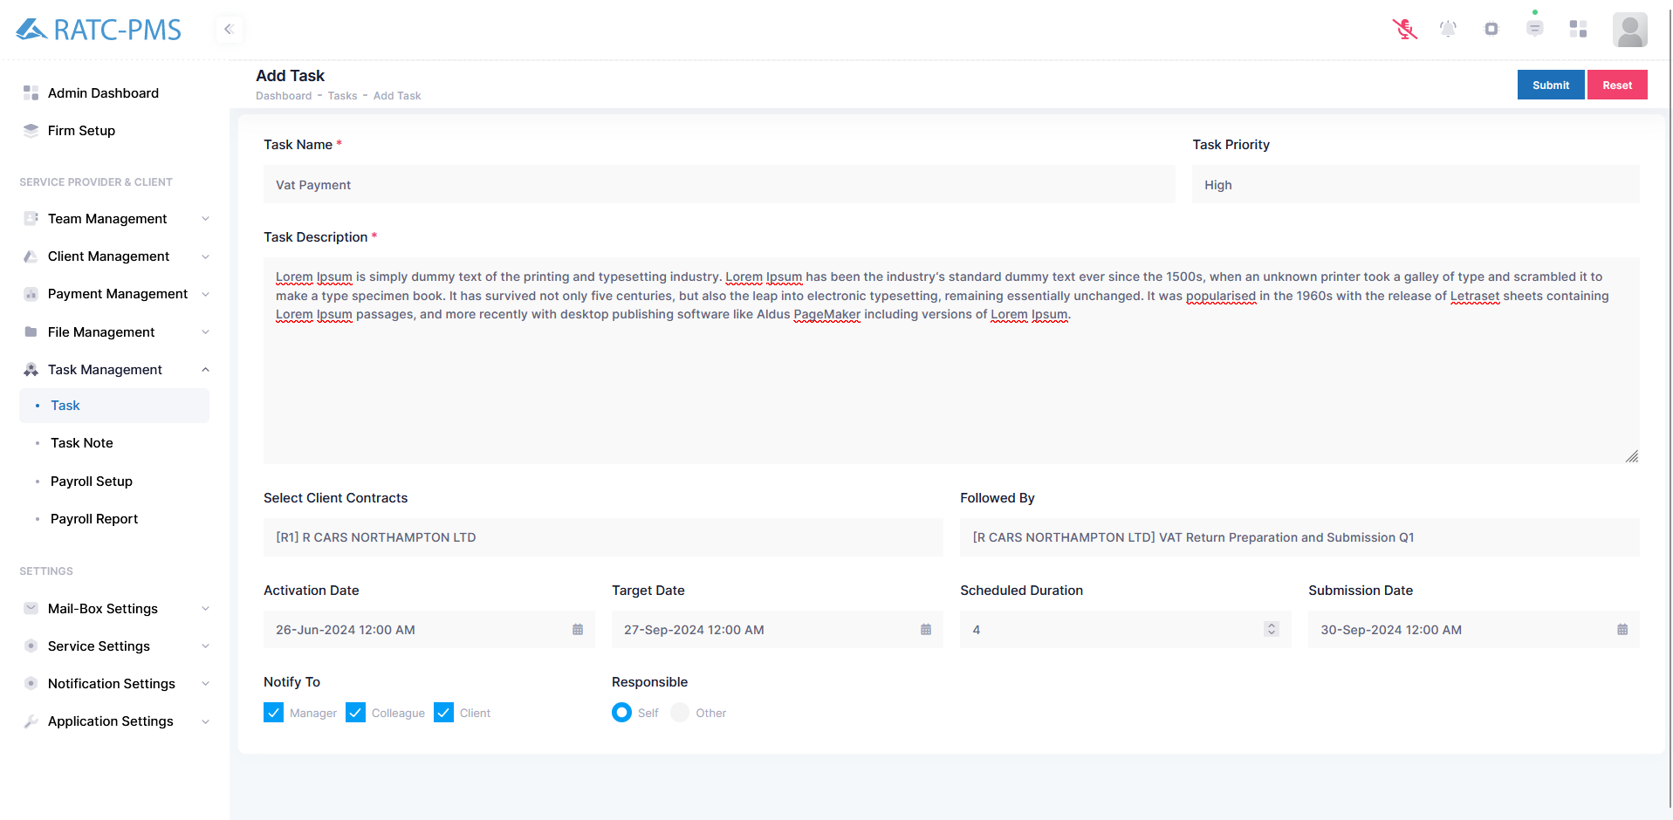

Fig: Create Task

### 

### 8.1.2 Filter

Filter options will help the user find his desired task quickly. There are several selection options in the filter tab. The Client button will help select the client. The Contracts button will help users to find the contract for the selected client. In the service button, the user will find all the services and the user can choose one desired service type and filter accordingly. In the progress button, the user will find all the progress stages and the user can choose one desired progress stage and filter accordingly. Users can also filter tasks using the responsible person name in the responsible text box. Target range will give users the option to choose two dates and the system will show only the tasks which fall between those two dates. At last, users can submit, reset or cancel the process.

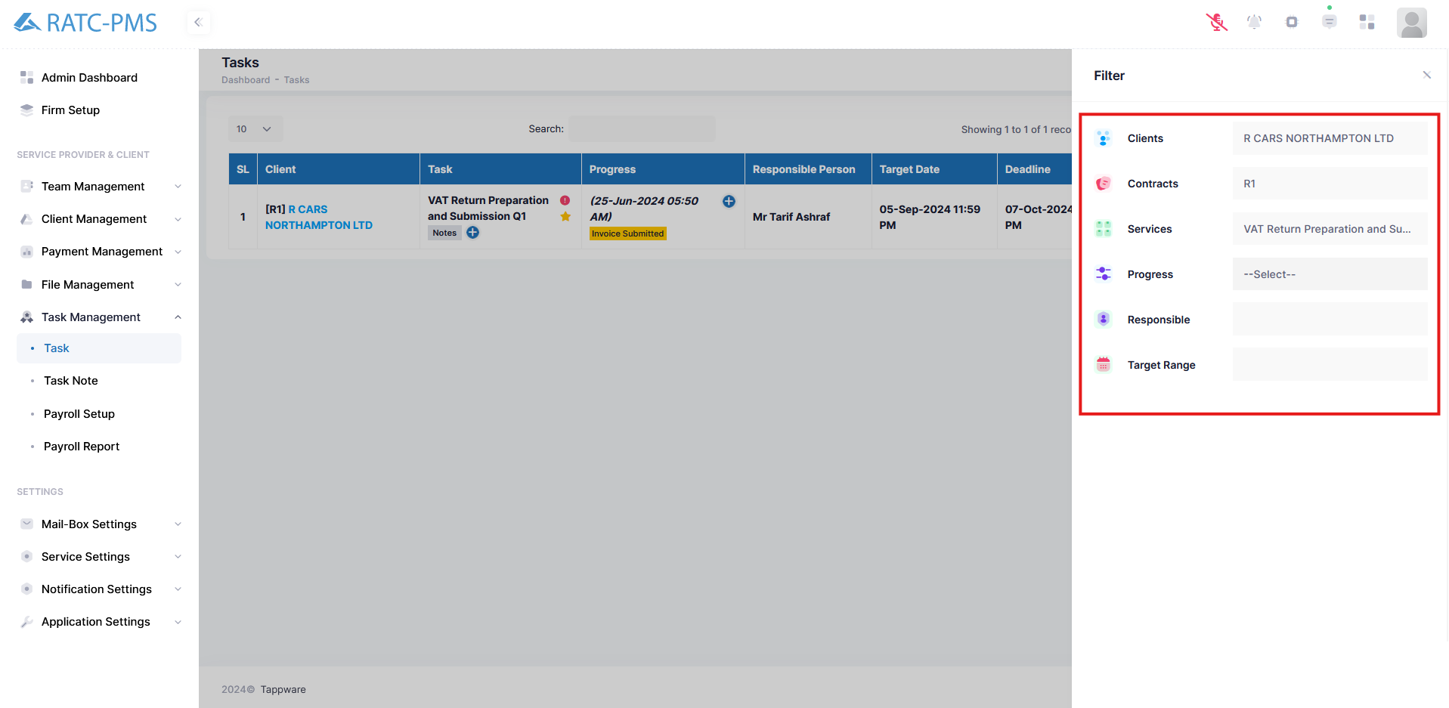

Fig: Filter Task

### 8.1.3 Notes Button

The notes button will display a sidebar. If there is a note, it will appear on the sidebar. Otherwise, it will display "**No notes available**" The note will have an edit and delete button.

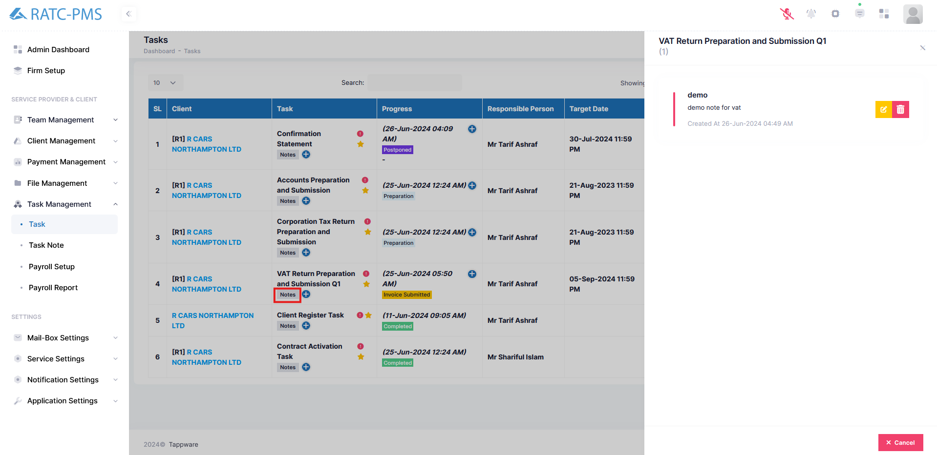

Fig: Notes Button

### 8.1.4 Add Task Note Button

This button will open a sidebar where Select Client Service Task will be auto selected. Users can also select Select Client Service Sub Task if there is any. Users can give title, set priority and write note. Atlast, users can save the note or cancel the process.

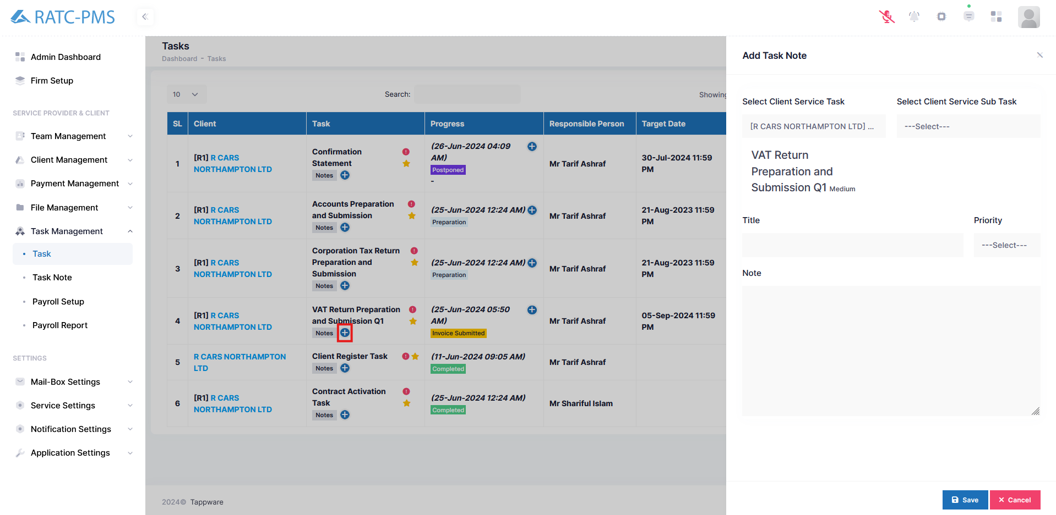

Fig: Add Task Button

### 8.1.5 Progress (+) button

#### 8.1.5.1 Draft

This button will provide progress information, from which the user can adjust progress in a step-by-step manner. Initially the progress will be in the draft stage.

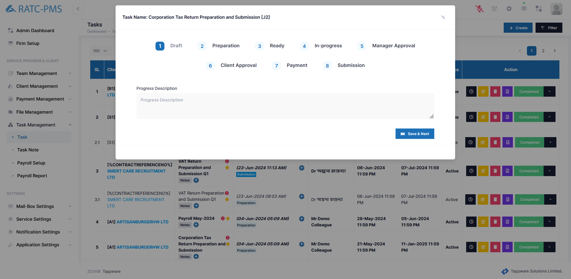

Fig: Draft Stage

#### 8.1.5.2 Preparation

In the preparation stage, client and colleague will communicate with each other. Clients will receive a query mail at this stage. In this stage the client will upload the necessary Service Documents. After uploading the documents the user will click save & next button which will take the user to Ready stage.

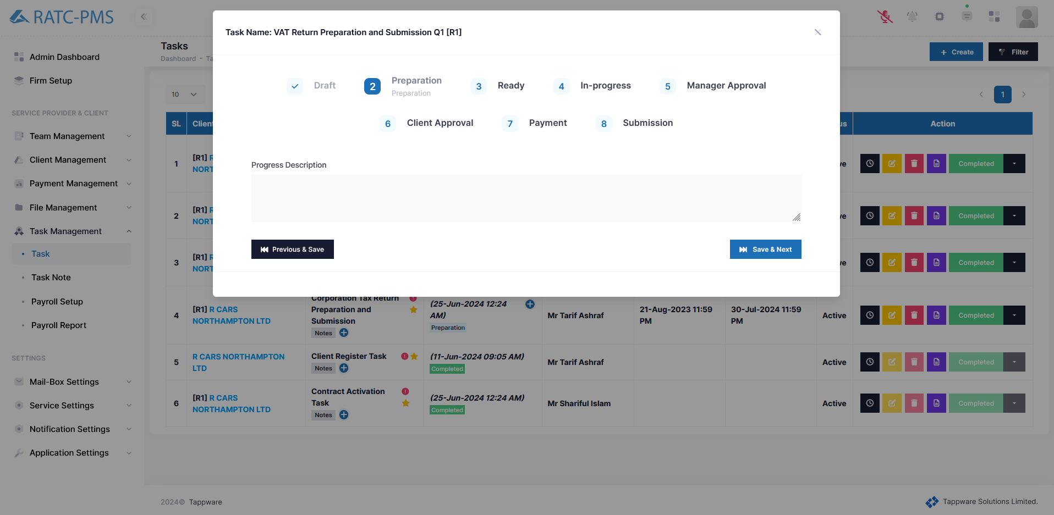

Fig: Preparation Stage

#### 8.1.5.3 Ready

In this stage, all the documents are ready to progress. Users should click save & next to continue.

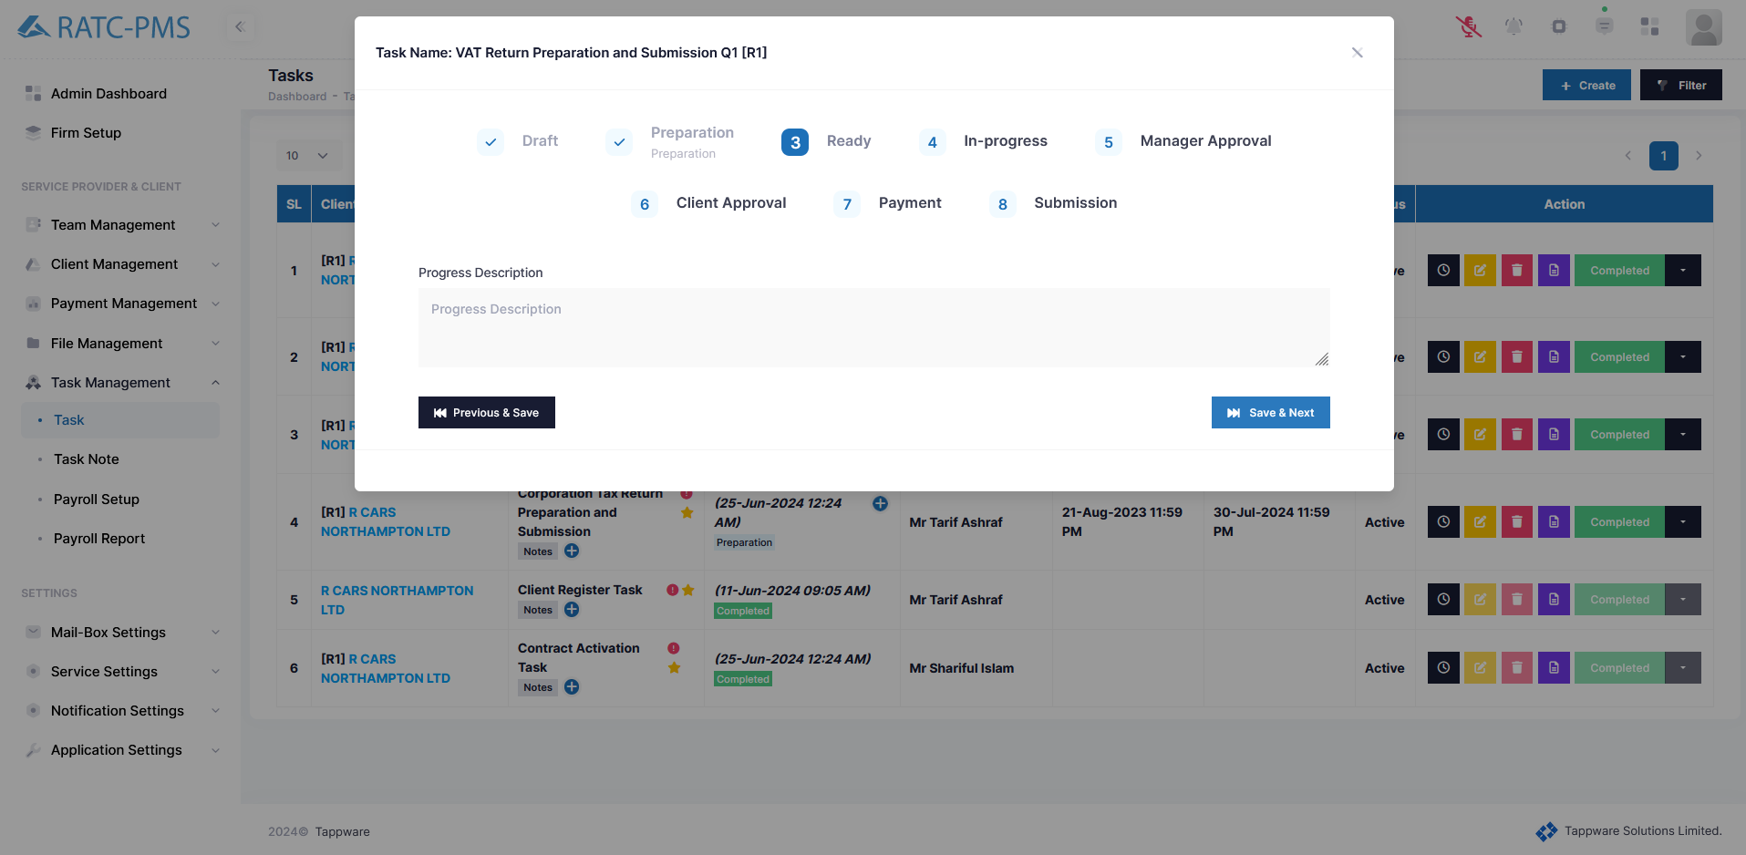

Fig: Ready Stage

#### 

#### 8.1.5.4 In-Progress

In this stage a colleague or manager will upload the necessary Service Delivery Documents. If a colleague uploads the documents, after uploading the document, the colleague will get an approval button. Colleague will click the approval button and it will be sent to the manager for approval (All this happens in the upload document page). Manager will approve the document. The progress will then automatically go to the manager approval stage from the in-progress stage.

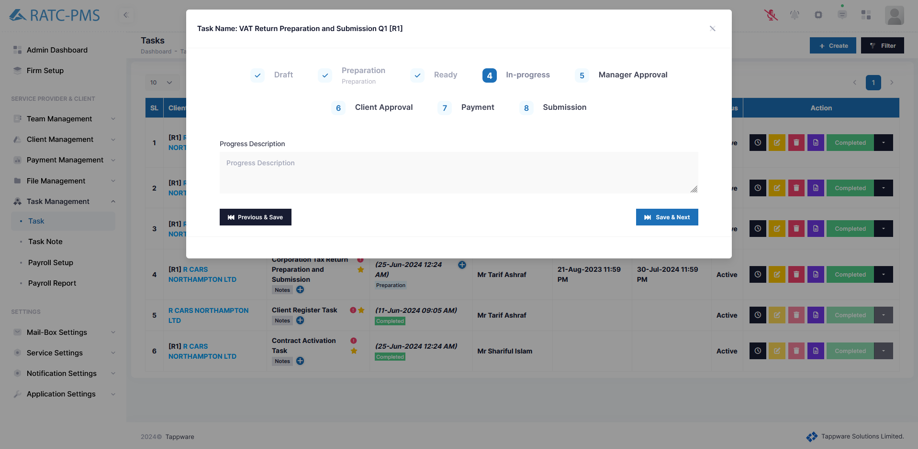

Fig: In-Progress Stage

#### 

#### 8.1.5.5 Manager Approval

When the manager approves the document, the document is automatically sent to the client for verification. After the client approves the document the status will be changed to client approval from manager approval.

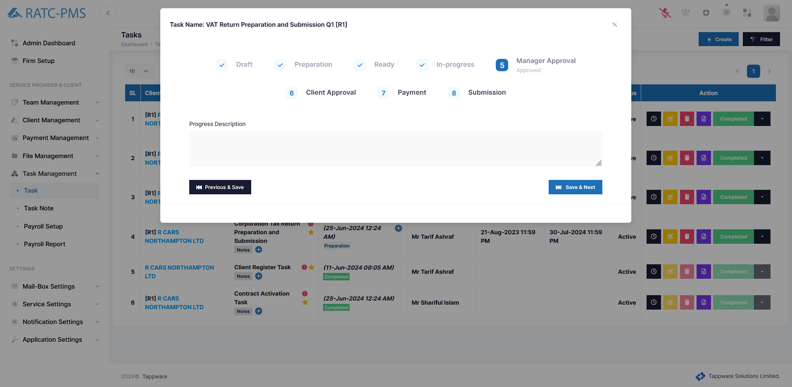

Fig: Manager Approval Stage

#### 8.1.5.6 Client Approval

When the client approves the documents the progress status will be Client Approval. Then the colleague will click save & next to proceed to payment.

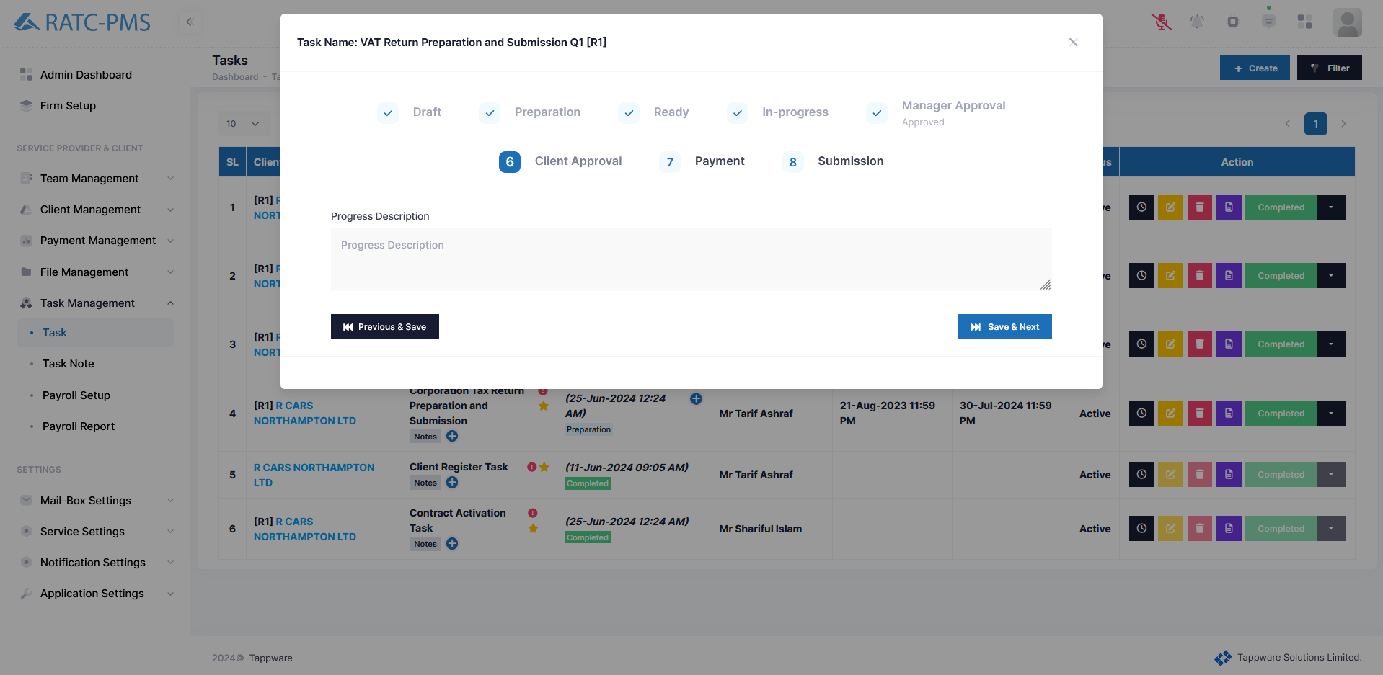

Fig: Client Approval Stage

#### 8.1.5.7 Payment

In the payment stage initially the status will be ‘Ready to Invoice’. Colleague will then generate an invoice and send it to the client. Client will make payment according to the invoice and send it to the manager for approval. After manager approval the status will be ‘Paid’.

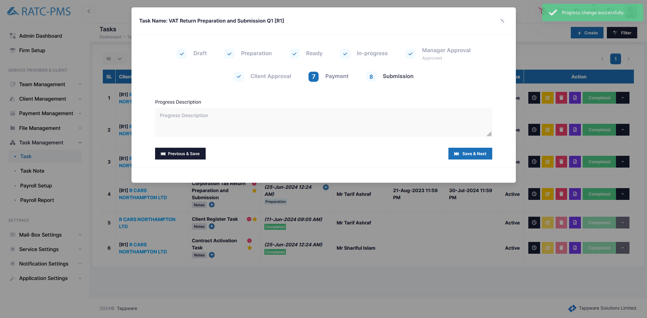

Fig: Payment Stage

#### 8.1.5.8 Submission

Submission stage refers to submission into HMRC submission. This will happen manually and after that colleague will click save and next. The progress status will be ‘submission’. After that colleague will click completed from the action column to end the task.

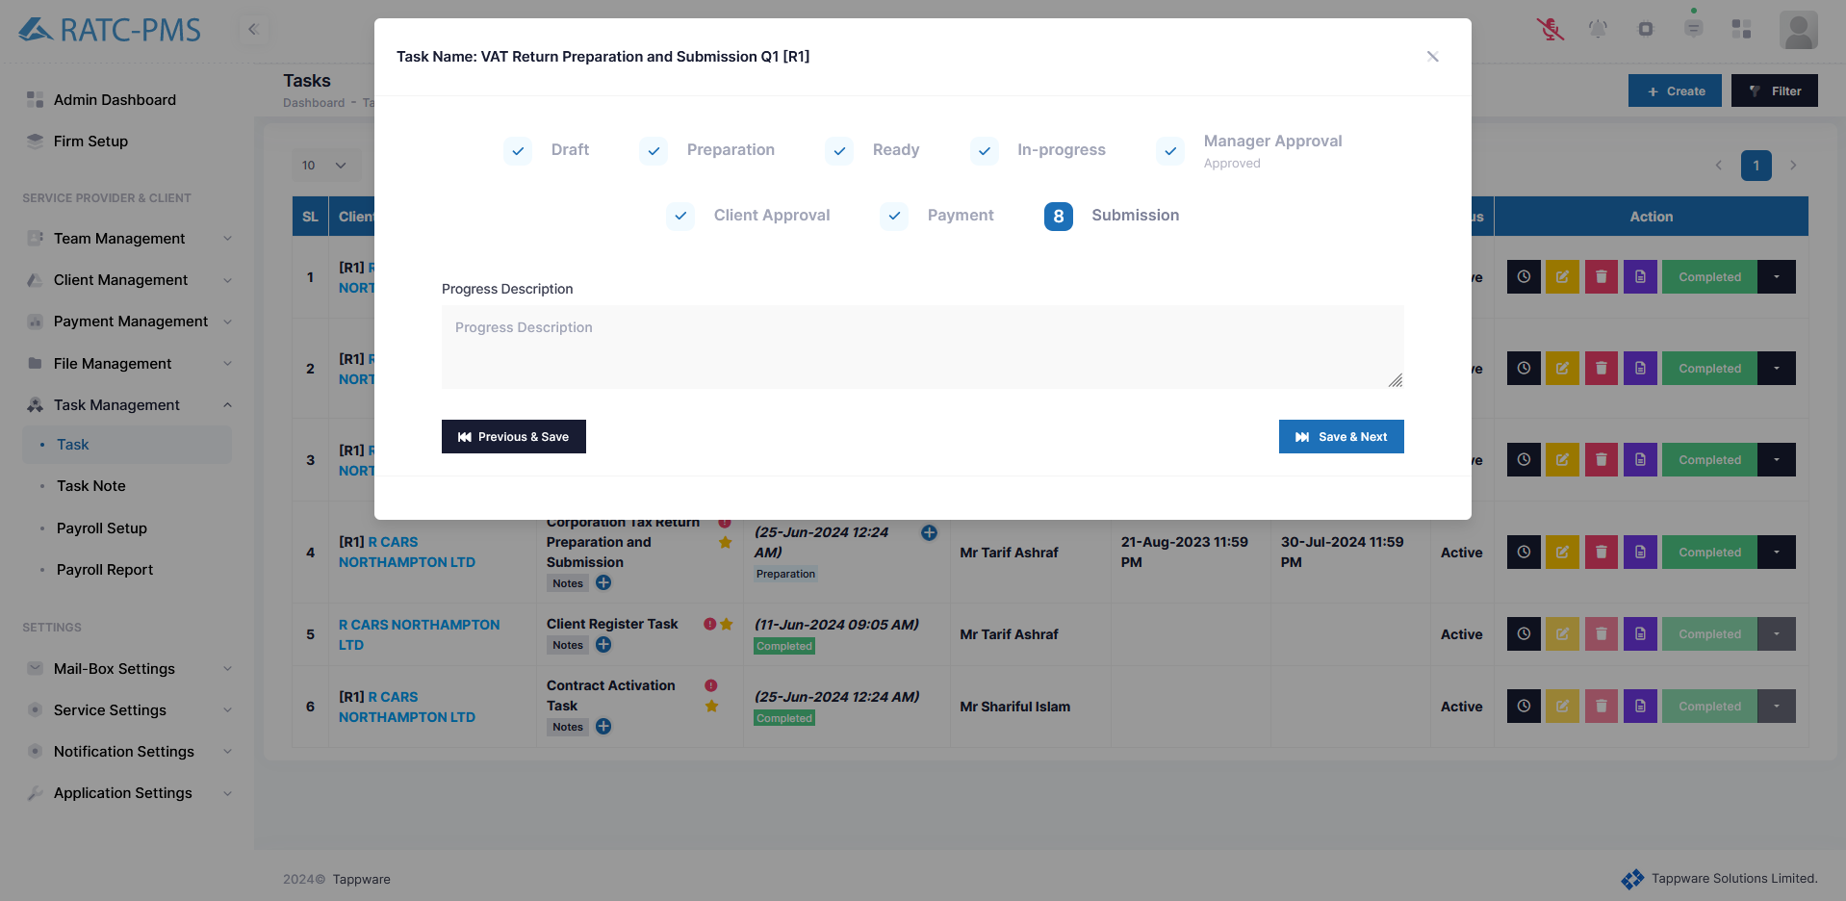

Fig: Submission Stage

### 8.1.6 Action Column Buttons

The Time Log displays any progress statuses with dates and times. The Edit button opens the Edit Task menu. Users can edit the task on this tab. Using the Delete button will result in the task being deleted. The Generate Invoice button will lead the user to the Generate Invoice page, where they may create an invoice. The completed button ensures that the task has been completed. The Status dropdown button provides three options: completed, canceled, and postponed. Completed signifies the assignment is finished, canceled means it has been canceled, and postponed means it has been postponed.

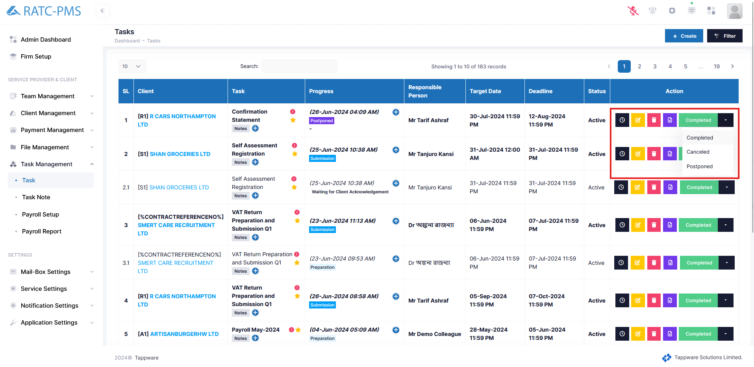

Fig: Action Buttons

## 8.2 Task Note

Task note shows all the task notes with information created by the user. Users can also edit or delete the note using the buttons in the action column.

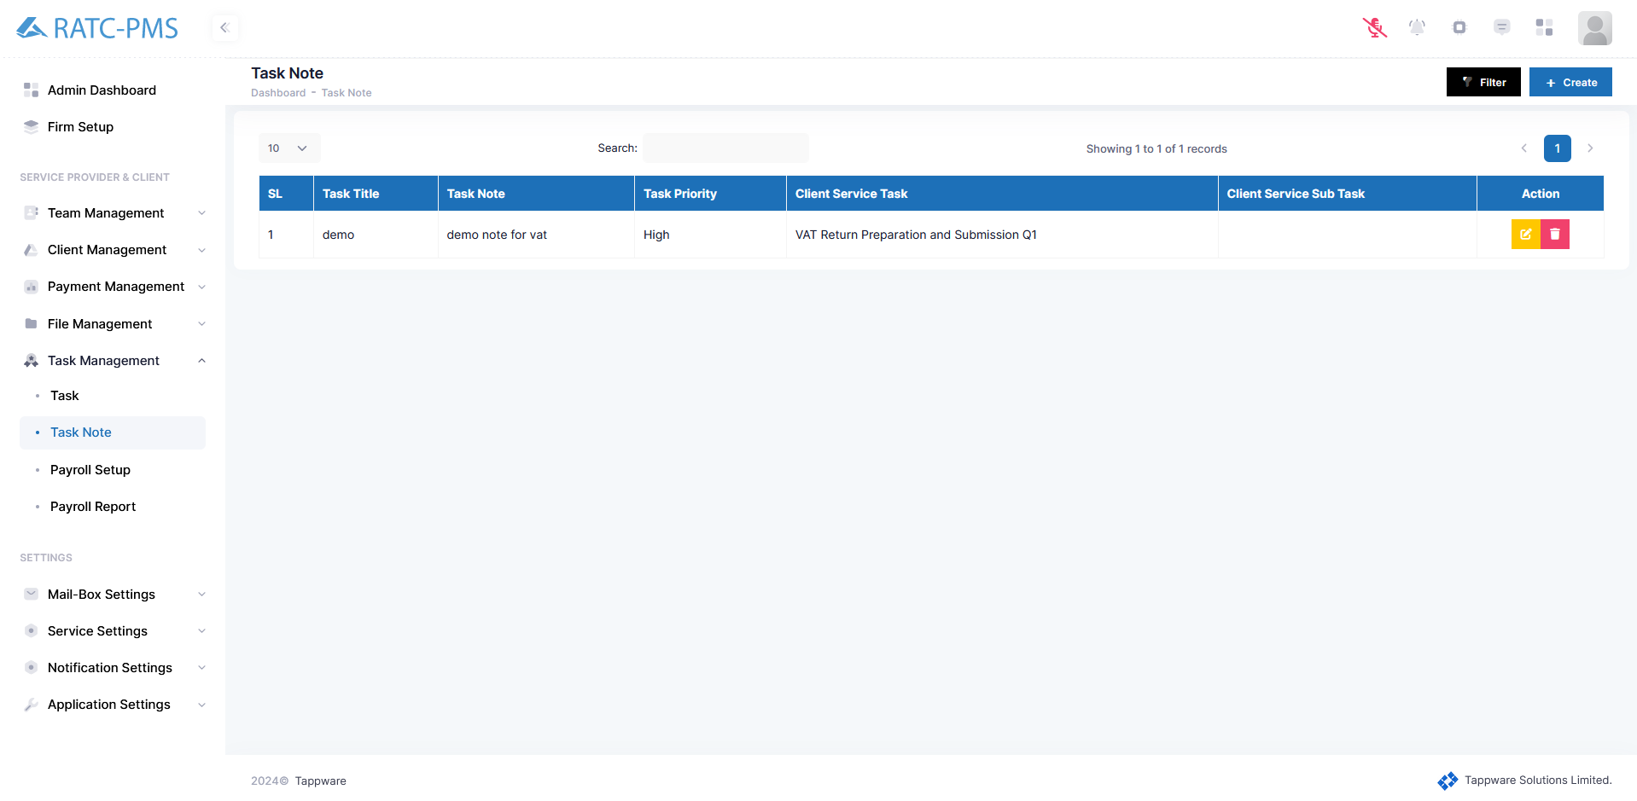

Fig: Task Note

## 8.3 Payroll Setup

Users can select clients, select contracts, select tasks and update the payroll options after the payroll works are done.

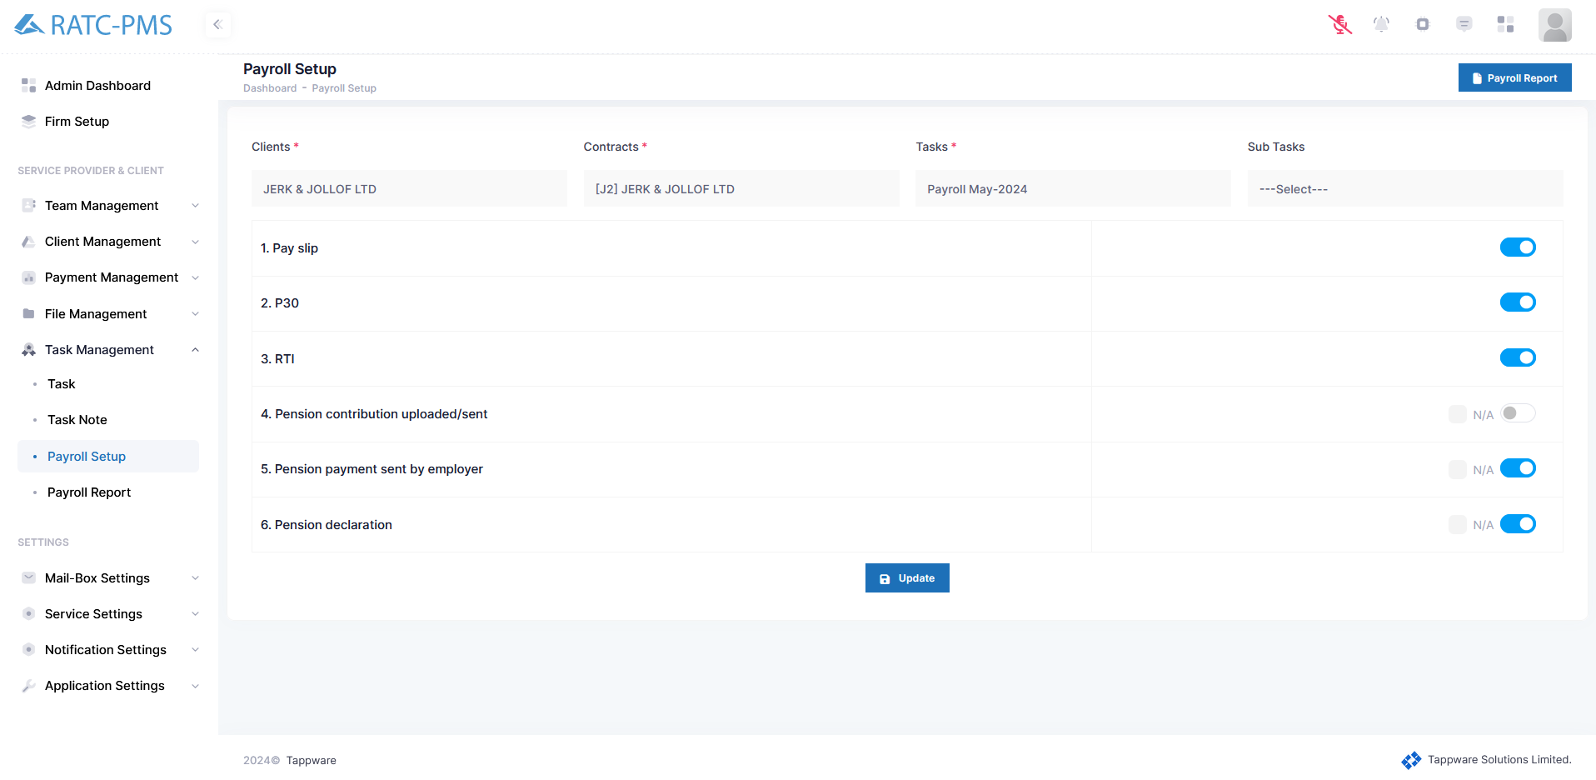

Fig: Payroll Setup

## 8.4 Payroll Reports

Users can keep track of all the payroll statuses from here. Users can also use filter options from the top right corner to find the desired report.

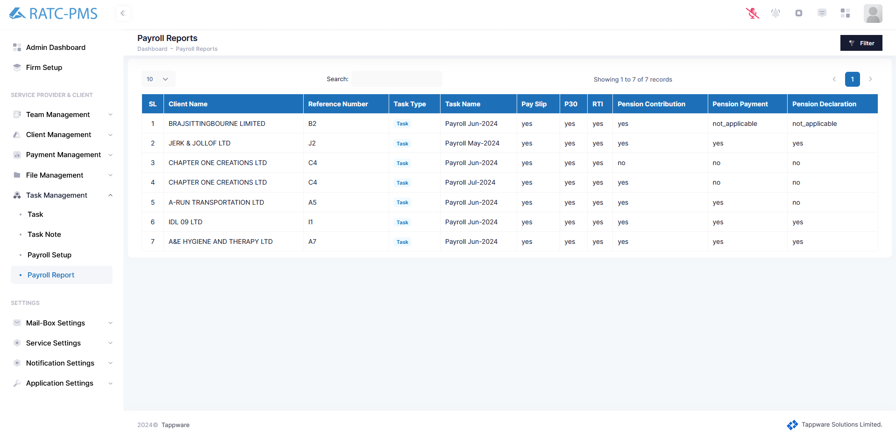

Fig: Payroll Reports

# Mail-Box Settings

## 9.1 Overview

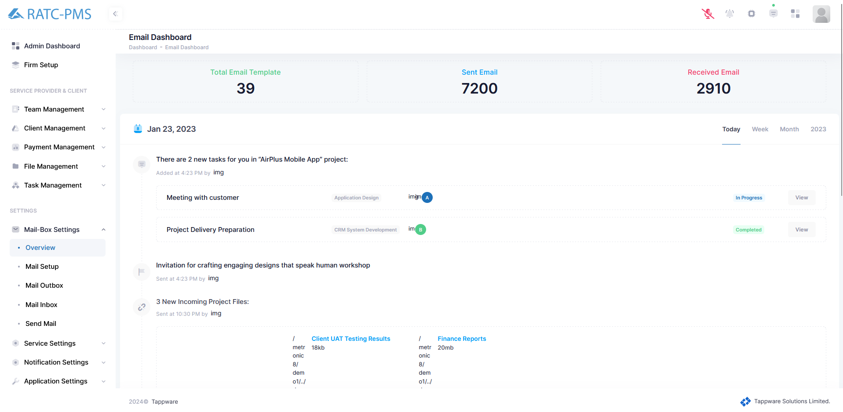

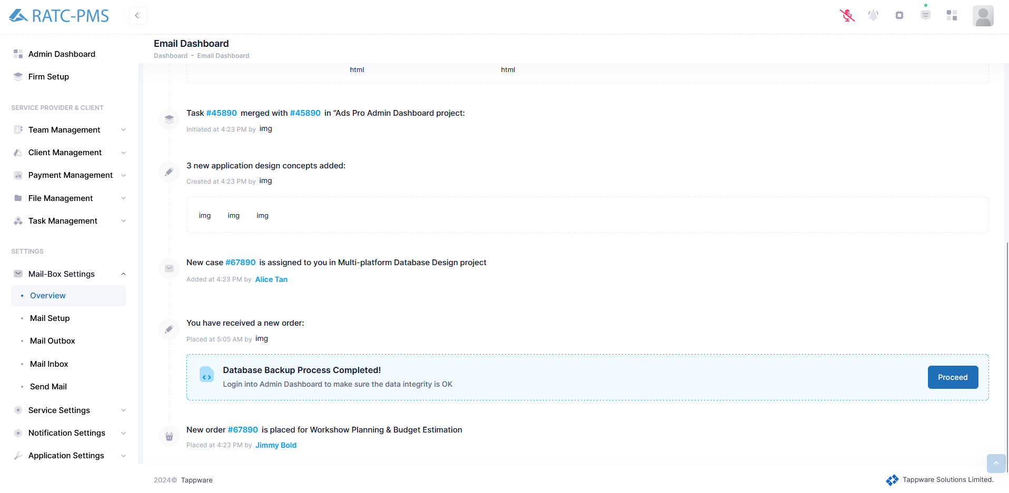

## 9.2 Mail Setup

This page displays all of the email templates. In the upper right corner, there is a create button that allows the user to create a message template. A checkbox in the status indicates whether the status is active or inactive. The action column has three buttons. The first option is the view button, which allows the user to view the template. Users can update the template by clicking the edit button. Users can also erase the template by clicking the delete button.

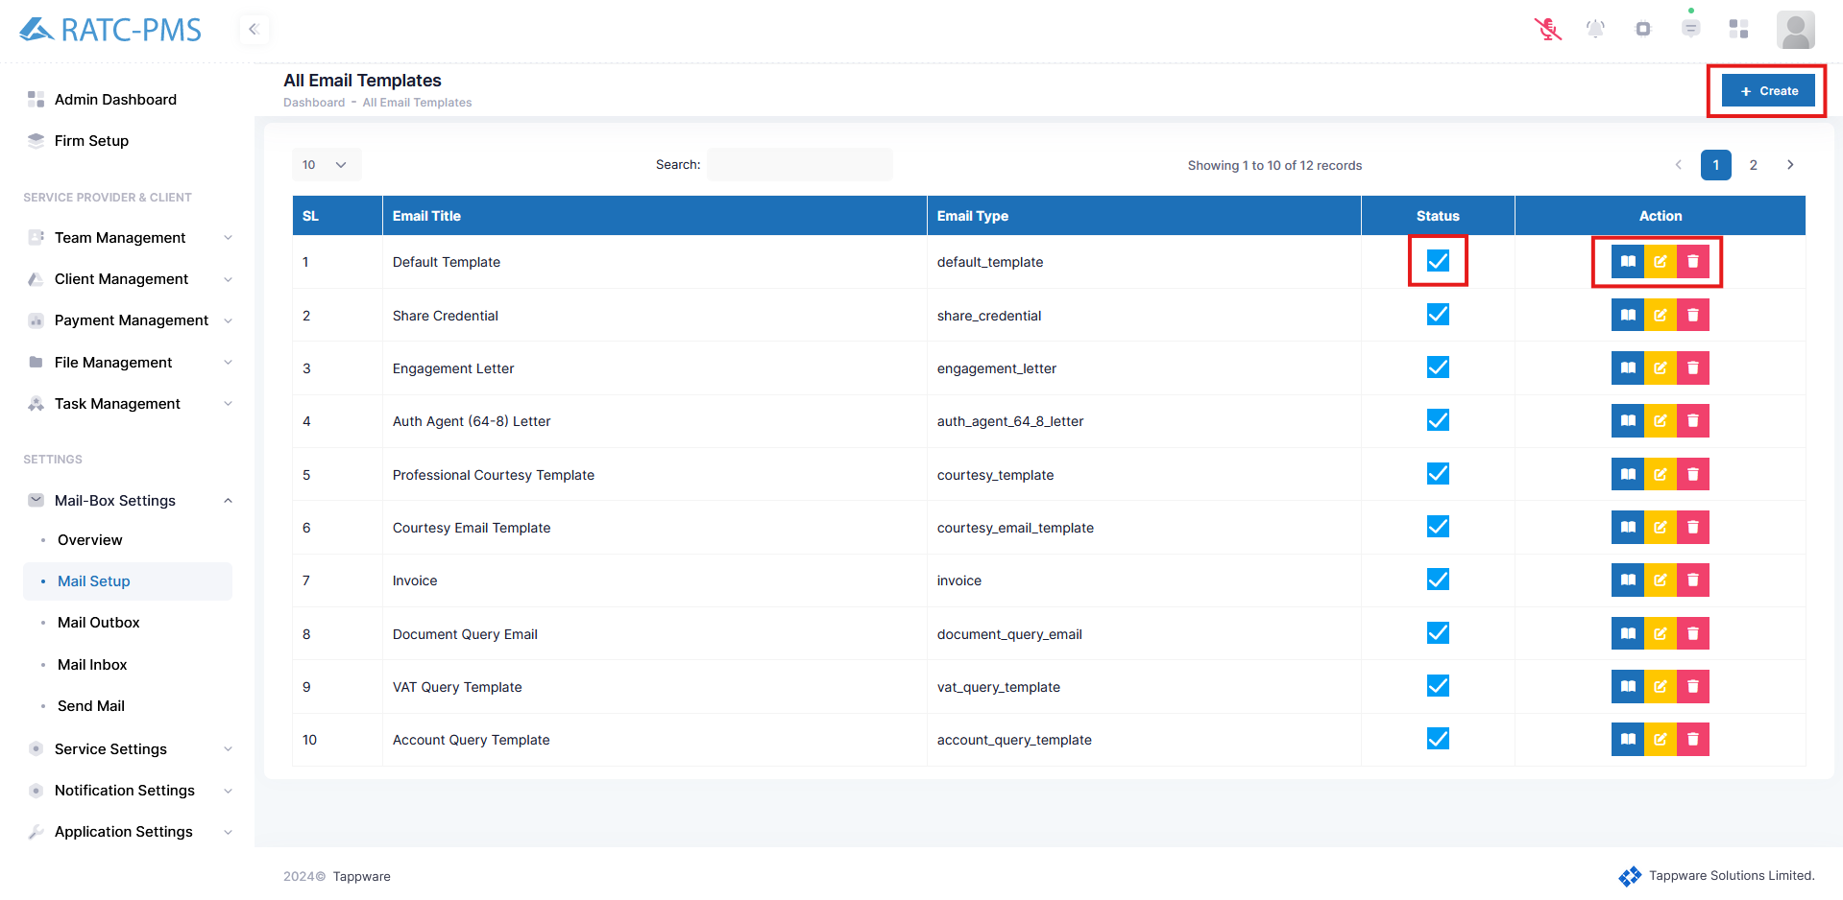

Fig: Mail Setup

## 

## 9.3 Mail Outbox

Users may view all outgoing mail from the mail outbox. The user may view mail information from here. Who the letter is sent to, the mail title, the template name, the number of attachments, and the date it was sent. The resent and view buttons in the action column allow the user to resend the email and see it.

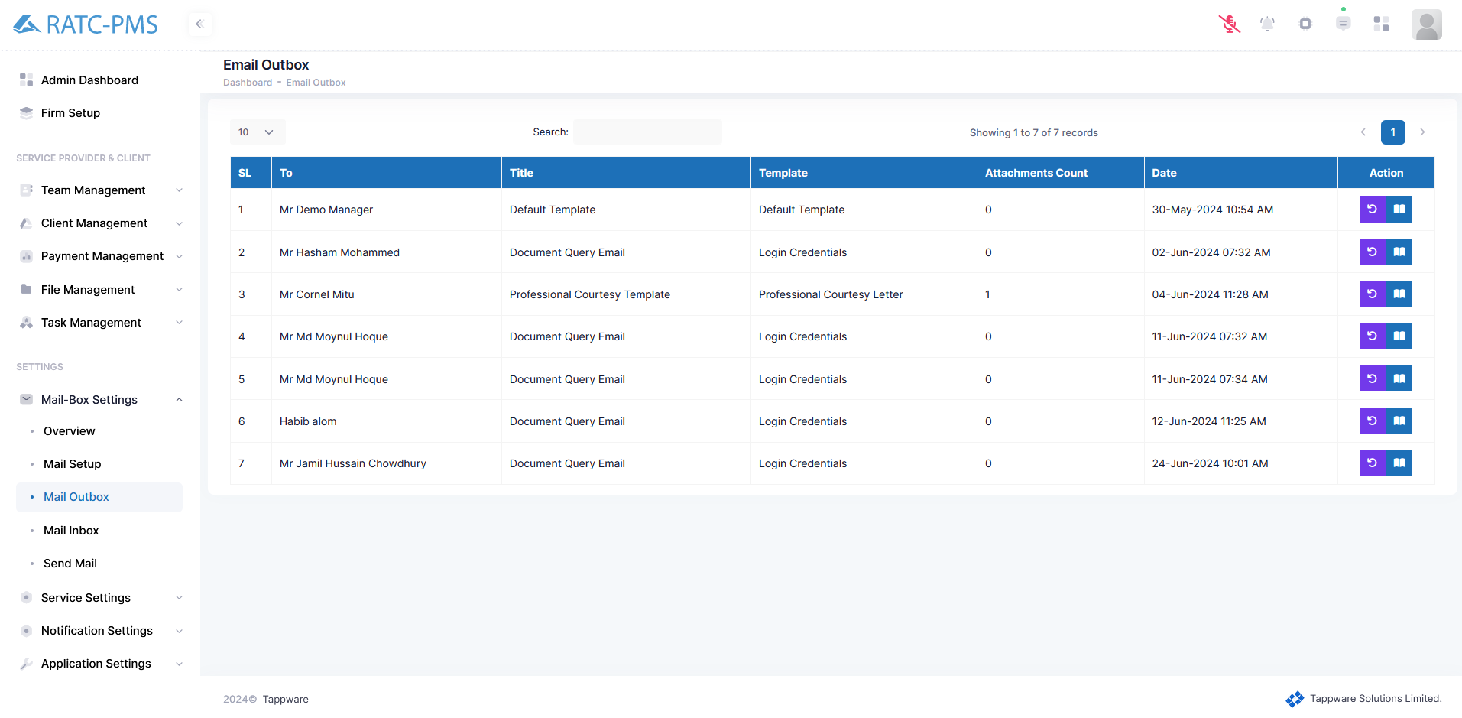

Fig: Mail Outbox

## 9.4 Mail Inbox

## 

## 9.5 Send Mail

The Send Email button will launch the Notify side window. Users can select how to alert the receiver. Users can pick between Push Notification, Send Email, and Send SMS. Following that, the user will pick the receiver. After that, the user will pick a template. After selecting the template, the subject box will appear, allowing the sender to enter the subject, and the entire template will be displayed below. User will then press the send button to send the mail. Users can also cancel the process.

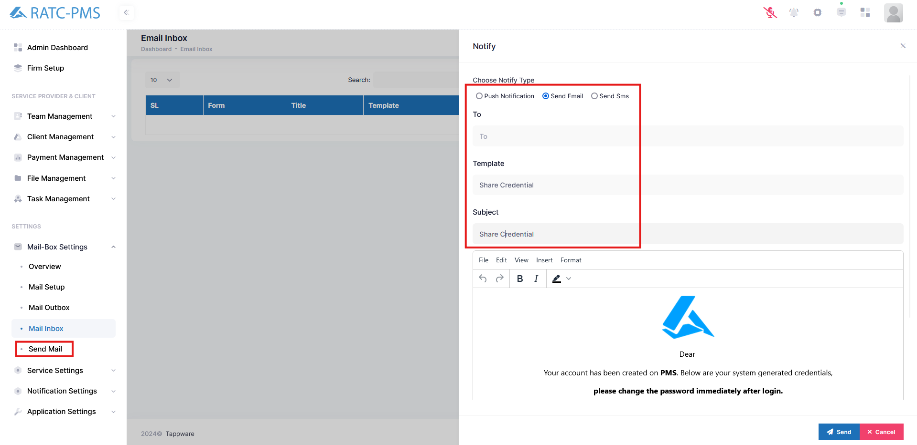

Fig: Send Mail

# Service Settings

## 10.1 Overview

In this page users can see an overview of the services. In the top there are four box buttons. First one shows us the service count and by clicking it will be navigated to the service list page. Second button shows how many mappings there are. Third button shows how many states are there in the services. Fourth button shows the document count and it navigates the user to the document list page. All Services button shows all the services.

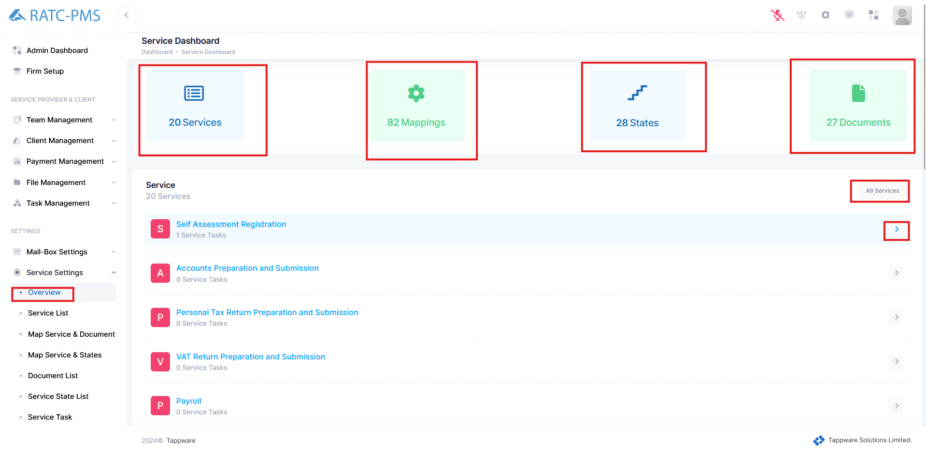

Fig: Overview

## 10.2 Service List

This page displays all of the services, including the name and description of the PMS. The top right corner has two buttons: Filter and Create. Users can utilize filters to find the service they are looking for. Create service enables users to build new services. In the action column, there are three buttons: view, edit, and delete. Users may see the service in further detail by clicking the view button. This includes the service configuration, map states, and map documents. The edit button enables users to change the service name and description. The Delete button will remove the service.

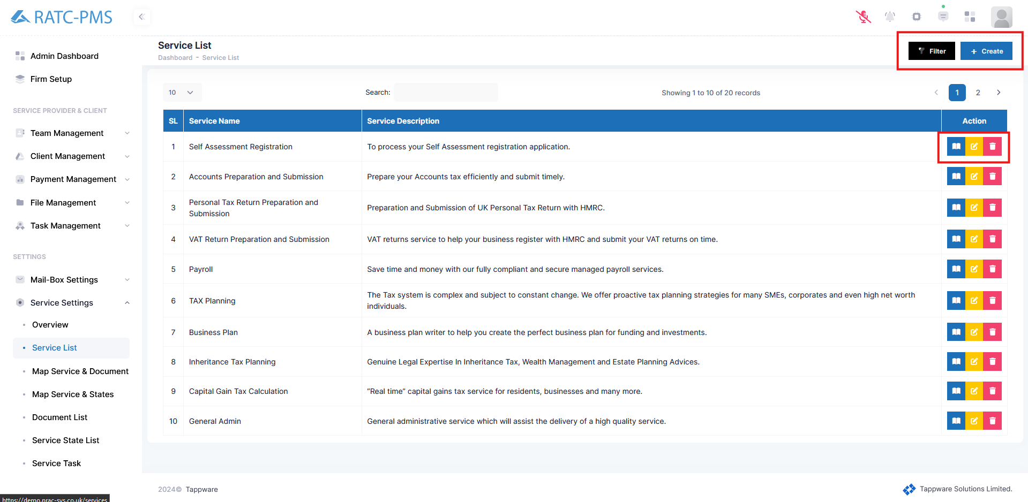

Fig: Service List

## 

## 10.3 Map Service & Document

This page displays the user what documents are required for a certain service. The user must pick a service using the select Service button. After selecting, the papers required for the task will appear. The 'Add Document' button allows users to add a document type.

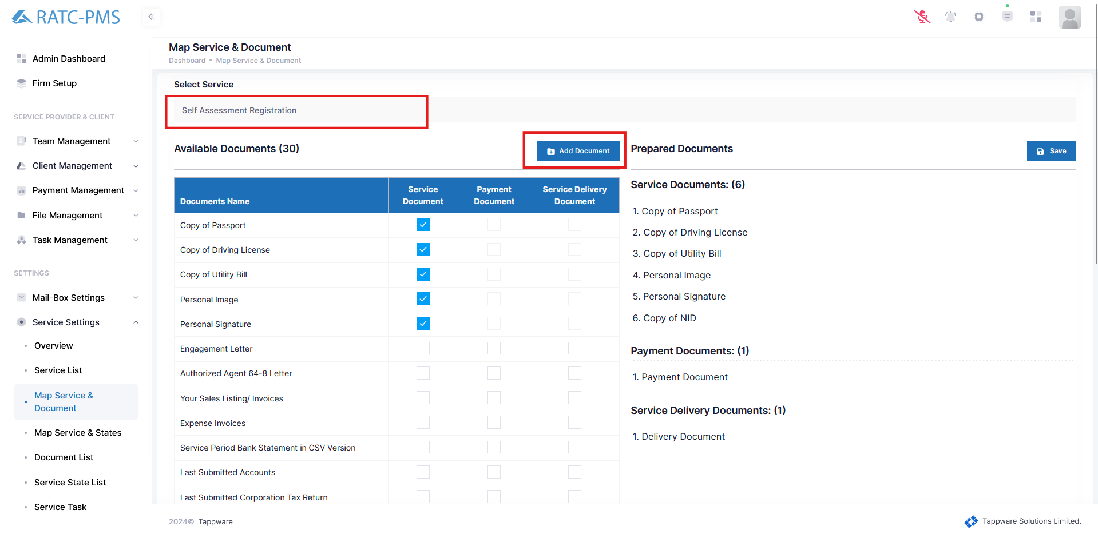

Fig: Map Service & Document

## 10.4 Map Service & States

On this page, the user will pick a service. After selecting a service, all available states for that service will be highlighted with a tick mark. Additionally, the Configured states will appear, which include Service State, Record Request Days, Payment Reminder Days, Completion Duration, and Notify To Roles. Users can alter and save these states.

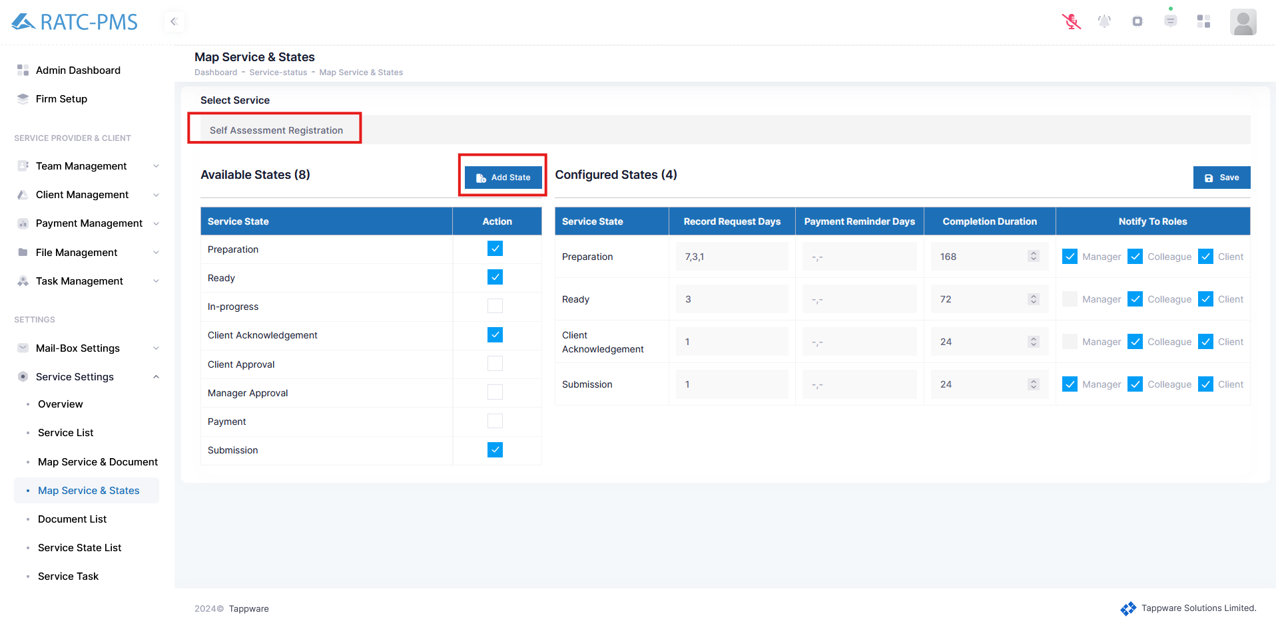

Fig: Map Service & States

## 10.5 Document List

In this page, users can view all the document list, document title, description, group of the document, approve roles (who are permitted to approve this document). Using the edit button, users can edit Document Title, Documents Group, Approve Roles, No of Files and Description of the Document. Users can remove a document type using the delete button.

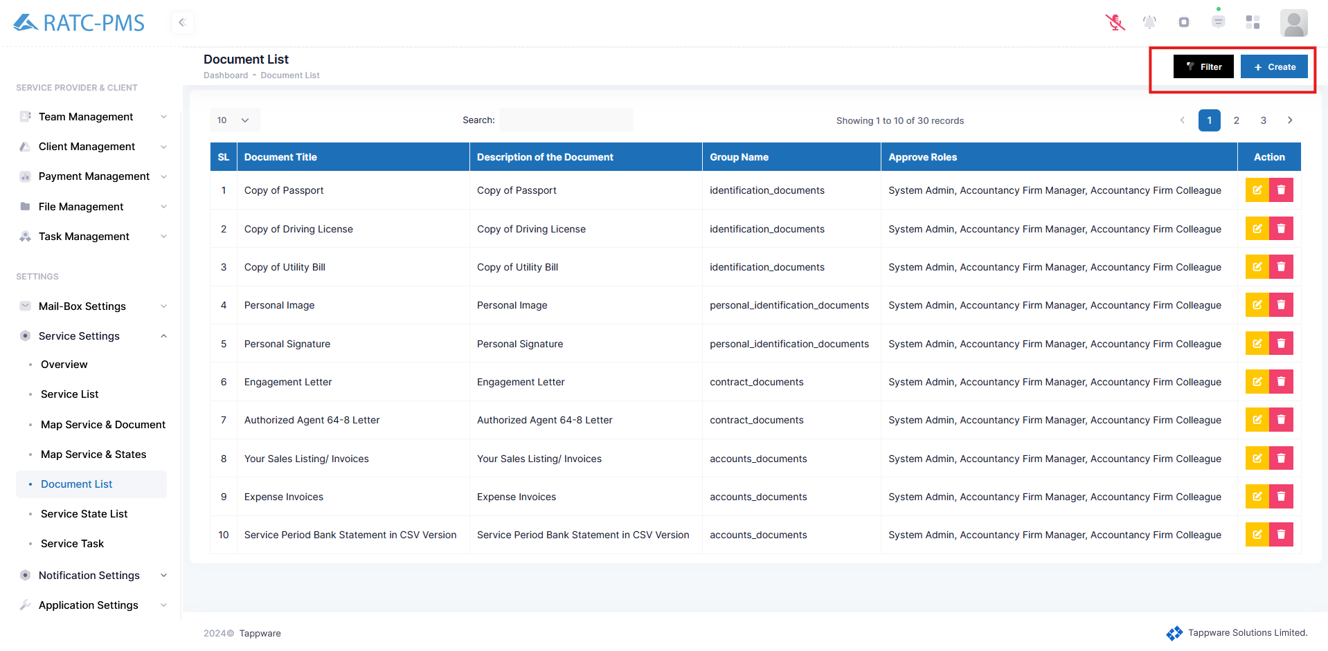

Fig: Document List

## 10.6 Service State List

Here users can view all the service progress states. Users can create a state using the create button. Users can also edit or delete an existing status.

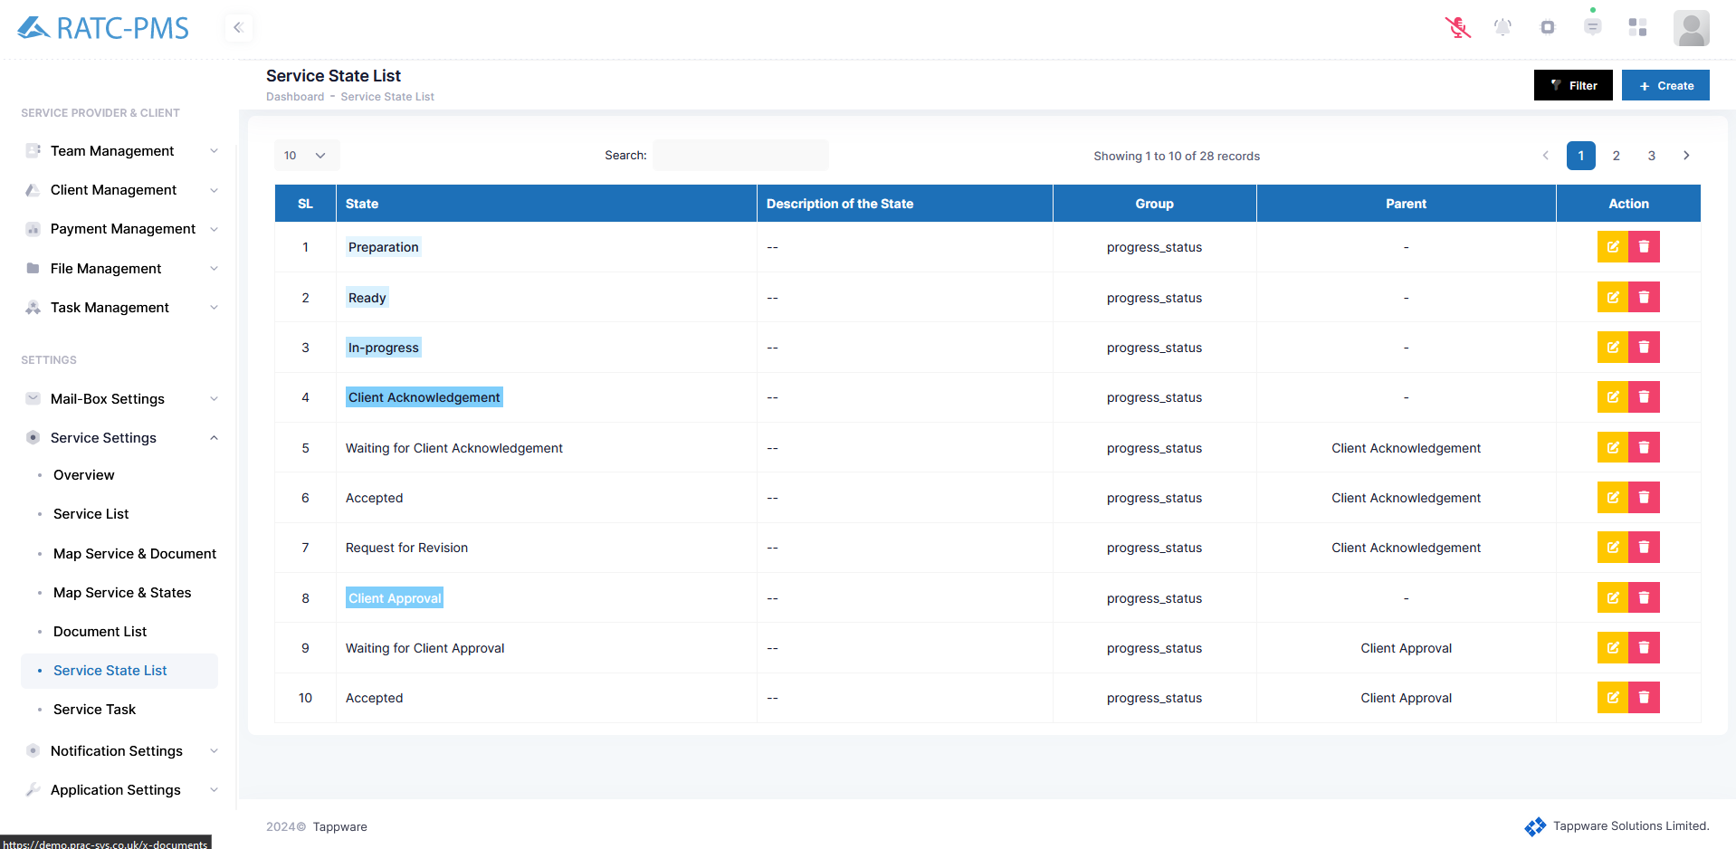

Fig: Service State List

## 10.7 Service Task

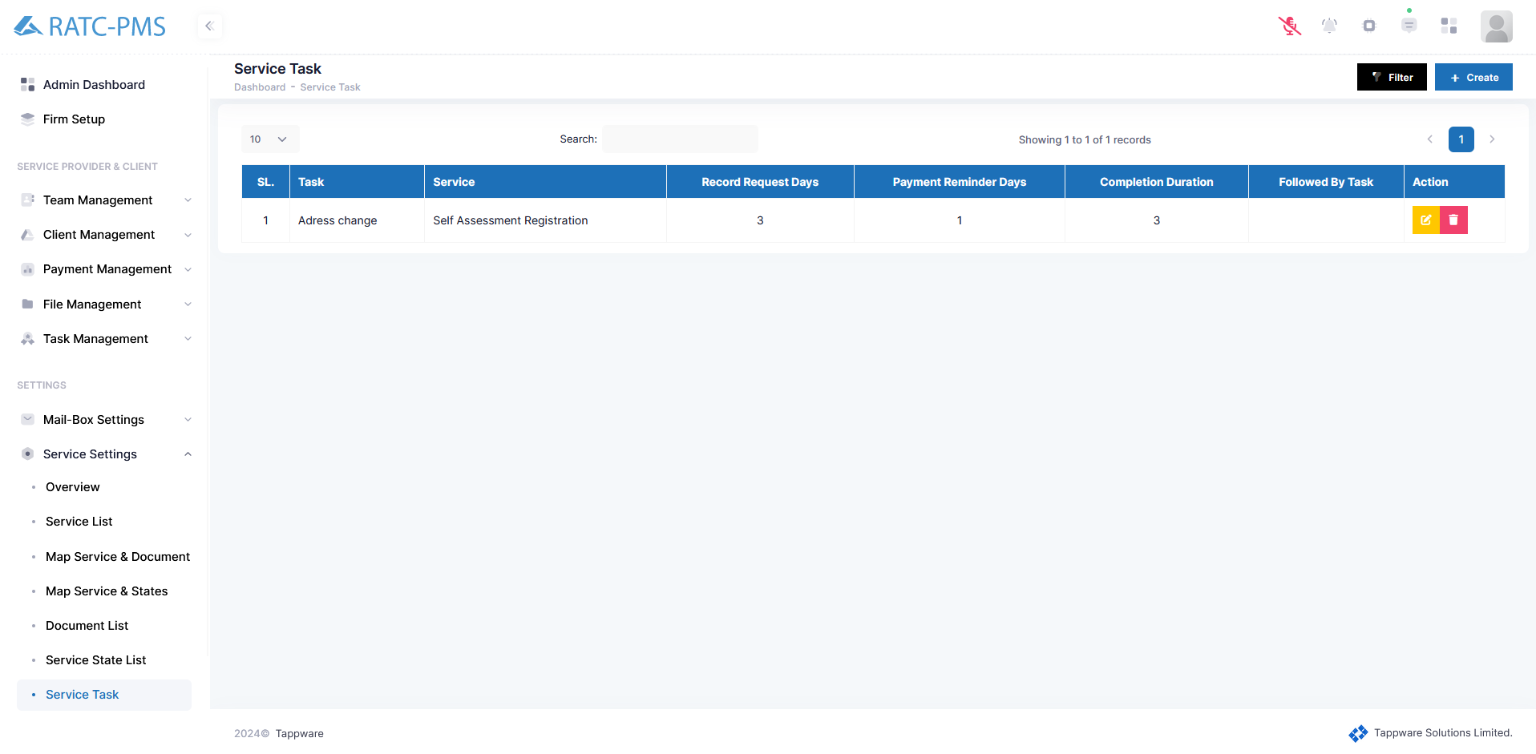

Fig: Service Task

# Notification Settings

## 11.1 Notifications

The user may see all of his notifications here. This page displays information such as notification type, message, receiver, sender, and time.

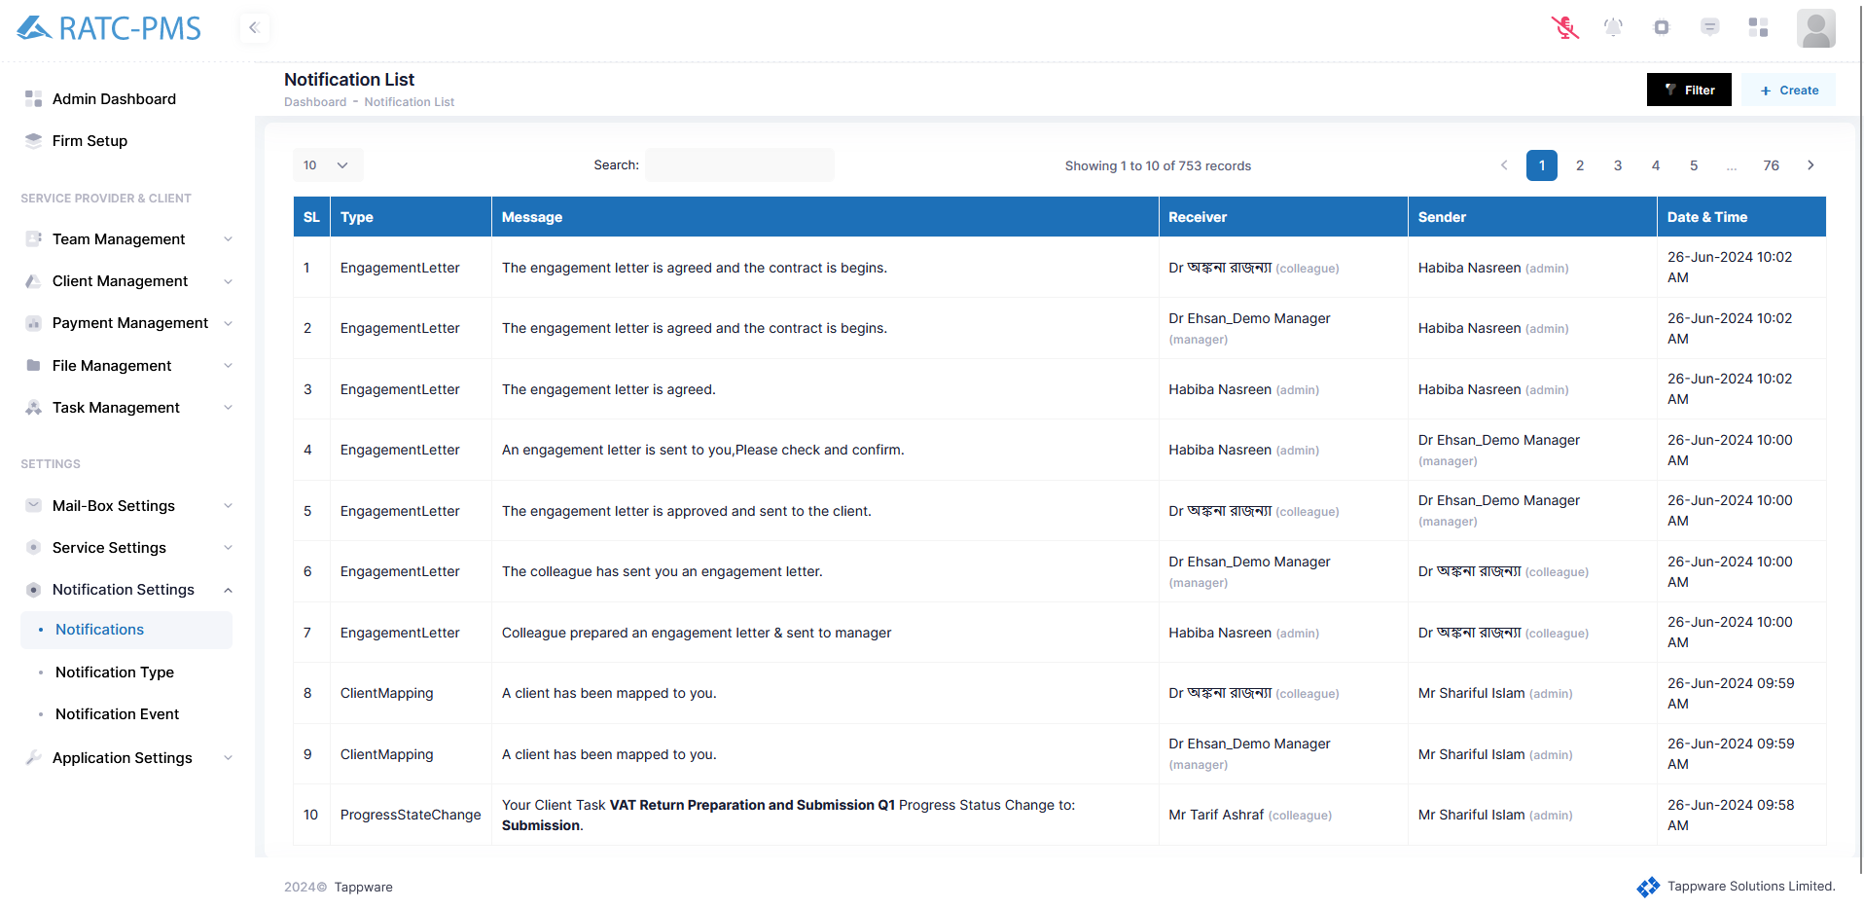

Fig: Notifications

## 11.2 Notification Type

Users can see all the notification types with name and description here. Users can edit or delete a notification type. Users can also create a notification type.

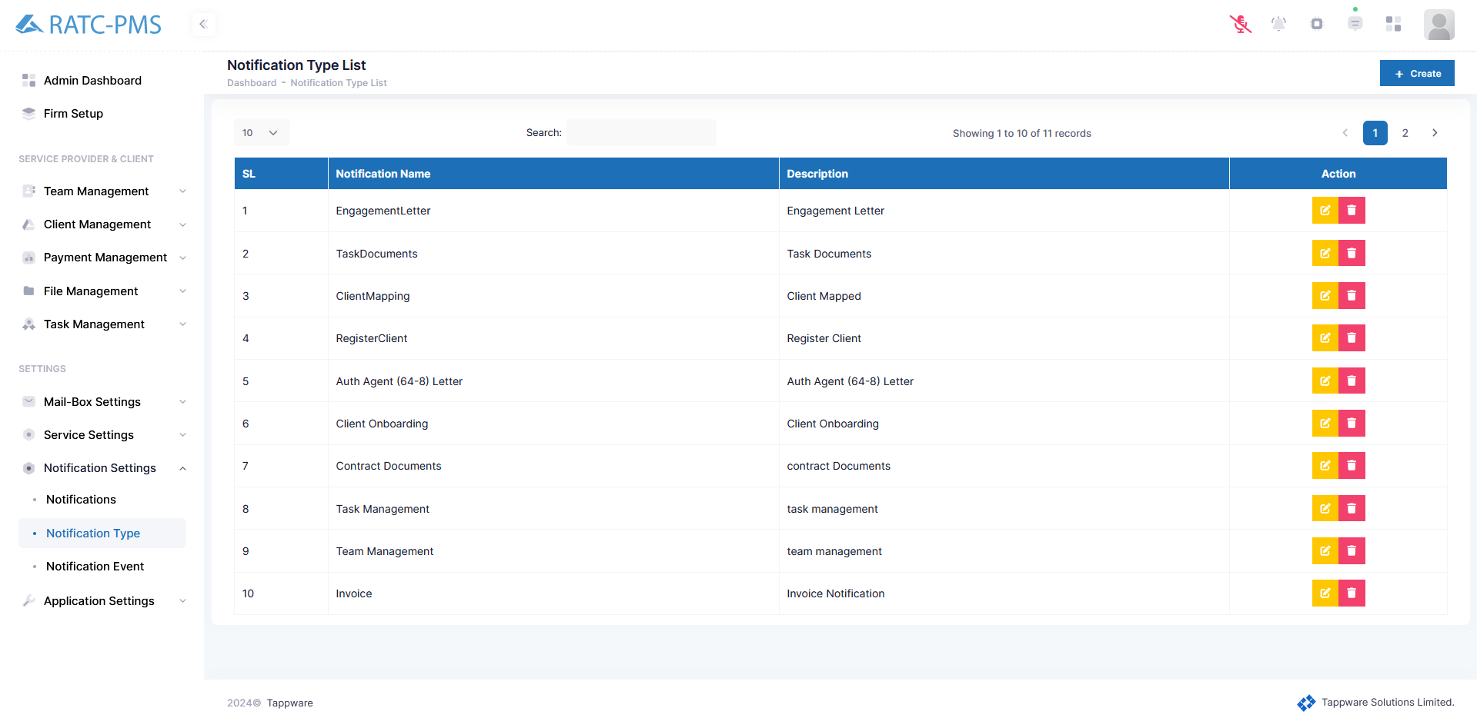

Fig: Notification Type

## 11.3 Notification Event

Here users can view all the notification events with notification type, name, title and description. Users can also edit or delete an event. Users can also create a notification event using the create button.

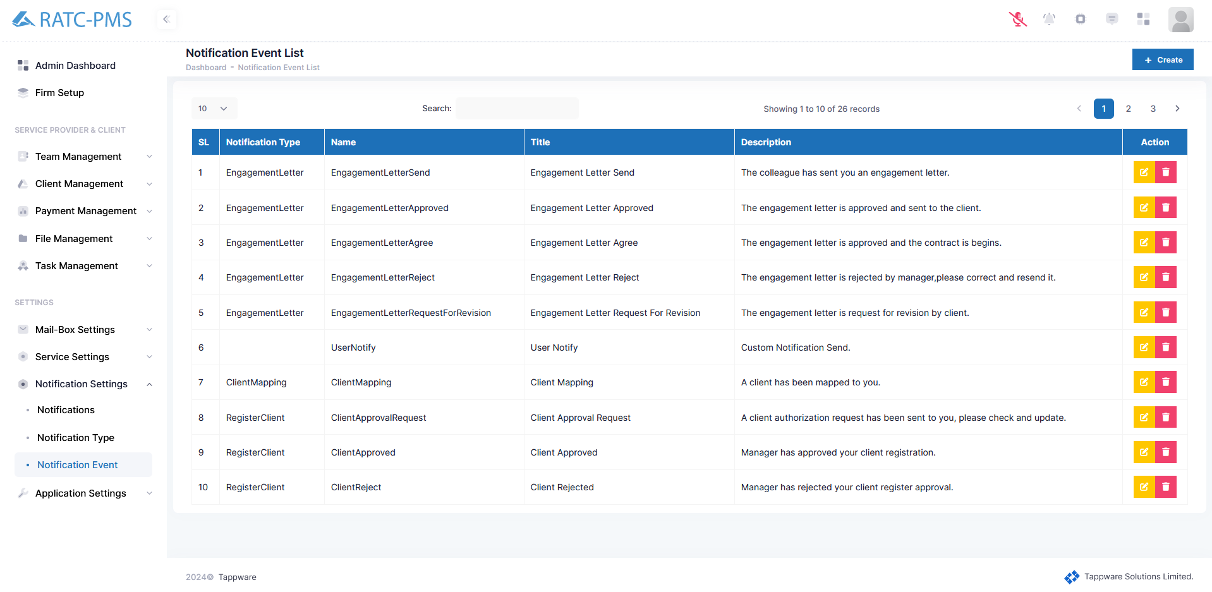

Fig: Notification Event

# Application Settings

## 12.1 Overview

## 12.2 Business type

The user may view all the business types with name, description and level. Users can also edit a certain business type using the edit button.

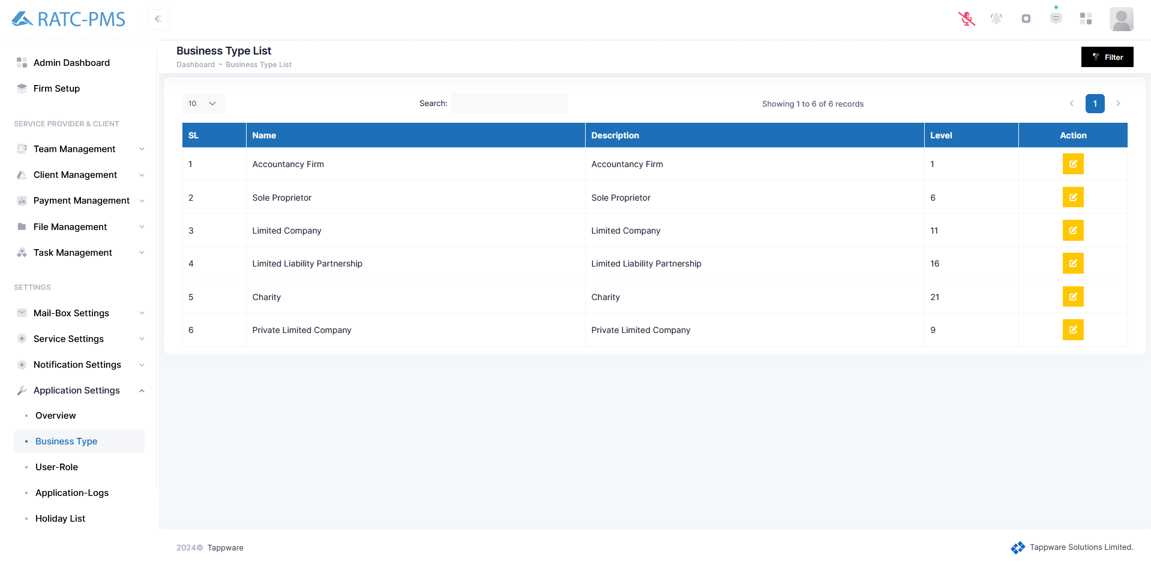

Fig: Business Type

## 

## 12.3 User-Role

Users can see all the user-roles for any business type from here. Users can create a role using the create button. Editing and deleting a role is also available in the action column.

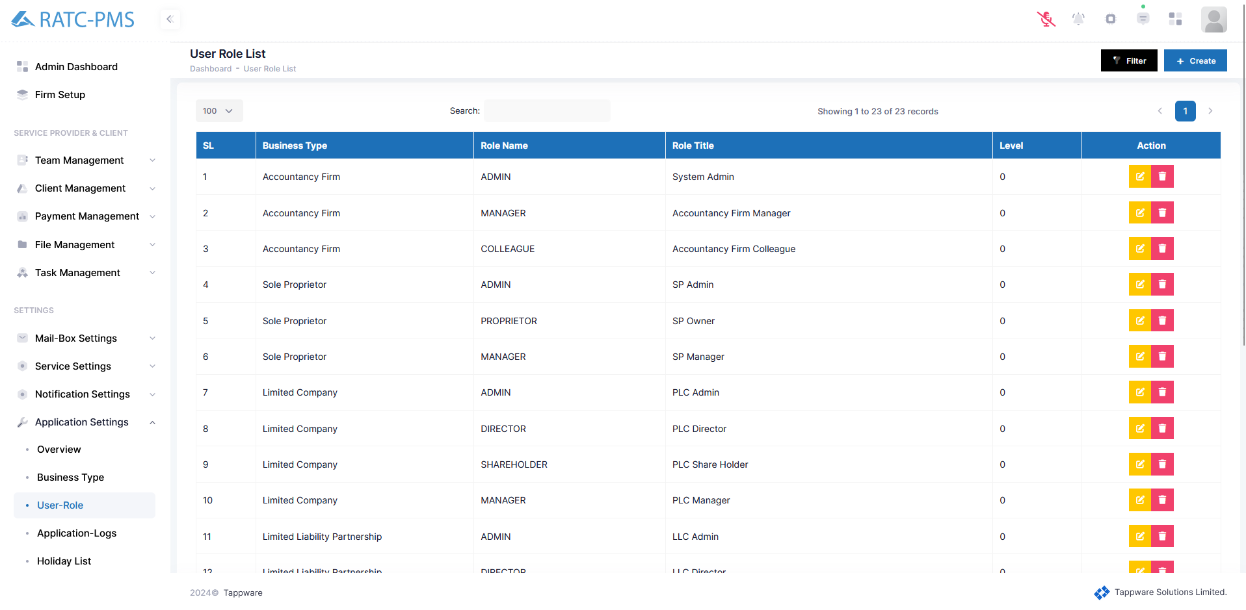

Fig: User-role

## 12.4 Application-Logs

There are three parts in Application-logs. Login Log will show all the login device, ip address and time. Error log shows the error times. Activity Log shows all the activities.

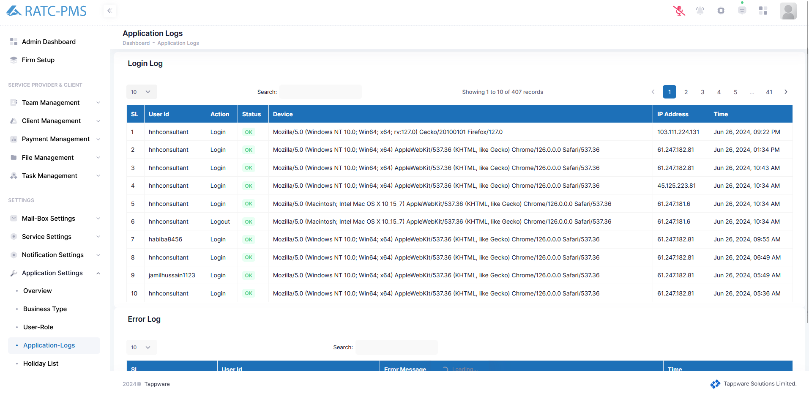

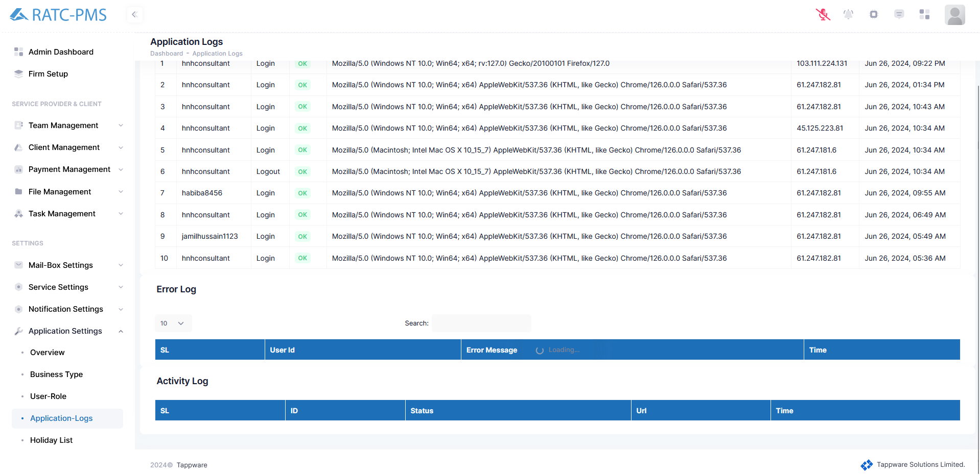

Fig: Application-Logs

## 12.5 Holiday List

## 12.6 Voice Command

This page shows all the voice commands to perform an action.

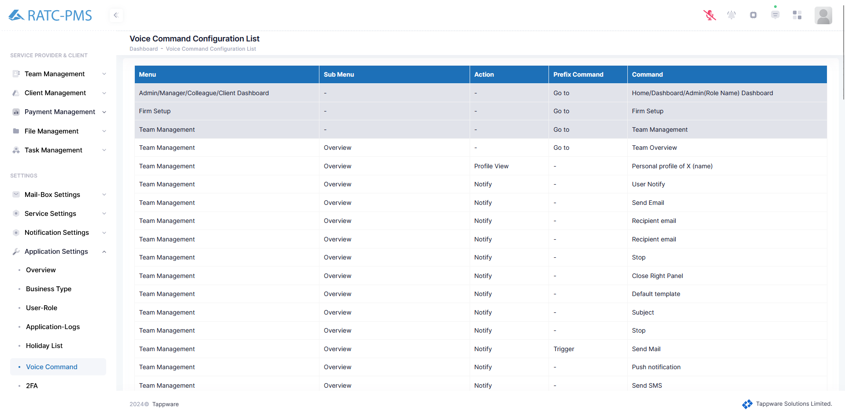

Fig: Voice Command

## 12.7 2FA

Users can enable two-factor authentication from this page.

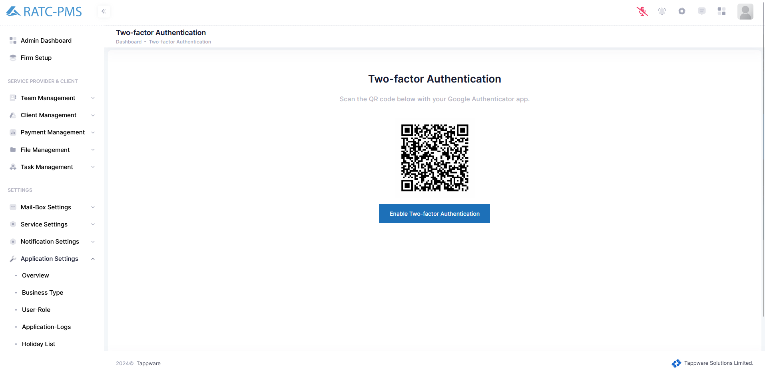

Fig: 2FA